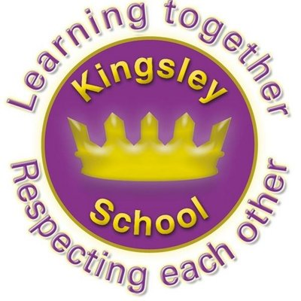
R E: Y 4

T: A

K S: B
B Q: W  J    ?

E K
P       :
W    ‘’ ? W  ?
W     J’  ? I J’      ?
W J     ?
W  J ? W    ? W    ?
D J’   ? H & ?
W  J   ? W      C?
W  C    J  ‘G F’    S  R ?
I J   ? W ? H   ?
W     J   21    ?
D    J    ?

Key Figures:
Jesus
God
Mary
Judas
Barabbas

Key Websites
www.bbc.co.uk/bitesize/subjects/z7hs34j

www.britannica.com

www.theschoolrun.com/other-subjects/religious-education-re

Prior Learning
Y3
What do different people believe about God?
Subsequent Learning
Y4
Why is Jesus inspiring to some people?

Key Vocabulary: inspiring, Gospels, teacher, resurrection, miracles, parables, symbols, ‘Good Friday’, crucifixion

