
R E: Y 4

T: S
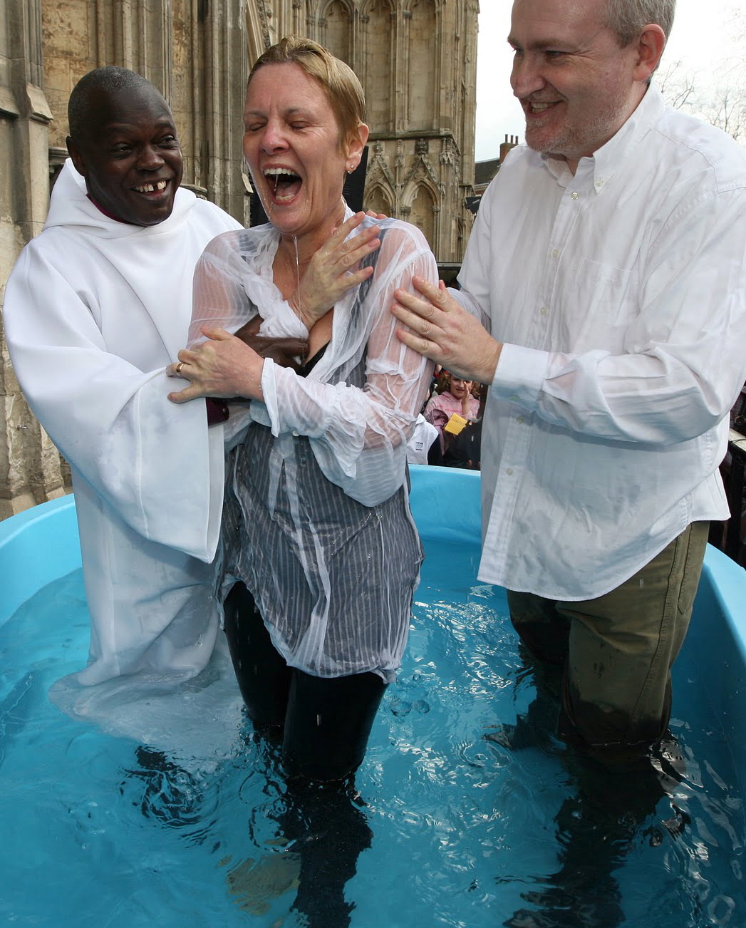

K S: E
B Q: W         ? W    ?

E K
P       :
W      ?
W        ?
W       C?
H  J     ?
W   H      ?
W    ?
A   ?
C      C, J   H?

Key Websites
- www.bbc.co.uk/bitesize/subjects/z7hs34j
- www.britannica.com
- www.theschoolrun.com/other-subjects/religious-education-re

Subsequent Learning
Y5
If God is everywhere, why go to a place of worship?
Prior Learning
Y3
Why are festivals important to religious communities? (Easter and Eid focus)
Key Figures:
Jesus
John the Baptist
Saul/Paul
Rabbi

K V: , , B Mz, B Mz, z, , D, K, M, , 

