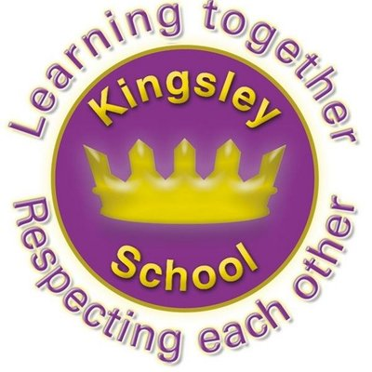
R E: Y 4

T: S
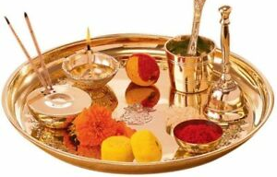

K S: L
B Q: W       H  B ?

E K
P       :

H  H   ?
W   (H )?
A H ;   ?
W  M G  H ?
W     M G?
W       H  B ?
Key Websites
- www.bbc.co.uk/bitesize/subjects/z7hs34j
- www.britannica.com
- www.theschoolrun.com/other-subjects/religious-education-re

Key Figures:

Mahatma Gandhi
Deities- Hanuman, Ganesh

Subsequent Learning

Y5
What does it mean to be a Muslim in Britain today?
Prior Learning

Y3
What does it mean to be a Christian today?

K V: , , , ,  , , , , , , , , 

