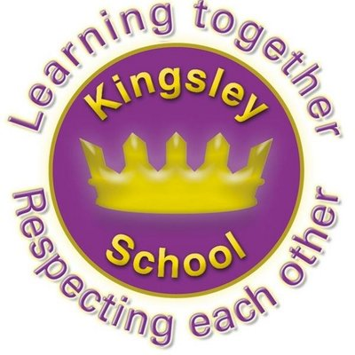
R E: Y 2

T: A

K S: B
B Q: W  M     ?
E K
P       :
W     G?
W   P M,       M?
W    P  M   ?
W         ? A  M?
W   ,      ?
H    M      ?
M    : W    ?
W     M  ?
W      E--F,  ?
W   M,     ?
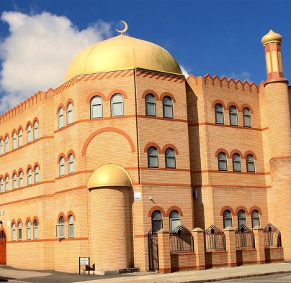
Key Websites
www.bbc.co.uk/bitesize/subjects/z7hs34j

www.britannica.com

www.theschoolrun.com/other-subjects/religious-education-re

Key Figures:
Prophet Muhammed
Allah
Bilal

Prior Learning
Y1
Who is Jewish and what do they believe?
Sbusequent Learning
Y3
What do different people believe about God?
Key Vocabulary:
Qu’ran, Islam, Imam Eid al-Fitr, Mecca, Salat, Hajj, Five pillars, Eid al-fitr, Kabba, hijab, mosque, Muslims

