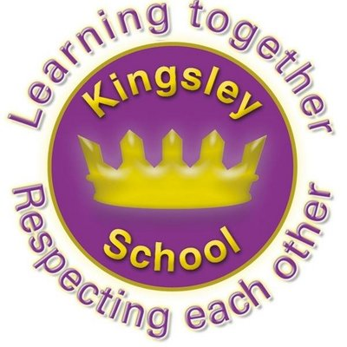
R E: Y 2

T: S

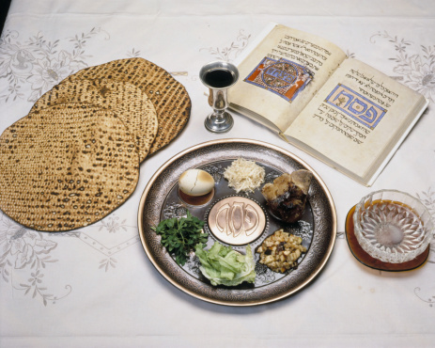
K S: E
B Q: H     
   ?
E K
P       :
W     ? W     ?
W   E       ?
H  C  E?
W    E?
W  J      P (P)  ?
W  M   I--F?

Key Websites
- www.bbc.co.uk/bitesize/subjects/z7hs34j
- www.britannica.com
- www.theschoolrun.com/other-subjects/religious-education-re

Key Figures:
Jesus
God
Pontius Pilate
Israelites
Prior Learning
Y1 What makes places sacred?
Subsequent Learning
Y3 Why are festivals important to religious communities? (Easter and Eid focus)

K V: , , M T, G F, E,  ,, , z, H, Q’, , , R, 

