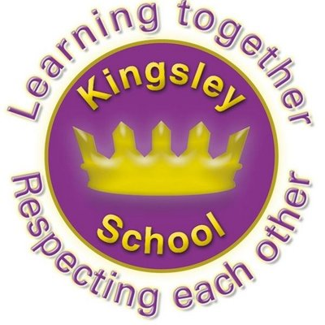
R E: Y 2

T: S
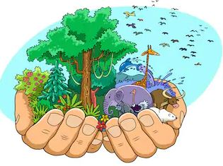

K S: L
B Q: H      
 ,     ?

E K
P       :
S    ?
W  C     ?
W         ?
H      ?
H        ?
W   C & J              ?
Key Websites
- www.bbc.co.uk/bitesize/subjects/z7hs34j
- www.britannica.com
- www.theschoolrun.com/other-subjects/religious-education-re

Key Figures:
Jesus
God
Allah
Prophet Muhammed

Prior Learning

Y1
What does it mean to belong to a faith community?
Subsequent Learning

Y3
What does it mean to be a Christian today?

K V: , , , z, ,  , , 

