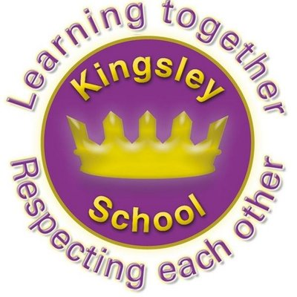
R E: Y 6

T: S
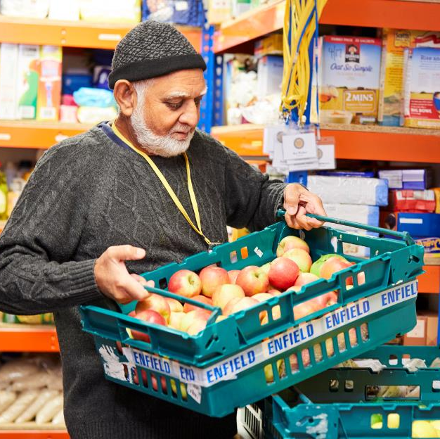

K S: E
B Q: I       
     ?
E K
P       :
W    ?
W    ? A   ?
W       ?
H     I   ? W    ?
M ,   :   ?
H  C        J?
W        ?
C  C         ‘  G’? W   ?
H    M      ?
H    C A     ?
W    C  M:  &     ? W    ?
Key Websites
- www.bbc.co.uk/bitesize/subjects/z7hs34j
- www.britannica.com
- www.theschoolrun.com/other-subjects/religious-education-re

Key Figures:
God
Jesus
Allah
Prophet Muhammed

Prior Learning
Y5
If God is everywhere, why go to a place of worship?
Subsequent Learning
Summer
What matters most to Christians and humanists?

K V: ,  , M , , , 

