
R E: Y 6

T: S

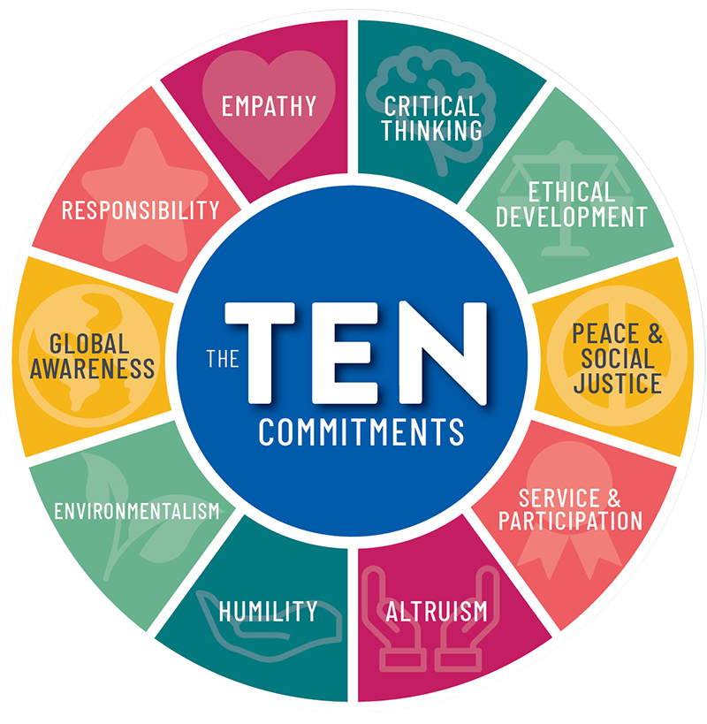
K S: L
B Q: W   
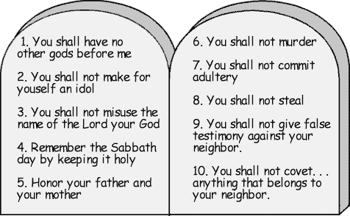
C  ?
E K
P       :

D  ? W? W     ?
W   ? W     -  ?
W           ,   ?
W     C   ?
W       ?
P:       ?
C           ?
Key Websites
www.bbc.co.uk/bitesize/subjects/z7hs34j

www.britannica.com

www.theschoolrun.com/other-subjects/religious-education-re

Prior Learning

Y4
What does it mean to be a Muslim in Britain today?
Key Figures:
Jesus
God
Good Samaritan
Moses

K V: , , , , ‘  ’, , , ‘T F’, , T C, ,  , , T G R

