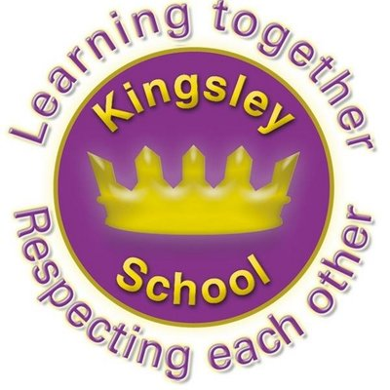
R E: Y 1

T: A

K S: B
B Q: W  J     ?
E K
P       :

W    ?
W    J ?
W   zz  J  ?
H    J   S?
H  J      C?
W     C    ?
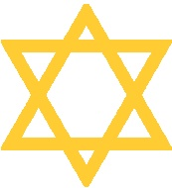
Key Figures:
Israelites
God

Key Websites
www.bbc.co.uk/bitesize/subjects/z7hs34j

www.britannica.com

www.theschoolrun.com/other-subjects/religious-education-re

Prior Learning

Reception

chanukah, places of worship
Prior Learning

Y2
Who is Muslim and what do they believe?

Key Vocabulary: precious, Jewish, Mezuzah, Challah, Kosher, Seder, Matzah, Chanukah, Kippa, Dreidel

