
R E: Y 1

T: S

K S: E
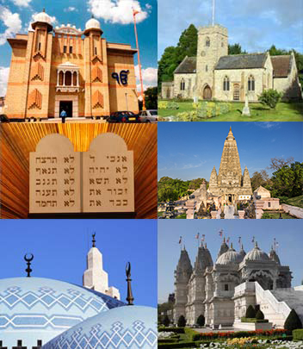
B Q: W    ?

E K
P       :
W  I  ?
W        ?
W       C?
W       J ?
W       M?
H       ?
W       ?

Key Websites
- www.bbc.co.uk/bitesize/subjects/z7hs34j
- www.britannica.com
- www.theschoolrun.com/other-subjects/religious-education-re

Key Figures:
priest/pastor
rabbi
imam
Subsequent Learning
Y2 How and why do we celebrate special and sacred times?
Prior Learning
Reception

Places of worship

K V: , , , C, J, , , B, J, ,  , , , , M, , z, , , zz 

