
R E: Y 1

T: S
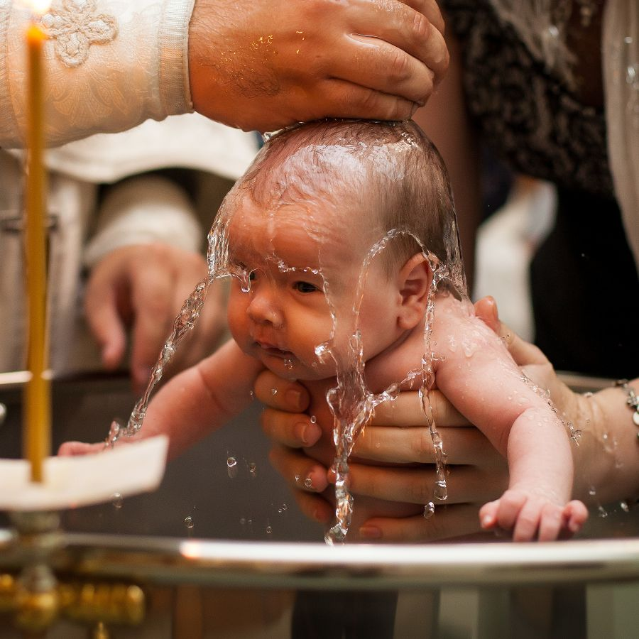

K S: L
B Q: W       
 ?

E K
P       :

D     ?
H  C   ?
H  M    ?
H J        ?
H  C    ?
H         ?
Key Websites
- www.bbc.co.uk/bitesize/subjects/z7hs34j
- www.britannica.com
- www.theschoolrun.com/other-subjects/religious-education-re

Subsequent Learning

Y2
How should we care for others and the world and why does it matter?
Prior Learning

Reception
Being a positive member of society
Key Figures:
Jesus
God
Allah
Prophet Muhammed
priest

K V: , M , I, C, ,  , 

