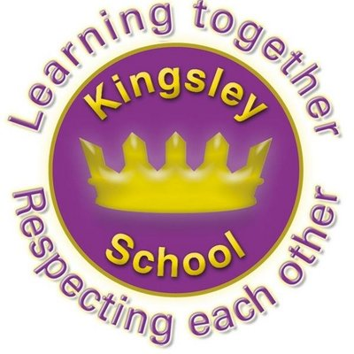
R E: Y 3

T: A

K S: B
B Q: W      G?

E K
P       :
‘S  B’-  ?
W  C   G?
W  I     G?
W     M   B B    G  C?
W  M   A?
W  M    H Q’?
H  H         ?
W       H   ?
W             G? W   ?
W          G?
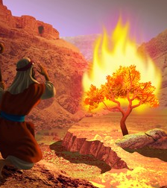
Key Figures:
Vishnu
Brahma
Shiva
God

Key Websites
www.bbc.co.uk/bitesize/subjects/z7hs34j

www.britannica.com

www.theschoolrun.com/other-subjects/religious-education-re

Prior Learning
Y2 Who is Muslim and what do they believe?
Subsequent Learning
Y4 Why is Jesus inspiring to some people?

Key Vocabulary: creator, shahadah, prophet, Hindu murtis, humanism

