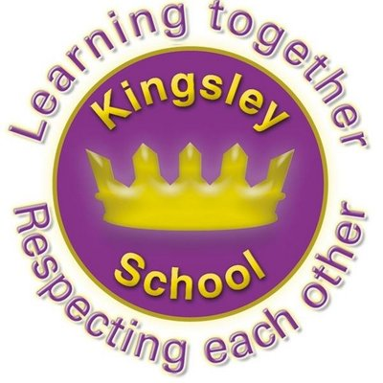
R E: Y 3

T: S
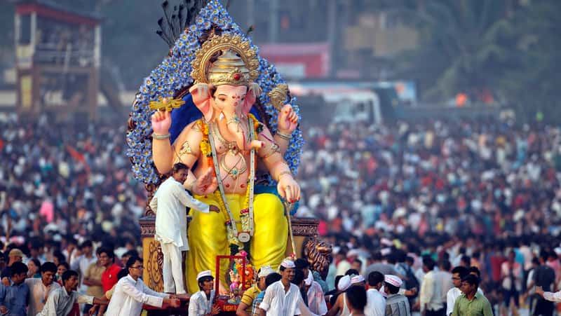

K S: E
B Q: W      ?

E K
P       :
W   ?
W  C   E?
W     J’     ?
W     J   C?
W  C    E S ?
W  D   H?
W  M     R?
W  J   P  ?
W       ?
Key Websites
- www.bbc.co.uk/bitesize/subjects/z7hs34j
- www.britannica.com
- www.theschoolrun.com/other-subjects/religious-education-re

Key Figures:
Jesus
Judas
Pilate
Barabbas
Mary
Ravana
Lakshmi
Moses
Pharaoh

Subsequent Learning
Y4
Why do some people think that life is a journey? What significant experiences mark this?
Prior Learning
Y2
How and why do we celebrate special and sacred times?

K V: E--F, E, P, Mz, D, P, , , , , , , , ,  

