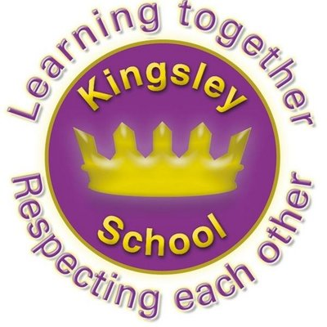
R E: Y 3

T: S
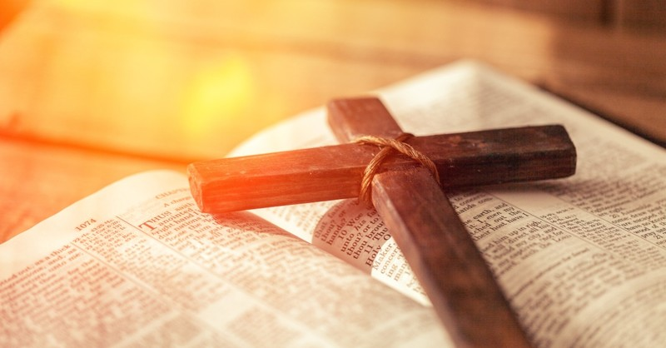

K S: L
B Q: W       C  B ?

E K
P       :

H  C      ?
W  C       C?
H     C    ?
H     C   ?
H  C       ?
W          ?
Key Websites
- www.bbc.co.uk/bitesize/subjects/z7hs34j
- www.britannica.com
- www.theschoolrun.com/other-subjects/religious-education-re

Key Figures:

Jesus
Rosa Parks
disciples/apostles

Subsequent Learning

Y4
What does it mean to be a Hindu in Britains today?
Prior Learning

Y2
How should we care for others and the world and why does it matter?

K V:
C, C W, H , C. H, C, O T, N T, P, , , 

