
R E: Y 5

T: S
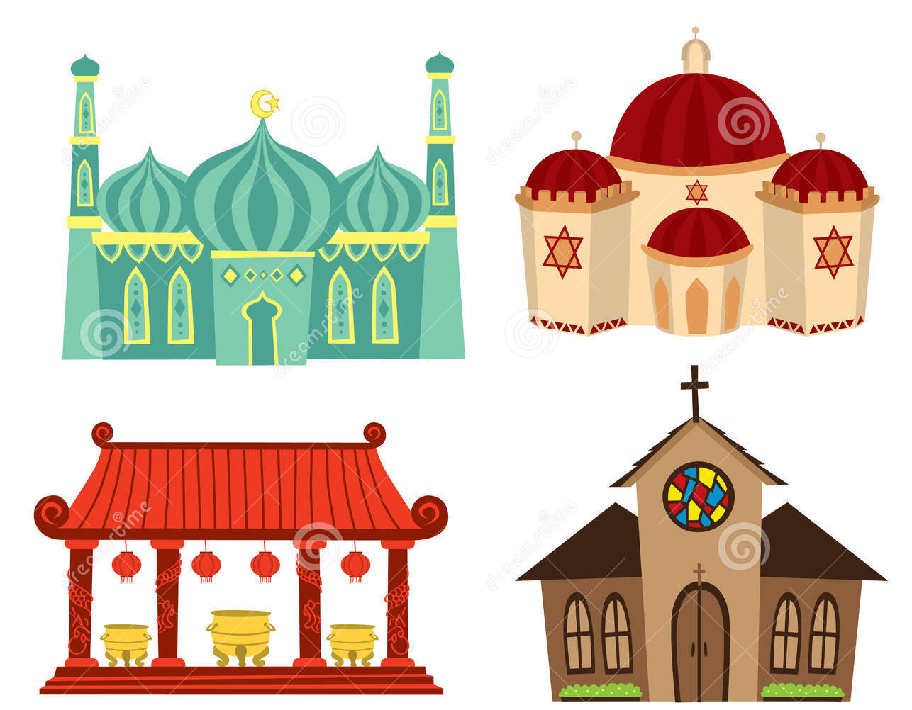

K S: E
B Q: I G  ,       ?
E K
P       :

W     ? W   ?
W   C   ? W   ?
W   H   ? W   ?
W  J   ? W   ?
A      ?
W        ?
W   ?

Key Websites
- www.bbc.co.uk/bitesize/subjects/z7hs34j
- www.britannica.com
- www.theschoolrun.com/other-subjects/religious-education-re

Key Figures:
priest
pastor
Jesus
Jew
Hindu
Muslim
Christian

Prior Learning
Y4 Why do some people think that life is a journey? What significant experiences mark this?

What significant experiences mark this?
Prior Learning
Y6- Is it better to express your beliefs in arts and architecture or in charity and generosity?

K V: , A, B, M, S, H , zz,  , , , , , OM, , , ,  N T, 

