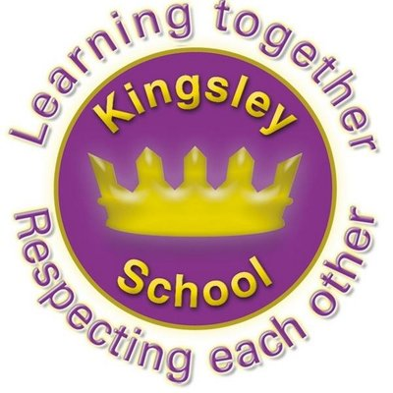
R E: Y 5

T: S
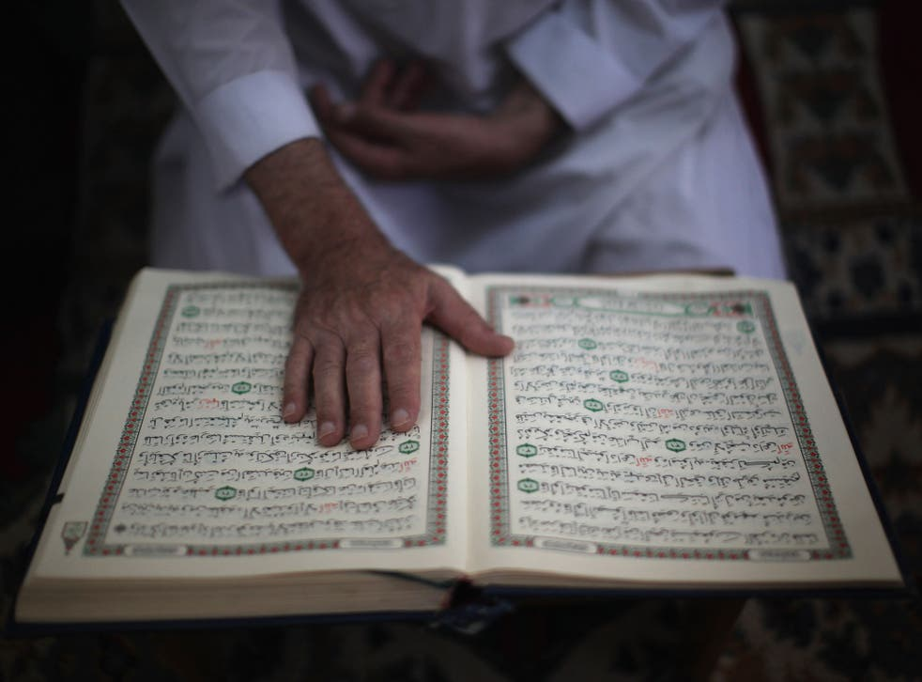

K S: L
B Q: W       M B ?
E K
P       :
W       ? W  M     ?
W      M? H     ?
W     M?
H  M  C  ?
H     M? H     ?
W  M ?
W  M      ?
W       ?
W      M?
C            ? W   M?

Key Websites
- www.bbc.co.uk/bitesize/subjects/z7hs34j
- www.britannica.com
- www.theschoolrun.com/other-subjects/religious-education-re

Key Figures:

Allah
Prophet Muhammad
Bilal

Prior Learning

Y6
What matters most to Christians and humanists?
Prior Learning

Y4
What does it mean to be a Hindu in Britain today?

K V: U, Mzz, ’, S, S, Z, S, H, M, E--A, M/M, H, S, I, 

