PSHE Policy (including RSE)
Kingsley Primary School
“Learning Together, Respecting Each Other”

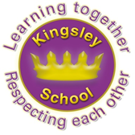

January 2022

Policy Context and Rationale
This policy covers our school approach to PSHE education (hereby known as PSHE) and has been written by the subject lead and in consultation with the curriculum lead and senior leadership team. Consultation has taken the form of pupil voice, staff and Governor voice (including parent representatives) and developed with curriculum leaders. As consultation and involvement of pupils in PSHE is crucial to meet their needs and address the issues they are facing, the pupils have been at the centre of our approach. Key needs have been identified by staff and pupils and underpinned by the Education Act 2011 and The Equality Act 2010. The need for promoting emotional well-being and physical development of all children is evident in our school. PSHE recognises a role in supporting children’s wider development and preparing all students for any opportunity, responsibility and experiences in later life. The 2006 Education and Inspections Act has placed a duty on Governing Bodies ‘to promote the wellbeing of pupils at the school’ and this is echoed in our bespoke planning and curriculum.

Our Key Values
Our school motto is ‘Learning Together, Respecting Each Other’
These key values are reflected in our everyday PSHE promotion where we fully support children’s personal, emotional, social, health, economic and mental well- being in order for them to become well rounded individuals in a safe and secure environment. We also fully believe in preparing children for the future in our ever changing world.
At Kingsley Community School we believe diversity is about, valuing, studying and celebrating our differences and uniqueness. When we are at our most inclusive, all members of the school community will be tolerant and respectful of each other’s differences as well as acknowledging what makes us the same; the promotion of ‘British Values’ will underpin and guide most of our work on tolerance and respect.

Our School Vision
At Kingsley Primary School we aim to develop children’s personal, social, health and emotional and economic education by ensuring that our PSHE curriculum provides strong opportunities for learning about today’s world and how to manage feelings, relationships and choices in order to maintain a balanced life and lifestyle. Our aim is to promote the spiritual, economic, moral, cultural, mental and physical development of pupils at the school and in society. We prepare our pupils for the opportunities, responsibilities and experiences of later life. We promote children’s understanding of current issues that are relevant to PSHE through discussions and opportunities to make sense of any difficulties and challenges that they face during their lives. It also helps keep them safe.
Introduction
At Kingsley Primary School we have high expectations of the right of every child to a broad and balanced PSHE curriculum as outlined by the National Curriculum and the PSHE Association programme of study. The children also experience a range of visitors in topical assemblies to further enhance their moral and social development. We ensure that the delivery and teaching of the PSHE key skills and learning objectives, outlined by the National Curriculum and the PSHE Association programme carefully matches our children’s needs. We also aim to fulfil the following for PSHE:-
• Make explicit the school’s commitment to delivering PSHE, through the implementation of the PSHE Framework in a whole-school approach where each child is highly valued as part of our school community.
• Provide guidance and support for staff.
• Inform parents/carers to enable the whole school community to work as part of a collaborative and supportive team.
• Create a variety of meaningful and enjoyable activities to promote emotional well-being and health in pupils, both in and out of school.
• Develop the knowledge, skills and attributes needed by pupils to manage their lives and maximize the opportunities afforded them.

Intent
The PSHE curriculum at Kingsley Primary is underpinned by appropriate learning objectives as set out in the primary national curriculum and the strong belief that PSHE is an extremely important and necessary part of children’s education. High emphasis is also placed upon children’s mental health and well-being in our ethos of PSHE. This is underpinned by our motto of ‘Learning Together, Respecting Each Other.’ To complement the PSHE taught in our school, we follow the PSHE Association scheme of work underpinned by the Medway Public Health Directorate, which also reflects the changes to the RSE expectations implemented from September 2020. Our PSHE curriculum encompasses important and relevant themes including drug education, financial education, sex and relationship education (RSE) and the importance of physical activity and diet for a healthy lifestyle. This also includes the use of social media and teaching the children about the influence of social media in today’s world. As stated by the government in terms of the compulsory teaching of RSE in primary schools, we wholly uphold the intent that “we want the subjects to put in place the key building blocks of healthy, respectful relationships, focusing on family and friendships, in all contexts, including online. This will sit alongside the essential understanding of how to be healthy.”
Planning
With the belief that PSHE is a cohesive theme in all subjects, we strive to ensure that children are well prepared for life in today’s world. Each year group from Year 1 to Year 6 teach PSHE. In the Early Years Foundation Stage; Personal, Social and Emotional Development is recognised as one of the building blocks of success in life. It supports children’s development by helping them to interact effectively and develop positive attitudes to themselves and others. All year groups follow the same overriding theme with activities and sub topics that are age appropriate. Due to the COVID 19 Pandemic, lessons have also been available to staff provided by Liverpool Local Authority to support children’s understanding of the recent worldwide events. The question-based model that all children follow as part of our PSHE curriculum are taught as discrete lessons or cross curricular links ie: Science: life cycle, ICT: Internet safety, RE: Cultural differences.
These are set out below:-
- Relationships
- Health and Wellbeing
- Living in a Wider World
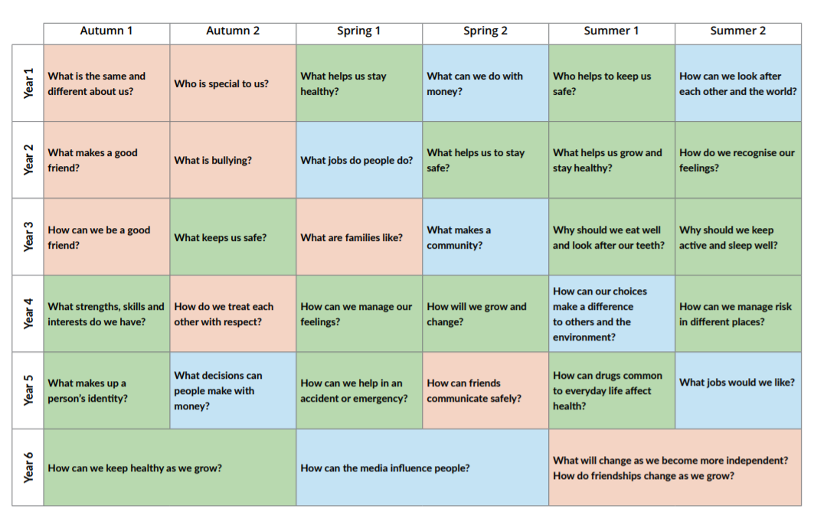

In addition, Relationships and Sex Education is also taught in line with the most current guidance set out from the DfE. This is taught by male and female staff and ensures that sensitive subjects are dealt with in appropriate ways. Parents are fully informed of when this takes place and the content involved when delivering this to the children.
Professional Development
The programme will be led by the PSHE Lead and supported by the Curriculum Lead and will be taught across the school, in all phases by teaching staff. It will be supported by teaching assistants who play a vital role in supporting pupils. Teachers responsible for teaching PSHE will receive training through bespoke CPD workshops led by the subject lead and will be guided through by detailed and high quality planning and resources.
Visitors to the classroom will be encouraged to bring their expertise or personal stories to enrich pupil’s learning. However, the teacher should always manage this learning, ensuring that learning objectives and outcomes have been agreed with the visitor in advance, and that any input from visitors should be part of a planned, developmental programme rather than a substitute for it. Teachers should always be present to manage the learning, and to ensure that it is safe. In RSE, a school nurse can present and teach objectives but this should always be followed up by the class teacher to answer any queries or questions.
Implementation
The PSHE curriculum at our school is implemented using plans designed by the PSHE Association to support developing a personalised and flexible PSHE education scheme of work over the course of the school year. It is inclusive for all children regardless of race, gender, cultural background, EAL and SEN. We believe that all children have equal access to the PSHE curriculum and believe that PSHE is a continuous and daily area of the children’s experience at school. It is evident through all other subjects and daily interactions with the children. It enhances the school’s motto of ‘Respecting Each Other’ and we aim to develop skills and attributes such as resilience, self esteem, risk management, teamwork and critical thinking in the context of the three core themes: Health and Wellbeing, Relationships and Living in the Wider World.
Our overall curriculum is designed to directly support the pastoral education of our pupils as well as the academic outcomes that the school aims for. Therefore our history aims to link knowledge of Britain’s past to the diverse and democratic country that we live in today through areas such as immigration, refugees and slavery. Within Geography, our aim is to ensure our pupils have a wide knowledge of the world and diverse cultures that exist beyond our school gates linking to topics such as Fairtrade and global warming.
At appropriate times in the year, there are themes weeks such as Anti Bullying Week, Black History Week and Enterprise Week where children focus on British Values and Economic Wellbeing.

The Role of the PSHE Subject Leader
It is the role of the PSHE subject lead to keep up to date with current issues both at local and national level and ensure that staff are kept up to date with what is happening in the subject of PSHE. Any resources that staff need and require are the responsibility of the subject leader to ensure the smooth teaching and implementation of PSHE. It is also the responsibility of the PSHE subject lead to monitor PSHE across the school to ensure consistency in teaching and enhance the children’s experiences in PSHE. The inclusion of parents is vital to value their input and the subject lead will ensure that parental involvement is a high priority in the development of PSHE. Pupil voice is also of high importance to involve the children in their own learning and development.

Risk Assessment
In line with the school’s health and safety policy and trips and visits documentation, any experiences involving PSHE are followed with relevant school policies in mind.
Entitlement and Equality of Opportunity

All classroom practice and pedagogy should take into account pupils’ ability, age, readiness and cultural backgrounds, and should be adjusted to enable all pupils to access the learning. Full PSHE provision should be accessible to every pupil. At Kingsley Primary, elements of reproduction education are taught in Science and not PSHE and have been since the curriculum changes in 2014. Parents do not have the right to withdraw their children from these lessons. https://www.gov.uk/government/publications/relationships-education-relationships-and-sex-education-rse-and-health-education/relationships-education-primary

We promote the needs and interests of all pupils, irrespective of gender, culture, ability or personal circumstance by promoting diversity and inclusion. We expect all children to consider the needs of others and we provide a curriculum and provision that can be fully accessed by all pupils. As far as is appropriate, pupils with special educational needs should follow the same PSHE programme as all other students. Careful consideration should be given concerning the level of differentiation needed, and in some cases the delivery will have to be adapted. Teachers and/or learning support assistants should work with individual pupils where required, and if appropriate. No child has the right to be withdrawn from PSHE to catch up on other national curriculum subjects: these aspects of personal and social development are as important to all pupils as their academic achievement.

Assessment/Impact

PSHE alone is not responsible for pupils’ future lifestyle choices: as with any other subject, assessment in PSHE should focus on learning, set against the lesson objectives and outcomes. Children inform the learning process by identifying needs, collecting information to certify achievement and competence and informing others by reflecting on what they have learnt and putting this into action. Some aspects of PSHE lend themselves to formal assessments for example knowledge of facts. Whereas assessing the development of skills or the consideration of attitudes and values, may need a greater range of formal and informal strategies and more open-ended approaches. In order to address this, we assess pupils’ learning and progression through pre unit assessments, ‘check its’ and end of unit assessments and these are captured in the PSHE Floor Books. This is implemented from Early Years to Year Six and presented in a variety of different ways through confidence banners, mini-quizzes and mind maps. The impact of PSHE is reflected through school displays, our staff who are all dedicated to the children of Kingsley Primary, extra- curricular activities offered, parental involvement, pupil voice opportunities and children’s behaviour and attitudes both in and out of the classroom and on the playgrounds. PSHE is reflected in how the children of Kingsley Primary consistently treat each other and adults with tolerance, patience and respect

It is also important to make sure you are assessing learning which is specific to PSHE and no other areas of the curriculum, such as English. It is important to recognise that assessment in PSHE is not about ‘passing or failing’, or about behavioural outcomes. Teachers and pupils both need to know what has been learned, and how learning and understanding has progressed.

Relationships and Sex Education
Aims
The aims of Relationships and Sex Education (RSE) at our school are to:
- Provide a framework in which sensitive discussions can take place
- Teach pupils the correct vocabulary to describe themselves and their bodies
- Prepare pupils for puberty, and give them an understanding of personal development and the importance of health and hygiene
- Help pupils develop feelings of self-respect, confidence and empathy
- Create a positive culture around issues of sexuality and relationships

Statutory requirements
As a maintained primary school we must provide relationships education to all pupils as per guidance stated in Relationships Education, Relationships and Sex Education (RSE) and Health Education (2020)
The Relationships Education, RSE, and Health Education (England) Regulations 2019 have made Relationships Education compulsory in all primary schools. Sex education is not compulsory in primary schools and the content set out in this guidance therefore focuses on Relationships Education. The content set out in this guidance covers everything that primary schools should teach about relationships and health, including puberty. The national curriculum for Science also includes subject content in related areas, such as the main external body parts, the human body as it grows from birth to old age (including puberty) and reproduction in some plants and animals. Scientific terminology is used throughout all lessons.
It is important that the transition phase before moving to secondary school supports pupils’ ongoing emotional and physical development effectively. The Department continues to recommend therefore that all primary schools should have a sex education programme tailored to the age and the physical and emotional maturity of the pupils. It should ensure that both boys and girls are prepared for the changes that adolescence brings and – drawing on knowledge of the human life cycle set out in the national curriculum for science. In teaching RSE, we must have regard to guidance issued by the Secretary of State. At Kingsley Primary School we teach RSE as set out in this policy.

Policy development
This policy has been developed in consultation with staff, PSHE Lead and Curriculum Lead. The consultation and policy development process involved the following steps:
- Review – a member of staff or working group pulled together all relevant information including relevant national and local guidance.

- Staff consultation – the Curriculum Lead and Senior Leadership Team were given the opportunity to look at the policy and make recommendations.

- First draft shared with Governors.

- Parent/stakeholder meeting – parents were invited to attend a meeting to discuss/view the content.

- Pupil consultation – we investigated what exactly pupils want from their RSE through Pre Unit Assessment style questions.

- Ratification – once amendments were made, the policy was shared with Governors and ratified.

Definition
RSE is about the emotional, social and cultural development of pupils, and involves learning about relationships, sexual health, sexuality, healthy lifestyles, diversity and personal identity.
RSE involves a combination of sharing information, and exploring issues and values.
RSE is not about the promotion of sexual activity.

Curriculum
We have developed the curriculum in consultation with parents, pupils and staff, taking into account the age, needs and feelings of pupils. If pupils ask questions outside the scope of this policy, teachers will respond in an age-appropriate manner so they are fully informed.

Delivery of RSE
RSE is taught within the personal, social, health and economic (PSHE) education curriculum. Biological aspects of RSE are taught within the Science curriculum, and other aspects are included in Religious Education (RE). RSE is taught to all pupils and is adapted to meet all children’s needs. RSE is always taught with a teacher and a teaching assistant present as sensitive topics are taught.
Relationships education focuses on teaching the fundamental building blocks and characteristics of positive relationships including:
Families and people who care for me
Caring friendships
Respectful relationships
Online relationships
Being safe

These areas of learning are taught within the context of family life taking care to ensure that there is no stigmatisation of children based on their home circumstances (families can include single parent families, LGBT parents, families headed by grandparents, adoptive parents, foster parents/carers amongst other structures) along with reflecting sensitively that some children may have a different structure of support around them (for example: looked after children or young carers).

Roles and responsibilities
The Governing Body will approve the RSE policy, and hold the head teacher to account for its implementation.

The Head Teacher is responsible for ensuring that RSE is taught consistently across the school, and for managing requests to withdraw pupils from [non-statutory/non-science] components of RSE (see below). The Head Teacher will meet with parents/carers along with the PSHE Lead to discuss the way in which these topics are taught. Parents will be invited in to view materials.

Staff are responsible for:
Delivering RSE in a sensitive way
Modelling positive attitudes to RSE
Complying with Equality Act 2010
Monitoring progress
Responding to the needs of individual pupils
All teaching staff are to deliver their RSE lessons and this is not to be taught by daily supply teachers. This to enable the correct learning environment for the children within the classroom. CPD will be provided.

Pupils are expected to engage fully in RSE and, when discussing issues related to RSE, treat others with respect and sensitivity.

Parents’ right to withdraw
By law, parents do not have the right to withdraw their children from Relationships Education. As components are not taught within RSE at Kingsley Primary, there is no right for any parent to request withdrawal from this curriculum subject.

Confidentiality and Handling Disclosures

Due to the nature of PSHE, pupils’ learning may result in them seeking advice or support on a specific personal issue. Teachers cannot offer complete confidentiality; it is important for everyone’s safety that teachers and pupils are clear about what can and cannot be kept confidential. It is also very important for external contributors, including school nurses, to be clear about these rules and that whilst working in the classroom, they are bound by the school’s confidentiality policy, not their own. Ground rules are to be explained every lesson so that the children are aware of what is expected within the classroom.

Responding to Pupils Questions

It is important that pupils feel able to ask any questions that they wish and that their questions are valued. However, consideration should be given to how to respond to questions. If necessary, teachers also need to feel able to ask a pupil to wait for an answer to give them time to consult with the school’s leadership team if they feel this appropriate, or if the question raises potential safeguarding concerns. Teachers should feel able to work with colleagues if necessary to construct an appropriate answer. We will allow pupils to raise anonymous questions by using the class worry/question box and notes passed to the teacher at the end of each lesson. If a safeguarding issue is raised by an anonymous question, we will follow the safeguarding policy currently in place in school.

Links to Other School Policies and Areas of the Curriculum
This policy supports the following policies:
- Safeguarding Policy
- Online Safety and Acceptable Use
- Child Protection
- Anti-bullying
- Drug and Substance Misuse Education
- First Aid
- Grief, Bereavement and Separation
- Intimate Care
- Safeguarding Escalation
- Transition
- SEND
- Equality and Diversity
- Safe touch/Intimate Care
- Behaviour Policy
- Staff Handbook
- Science Policy

Involving Parents and Carers

We are committed to working with parents and carers in all aspects of PSHE. All key documents are available through the school website. We will communicate with families and carers through online platforms including texting, emailing, Twitter and the school website. If a parent has any concerns, we will offer a meeting with the Head Teacher to explore all aspects of the curriculum and discuss the matter.

Review Date

The PSHE policy will be reviewed at least every 2 years to ensure that it continues to meet the needs of pupils, staff and parents, and that it is in line with current DfE advice and guidance, unless there’s urgent need to do so earlier. This policy will be reviewed in Spring 2024 and will be reviewed by the Curriculum Lead and Subject Lead.

Next review date: Spring 2024

