Policy For:
Parent/ Carer Code Of Conduct

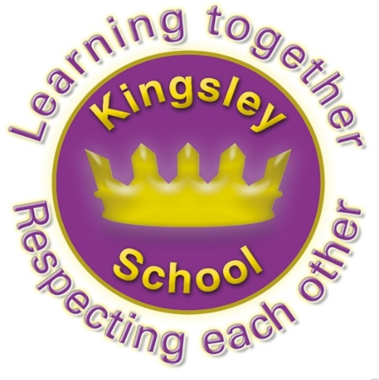

Kingsley Community Primary November 2025
Agreed by Governors November 2025

Equality Statement Under the Equality Act 2010.
We have a duty not to discriminate against people on the basis of their age, disability, gender, gender identity, pregnancy or maternity, race, religion or belief and sexual orientation. We have carefully considered and analysed the impact of this policy on equality and the possible implications for pupils with protected characteristics, as part of our commitment to meet the Public Sector Equality Duty (PSED) requirement to have due regard to the need to eliminate discrimination, advance equality of opportunity and foster good relations.
We believe that it is in line with the Equality Act 2010 as it is fair, it does not prioritise or disadvantage any pupil and it helps to promote equality at Kingsley Community Primary School.

Contents
1. Introduction
2. Purpose and Scope
3. Behaviour and Expectations
4. Behaviour which will not be tolerated
5. Breaching the Code of Conduct

- Introduction
At Kingsley we are fortunate to have a supportive and friendly parent body. Our parents and carers recognise that educating children is a process that involves partnership between parents, class teachers and the school community. As a partnership, our parents/carers will understand the importance of good working relationships to equip children with the necessary skills for adulthood. For these reasons we continue to welcome and encourage parents/carers to participate fully in the life of our school.

- Purpose and Scope
The purpose of this policy is to provide a reminder to all parents, carers and visitors to our school about the expected conduct. This is so that we can continue to flourish, make progress and grow in an atmosphere of mutual kindness and respect.

At Kingsley Primary School, we believe it is important to:
• Work in partnership with parents/carers to support their child’s learning
• Create a safe, respectful and inclusive environment for pupils, staff and parents
• Model appropriate behaviour for our pupils at all times.
To help us do this, we set clear expectations and guidelines on behaviour for all members of our community. This includes staff (through the staff code of conduct) and pupils (through our behaviour policy). This code of conduct aims to help the school work together with parents/carers by setting guidelines on appropriate behaviour.
We use the term ‘parents/carers’ to refer to:
• Anyone with parental responsibility for a pupil
• Anyone caring for a child (such as grandparents or child-minders)

- Behaviour and Expectations
- We expect parents, carers and other visitors to:
- Respect the ethos, vision and values of our school: We show kindness and respect.
- Work together with staff in the best interests of our pupils
- Treat all members of the school community with respect – setting a good example with speech and behaviour and forms of communication (including verbal and written)
- Seek a peaceful solution to all issues
- Correct their own child’s behaviour (or those in their care), particularly in public, where it could lead to conflict, aggression or unsafe conduct
- Approach the right member of school staff to help resolve any issues of concern.
- Prevent disrupting, or threatening to disrupt, school operations (including events on the school grounds and sports team matches)
- Avoid gathering in large groups which may appear intimidating to others
  - Avoid making any contact, in all instances, towards other adults where this would breach the school’s code of conduct for acceptable behaviour
- To treat school equipment with respect and return it to school when required
- To supervise their children on school premises, as once they have been handed over they are parents responsibility.
- To pick their children up promptly at the designated times

4. Communication.
It is expected that the first point of concern that any parent has is addressed in person with the appropriate staff member at the earliest opportunity. Email correspondence should not be used as a substitute for in person conversation.
Parents should not place unreasonable demands on the time of office or other staff , in terms of responding to lengthy or repetitive emails.

5. The use of A.I.
School will consider whether correspondence has or appears to have been generated by Artificial Intelligence (“AI”) programmes such as Chat GPT.
School will not refuse to engage with correspondence just because it has been generated with the assistance of an AI programme. However, where the volume of correspondence which is or appears to be generated by AI becomes administratively unworkable for School such that engaging with the correspondence no longer represents a fair and proportionate use of resources, School may cease to engage further unless the correspondence is prepared to narrow the issues in such a way that School could reasonably be expected to respond.

6. Behaviour which will not be tolerated.

We will not tolerate:

- Swearing, or using offensive language to others
- Displaying a temper, or shouting at members of staff, pupils or other parents
- Threatening any member of the school community
- Sending abusive messages to another member of the school community, including via text, email or social media
- Making or posting defamatory, offensive or derogatory comments about the school, its staff or any member of its community, on social media platforms or within WhatsApp groups.
- Use of physical punishment against your child
- Any aggressive behaviour (including verbally or in writing) towards another child or adult
- Disciplining another person’s child – please bring any behaviour incidents to a member of staff’s attention
- Smoking (including vaping) or drinking alcohol on the school premises or collecting children from school when intoxicated.
- Possessing or taking drugs (including legal highs)
- Bringing dogs onto the school premises without prearranged permission (other than guide dogs
- Children using the equipment before or after the school day.
- Using bikes or E-Scooters on school premises
- Using your phone inside the school building
- Any other action that at the Head Teacher’s discretion disrupts or may disrupt the operation of School or the education of its pupils, or may otherwise bring School into disrepute.

5. Breaching the Code of Conduct

- If the school suspects, or becomes aware, that a parent/carer has breached the code of conduct, the school will gather information from those involved and speak to the parent/carer about the incident, where appropriate. Depending on the nature of the incident, School may take one or more of the below steps:
- Send a warning letter to the parent;
- Invite the parent in to school to meet with a senior member of staff or the Headteacher
- Contact the appropriate authorities (in cases of criminal behaviour);

- Implement a communication strategy, limiting the means by and frequency with which the parent/carer is permitted to contact the school;
- Ban the parent from the school site (in accordance with Section 547 of the Education Act 1996) The ban can be for a fixed period of time or indefinitely, depending upon the nature of the incident(s).

The school will always respond to an incident in a proportional way. If a parent is banned from the school site, the school will send a letter detailing the reasons for the ban and whether or not the ban is for a fixed period of time or indefinitely. The school will share this policy with them and inform them that they have the opportunity to present their side within the letter they are issued. Following a fixed-period ban, the parent must make an appointment to meet with the Headteacher for a reintegration meeting before they will be permitted back on site, detailed within the letter they are issued. After the individual’s side has been heard, the school can decide whether to continue with banning them. The decision will be reviewed within a reasonable time, decided by the school. Please note that failure to comply with the ban may result in a fixed period ban becoming indefinite. The Headteacher will consult the Chair of Governors before banning a parent from the school site.

The final decision for how to respond to breaches of the code of conduct rests with the Headteacher.
This policy will be reviewed annually by the Head Teacher.

