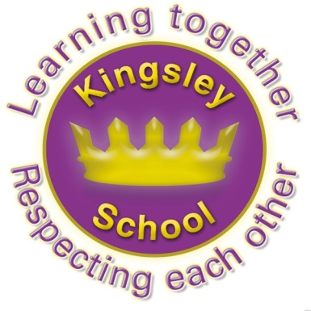
Kingsley Community School,
Eversley Street,
Liverpool.
L8 2TG.
Telephone: 0151 709 6727
Fax: 0151 708 5105
Website: www.kingsley.liverpool.sch.uk

Head Teacher: Mrs A Whittaker

Save Kids From Sugar Campaign 2nd December 2024

Kingsley has been asked to support a campaign by Liverpool City Council to help reduce the sugar that children have in their diet, in particular in drinks. Liverpool children have some of the worse dental issues in the country and we are asking all parents to help tackle this in as many ways as they can. Avoiding sugary drinks will make a big difference to your child’s dental as well as overall health. Sugary drinks can cause tooth decay and an unhealthy weight. We have ben given a free water bottle for every child , which they will bring home with this letter, to help raise awareness.

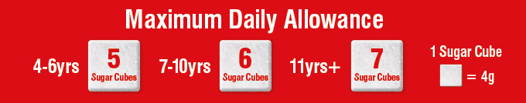
The amount of sugar in some popular drinks is staggering to say the least. Some drinks can contain double or even triple a child’s maximum daily sugar allowance. Giving your child drinks like these on a regular basis can put their health at risk. There’s simply no place in a child’s diet for these types of drinks. Given the risk that these drinks pose to a child’s health you would expect them to be clearly marked as such, unfortunately this is not the case. It can be difficult to see which drinks to avoid, which is why we’ve put together a clear list that you can use to help keep your child safe from sugar. See the chart overleaf to see which drinks contain the most sugar.

You can’t beat water!

When it comes to healthy refreshing drinks, water is king! Try and get into the habit of serving water either at meal times or when your child is thirsty throughout the day. Once they get used to regularly drinking water they should be more hydrated and crave sugary drinks less. And if you’re giving your children flavoured water check the label first as some can contain added sugar.

Milk is good for teeth
Tooth friendly and packed with vitamins and minerals, milk is a great choice for people of all ages. It’s also a good source of calcium, which helps to build and keep bones and teeth healthy.

Dentist’s tips
1. The sugar found in sugary drinks, including fruit juice can cause tooth decay
2. The acid found in all soft drinks, including diet and ‘no added sugar’ may cause enamel damage.
3. Brush your teeth twice a day with fluoridated toothpaste, last thing before bed and one other time every day.

Thanks for your support in this matter!

Mrs A. Whittaker, Head Teacher.



