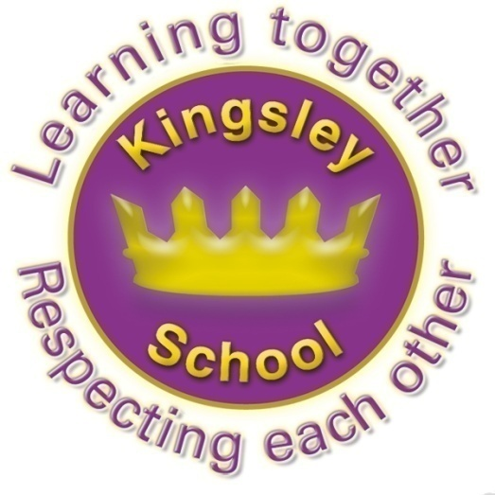

Kingsley Primary School

School uniform policy

January 2026

Approved by: | Care Culture Ethos Committee | Date: March 2026
Last reviewed on: | January 2026
Next review due by: | 2028

Contents
1. Aims 3
2. Our school’s legal duties under the Equality Act 2010 3
3. Limiting the cost of school uniform 3
4. Expectations for school uniform 4
5. Expectations for our school community 5
6. Monitoring arrangements 6
7. Links to other policies 6

1. Aims
This policy aims to:
- Set out our approach to requiring a uniform that is of reasonable cost and offers the best value for money for parents and carers
- Explain how we will avoid discrimination in line with our legal duties under the Equality Act 2010
- Clarify our expectations for school uniform

2. Our school’s legal duties under the Equality Act 2010
The Equality Act 2010 prohibits discrimination against an individual based on the protected characteristics, which include age, sex, disability, race, religion or belief, pregnancy and maternity, and gender reassignment.
To avoid discrimination, our school will:
- Avoid listing uniform items based on sex, to give all pupils the opportunity to wear the uniform they feel most comfortable in or that most reflects their self-identified gender
- Make sure that our uniform costs the same for all pupils
- Allow all pupils to have long hair (though we reserve the right to ask for this to be tied back)
- Allow all pupils to style their hair in a way that is appropriate for school and makes them feel most comfortable
- Allow pupils to request changes to swimwear for religious reasons or if they are experiencing discomfort related to their sex, gender or gender reassignment
- Allow pupils to wear headscarves and/or other religious garments (although we reserve the right to stipulate colour and style)
- Allow pupils with sensory or physical needs to make reasonable adaptations to their uniform depending on their specific needs
- Allow for reasonable adaptations to our policy on the grounds of equality by asking pupils or their parents/carers to get in touch with the Head Teacher who can answer questions about the policy and respond to any requests. These will be considered on a case-by-case basis

3. Limiting the cost of school uniform
Our school has a duty to make sure that the uniform we require is affordable, in line with statutory guidance from the Department for Education (DfE) on the cost of school uniform.
We understand that items with distinctive characteristics (such as branded items, or items that need to have a school logo or a unique fabric/colour/design) cannot be purchased from a wide range of retailers and that requiring many such items limits parents/carers’ ability to ‘shop around’ for a low price.
We will make sure our uniform:
- Is available at a reasonable cost , we sell at cost price, the school makes no profit.
- Provides the best value for money for parents/carers
We will do this by:
- Carefully considering whether any items with distinctive characteristics are necessary
- Limiting any items with distinctive characteristics where possible . In Kingsley a logo is limited to jumpers and cardigans only, and parents are free to purchase non logoed items of the same colour.
- Limiting items with distinctive characteristics to low-cost and/or long-lasting items, such as ties
- Considering cheaper alternatives to school-branded items, such as logos that can be ironed on, as long as this doesn’t compromise quality and durability
- Avoiding specific requirements for items pupils could wear on non-school days, such as coats, bags and shoes
- Keeping the number of optional branded items to a minimum, so that the school’s uniform can act as a social leveller
- Avoiding different uniform requirements for different year/class/house groups, the only exception being ties being compulsory for key stage 2.
- Avoiding different uniform requirements for extra-curricular activities
- Considering alternative methods for signalling differences in groups for interschool competitions, such as creating posters or labels
- Making sure that arrangements are in place for parents/carers to acquire second-hand uniform items
- Avoiding frequent changes to uniform specifications and minimising the financial impact on parents/carers of any changes
- Consulting with parents/carers and pupils on any proposed significant changes to the uniform policy and carefully considering any complaints about the policy

4. Expectations for school uniform
4.1 Our rationale for uniform wearing.
It is vital that a large and busy organisation like a school has rules and expectations which everyone follows. This is for many reasons, but our rules:
- ensure everyone is safe and happy at school,
- ensure our children do well
- ensure our children are ready for secondary school and society, where there are often even more rules!

Behaviour and safety are key strengths strength of our school. Choosing our school means you choose our rules. We ask all of our pupils to wear uniform Kingsley. What we believe is that uniform helps the children to:
- have a sense of belonging and identity
- be reminded about rules and respect
- avoid competitiveness about clothing brands
- adopt a smart approach to learning and to school
- Get ready for secondary school and the world of work

4.2 Our uniform

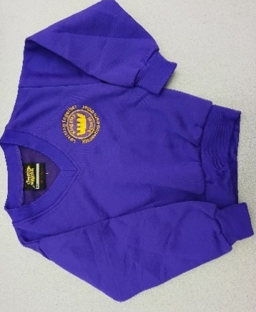
Reception and KS1
Children in Reception, year 1 and year 2 must wear:
Grey / black school trousers or skirt
Grey / black leggings, tights or socks
White polo shirt
Purple cardigan / jumper with the school logo on
Black shoes – no trainers allowed
A plain purple or black hijab
In the summer children can wear:
Grey / black school shorts
Yellow or lilac summer dress
White socks
For PE children need to wear:
Black shorts, leggings or tracksuit bottoms
Plain white t shirt
Trainers or pumps
Most items can be bought from local supermarkets such as Asda/ Tesco.

The following items can be purchased from school:
Purple cardigans with logo size 24 to 32 - £10.00. Size 34
Purple jumpers with logo size 24 to 32- £9.00. Size 34
Purple hijab
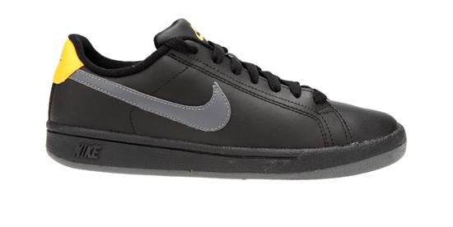
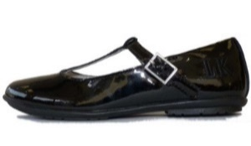
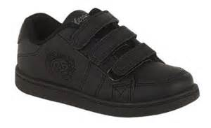

Children are not allowed to wear any jewellery in school except for small studs in pierced ears.
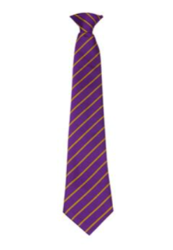
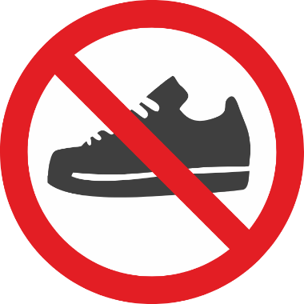
Trainers

Trainers are NOT part of uniform. They can be worn for PE only. They should not be worn at any other time.

Ties MUST be worn from y3 onwards.

Hijabs/ Prayer Hats

Headwear must be PLAIN black or purple ( white is allowed in the Summer term alongside Summer shorts/ dresses)
If your child wears a hijab, up to y5 it must be an all in one style, not a loose scarf. Y6 are allowed to wear a scarf style hijab, but this must be pinned or worn tucked / tied so that the ends are not loose. This is becoming a particular hazard in PE lessons.

Hijabs should be black or purple, or white in the Summer. Hijabs should be just as neat and tidy as the rest of a uniform, and fit for purpose.
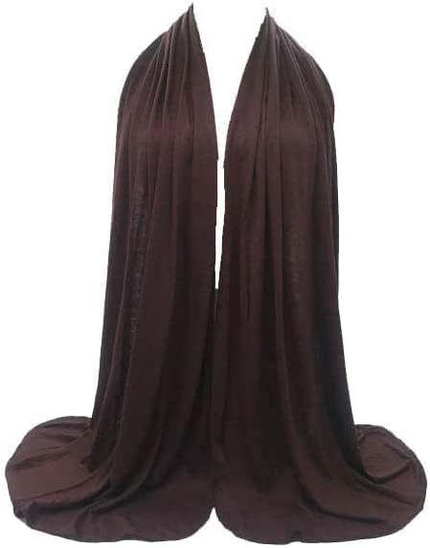
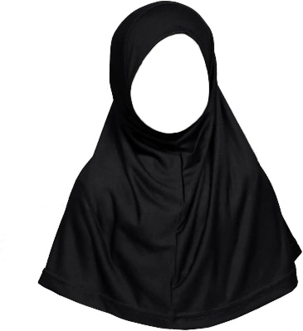

This style SHOULD be worn

This style should NOT be worn
PE KITS Are:

White T shirt
Black shorts or leggings
Pumps or trainers.

NOT Football kits
4.3 Where to purchase it

Jumpers , ties and cardigans can be purchased from the school office. Every child gets their first tie for free in y3.
All other items can be purchased from supermarkets.
Every half term we hold a pre loved uniform shop, with donations only requested for anything purchased.

5. Expectations for our school community
5.1 Pupils
Pupils are expected to wear the correct uniform at all times (other than specified non-school uniform days) while:
- On the school premises
- Travelling to and from school
- At out-of-school events or on trips that are organised by the school, or where they are representing the school (if required)
Pupils are also expected to contact the Head Teacher if they want to request an amendment to the uniform policy in relation to their protected characteristics.
5.2 Parents and carers
Parents and carers are expected to make sure their child has the correct uniform and PE kit, and that every item is:
- Clean
- Clearly labelled with the child’s name
- In good condition
Parents/carers are also expected to contact the Head Teacher if they want to request an amendment to the uniform policy in relation to:
- Their child’s protected characteristics
- The cost of the uniform
Parents/carers are expected to lodge any complaints or objections relating to the school uniform in a timely and reasonable manner.
Disputes about the cost of the school uniform will be:
- Resolved locally
- Dealt with in accordance with our school’s complaints policy
The school will work closely with parents/carers to arrive at a mutually acceptable outcome.
5.3 Staff
Staff will closely monitor pupils to make sure they are in correct uniform. They will give any pupils and families breaching the uniform policy the opportunity to comply, but will follow up with the headteacher if the situation doesn’t improve. Letters will be sent home to inform, remind parents about compliance with uniform policy.
Ongoing breaches of our uniform policy will be dealt with by our school’s behaviour policy.
In cases where it is suspected that financial hardship has resulted in a pupil not complying with this uniform policy, staff will take a mindful and considerate approach to resolving the situation.
5.4 Governors
The governing board will review this policy and make sure that it:
- Is appropriate for our school’s context
- Is implemented fairly across the school
- Takes into account the views of parents/carers and pupils
- Offers a uniform that is appropriate, practical and safe for all pupils
The board will also make sure that the school’s uniform supplier arrangements give the highest priority to cost and value for money, for example by avoiding single supplier contracts and by re-tendering contracts at least every 5 years.

6. Monitoring arrangements
This policy will be reviewed every 2 years.

7. Links to other policies
This policy is linked to our:
- Behaviour policy
- Equality information and objectives statement
- Anti-bullying policy
- Complaints policy

