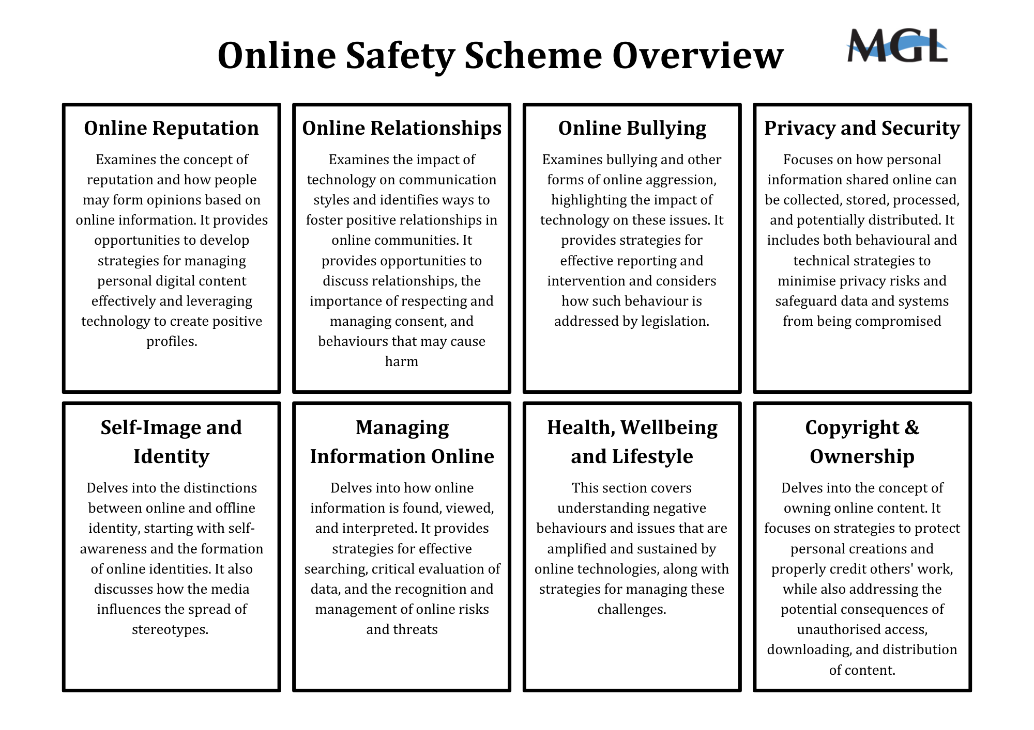
Year 1 & 2 Lesson Overview

 |  |  |  | Online Reputation
 |  |  |  | Objectives | - To learn to identify the difference between a positive and negative reputation  - To know how to protect our online reputation
 |  |  |  | Task One: Creating an avatar. |  | Task Two: Class discussion on how to behave online.
 |  |  | Online Relationships
 |  |  | Objectives |  | - To understand what a friend is and can identify the features of a friend.  - To know the difference between a real-life friend and an online friend
 |  |  | Task One: Creating a collage about being a good friend |  |  | Task Two: Class discussion about online friends.
 |  | Online Bullying
 |  | Objectives |  |  | - To understand the term Online Bullying, how we can recognise negative online behaviour and who can help.
 |  | Task One: Groups brainstorm how online bullying affects people. |  |  |  | Task Two: Creating a video to describe online bullying.
 | Privacy and Security
 | Objectives |  |  |  | - To recognise aspects of personal information and name some of these.  - To understand why personal information should not be shared with strangers  - To understand why and how to use passwords
 | Task One: Use Chatterpix to share what details are included in personal information. |  |  |  |  | Task Two: Children to create passwords based on what they know about strong passwords.
Self-Image and Identity
Objectives |  |  |  |  | - To identify good and bad aspects of using the Internet.  - To know who can help keep them safe
Task One: Create a logo for their class. |  |  |  |  |  | Task Two: Children will explore who can help if they are unsure of anything that upsets them online.
Managing Information Online
Objectives |  |  |  |  | - To understand how to use a search engine effectively and safely to make a simple search.  - To understand that opinions and reactions can be helpful  - To show respect online
Task One: Learning how to effectively search on search engines. |  |  |  |  |  | Task Two: Children explore different ways to share information online.
Health, Wellbeing and Lifestyle
Objectives |  |  |  |  | - To understand how rules help us to keep safe and well  - To recognise the signs of too much tech and how this affects us.  - To understand about PEGI ratings and why they are needed.
Task One: Create class set of rules for using computers. |  |  |  |  |  | Task Two: Children draw activities they could do instead of using a computer.
Copyright and Ownership
Objectives |  |  |  |  | - To understand how to name documents and how they can identify their own work  - To understand that when items are copied online that these documents do not belong to them
Task One: How to identify the copyright symbol on websites. |  |  |  |  |  | Task Two: Children will use search engines to search for copyright free images.
Year 3 & 4 Lesson Overview

 | Online Reputation
 | Objectives | - I can explain strategies anyone can use to protect their ‘digital personality’ and online reputation.  - I can explain what a digital footprint is, evaluate my current digital footprint, and describe steps to create a positive digital footprint in the future.
 | Task One: Children will create a class online reputation charter. |  | Task Two: Children will create their digital footprint and evaluate its impact.
Online Relationships
Objectives |  | - I can explain what is meant by ‘trusting someone online’, why this is different from ‘liking someone online’, and why it is important to be careful about who to trust online including what information and content they are trusted with.  - I can give examples of how to be respectful to others online and describe how to recognise healthy and unhealthy online behaviours.
Task One: Children will create a poster sharing their trusted adults. |  |  | Task Two: Class discussion about online friends.

 | Online Bullying
 | Objectives | - I can give examples of how bullying behaviour could appear online and how someone can get support.  - I can describe appropriate ways to behave towards other people online and why this is important.
 | Task One: Children will explore different online bullying scenarios and share the impact and what they would do. |  | Task Two: Children will create a poster about online bullying, its impact and how to get help.
Self-Image and Identity
Objectives |  | - I can explain ways in which someone might change their identity depending on what they are doing online (e.g. gaming; using an avatar; social media) and why.  - I can demonstrate how to make responsible choices about having an online identity, depending on context.
Task One: Children to create an avatar based how they should be represented online. |  |  | Task Two: Children will evaluate several profiles, sharing how they could improve them.
Managing Information Online
Objectives |  | - I can describe how to search for information with Boolean to increase the accuracy of results and information.  - I can explain what is meant by fake news e.g. why some people will create stories or alter photographs and put them online to pretend something is true when it isn’t.
Task One: Children will learn to use BOOLEAN to help with more accurate searches. |  |  | Task Two: Children will make a ‘how to…’ guide to fake news.

 | Health, Wellbeing and Lifestyle
 | Objectives | - I can describe ways technology can affect health and well-being both positively and negatively and suggest strategies to balance the impact.  - I can describe common systems that regulate age-related content (PEGI, BBFC, parental warnings).
 | Task One: Children to make a two-part poster looking at the positives and negatives of using technology. |  | Task Two: Children will create a new PEGI rating they would like to see on games.
Copyright and Ownership
Objectives |  | - I can explain why copying someone else’s work from the internet without permission isn’t fair and can explain what problems this might cause.
Task One: Children will brainstorm/ debate copyright, exploring its importance in protecting creators.
Security and Privacy
Objectives |  | - I can describe and explain some rules for keeping personal information private (e.g. creating and protecting passwords).
Task One: Children will explore scenarios based around privacy and security, the creating a poster to share how to keep personal information safe and keep passwords secure.

Year 5 & 6 Lesson Overview

 | Online Reputation
 | Objectives | - I can describe ways that information about anyone online can be used by others to make judgments about an individual and why these may be incorrect.  - I can explain strategies to protect online reputation and digital identity on social media, including how to use privacy settings.
 | Task One: Children will create a mini-biography using information on different websites and viewpoints. |  | Task Two: Children are to create a new social platform, considering safety and privacy.
Online Relationships
Objectives |  | - I can demonstrate an understanding of the different types of online relationships and how to support others, including those who are experiencing difficulties, while staying safe.  - I can describe how to kind and respectful in online relationships and how to support others, including the importance of respecting other’ boundaries regarding what is shared online, and how to support the, if their boundaries are not respected.
Task One: Children to create a guide about managing online relationships |  |  | Task Two: Children to review a series of scenarios sharing the issue and what to do.

 | Online Bullying
 | Objectives | - I can explain why people need to think carefully about how content they post might affect others, their feelings and how it may affect how others feel about them (their reputation).  - I can recognise online bullying can be different to bullying in the physical world and can describe some of those differences.
 | Task One: Children to explore how victims of online bullying feel. |  | Task Two: Children to create a short film about online bullying.
Privacy and Security
Objectives |  | - I can explain how many free apps or services may read and share private information (e.g. friends, contacts, likes, images, videos, voice, messages, geolocation) with third parties.  - I can describe ways in which some online content targets people to gain money or information illegally; I can describe strategies to help me identify such content (e.g. scams, phishing).
Task One: Children create a poster about the importance of reading terms and conditions and the digital age of consent. |  |  | Task Two: Children will create a guide about how to recognise and avoid scams.

Self-Image and Identity
Objectives | - I can demonstrate how to make responsible choices about online identities by evaluating and amending profiles to protect personal data and maintain user privacy, depending on the context.  - I can evaluate online content relating stereotypes and explain why it is important to challenge and reject inappropriate representations online.
Task One: Children to create a good example of what an online personal profile should look like. |  | Task Two: Children will create an advert based on varying stereotypes.
Managing Information Online
Objectives | - I can define the terms ‘influence’, ‘manipulation’ and ‘persuasion’ and explain how someone might encounter these online (e.g. advertising and ‘ad targeting’ and targeting for fake news).  - I can describe the difference between on-line misinformation and dis-information.
Task One: Children to write an informative leaflet about clickbait. |  | Task Two: Children to create an poster about the difference between mis-information and dis-information.
Health, Wellbeing and Lifestyle
Objectives | - I can recognise the benefits and risks of accessing information about health and well-being online and how we should balance this with talking to trusted adults and professionals.  - I can describe common systems that regulate age-related content (PEGI, BBFC, parental warnings) and understand their purpose.
Task One: Children are to share what to do when people experience something negative online |  | Task Two: Children to create a leaflet or presentation about PEGI Rating and Age Restriction
Copyright and Ownership
Objectives | - When searching on the internet for content to use, I can explain why I need to consider who owns it and whether I have the right to reuse it.
Task One: Children to create a guide on Creative Commons and its different uses.

