View this email in your browser

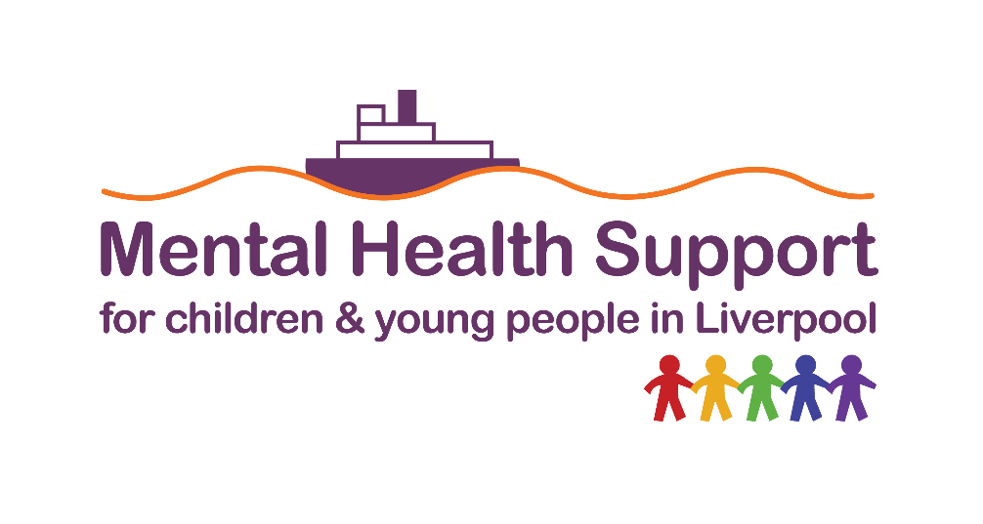

Make an online referral to Liverpool's Children & Young People's Mental Health Support
Children and young people, parents and carers in crisis can access support
24 hours a day, seven days a week, freephone 0808 196 3550.
Visit the emergency advice page for more information.

Cheshire & Merseyside mental health services - click here to view

 | Share

 | Tweet

 | Forward

In this month's newsletter:
- Training for parents/carers & professionals working with children & young people
- New educational films to address Child and Adolescent to Parent Violence and Abuse (CAPVA)
- New Growing Stronger ACEs Training Dates
- Growing Together as a Family
- Children’s Mental Health Week 2025
- Bed Poverty: free beds for children in Liverpool schools
- Mapping the mental health of the UK’s young people
- ROAR Training in schools *New 2025 dates*
- Get involved & CYP Mental Health Support

Training for parents/carers &
professionals working with children & young people

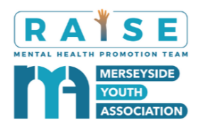
Merseyside Youth Association’s mental health promotion team (RAISE Team) deliver a range of FREE bite-size courses covering a range of mental health issues that impact children, young people and their families.


Bite-size sessions coming up in December, delivered via Zoom...

Behaviour as Communication - 02/12/2024 12:00 pm - 1:00 pm Book here
Safety Planning - 03/12/2024 12:30 pm - 3:30 pm Book here
Mental Health Support for Children and Young People in Liverpool - 09/12/2024 9:30 am - 11:00 am Book here
Building Resilience - 09/12/2024 10:00 am - 11:00 am Book here
An Introduction to Psychosis - 09/12/2024 11:00 am - 12:00 pm Book here
Suicide Awareness - 09/12/2024 2:30 pm - 3:30 pm Book here
Emotionally-Based School Avoidance - 09/12/2024 5:00 pm - 6:00 pm Book here
The Online World and Mental Health - 10/12/2024 10:00 am - 11:00 am Book here
Introduction to Self-Harm -12/12/2024 10:00 am - 11:00 am Book here
Understanding Low Mood and Depression - 16/12/2024 10:00 am - 11:00 am Book here
Sleep - 16/12/2024 12:00 pm - 1:00 pm Book here
Managing Challenging Conversations - 16/12/2024 5:30 pm - 6:30 pm Book here

See the CAMHS training calendar here

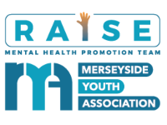

New educational films to address Child and Adolescent to Parent Violence and Abuse (CAPVA)

Merseyside Youth Association’s (MYA) RAISE Mental Health Promotion Team is proud to announce the launch of a series of educational films as part of a campaign to raise awareness and provide support on Child and Adolescent to Parent Violence and Abuse (CAPVA).

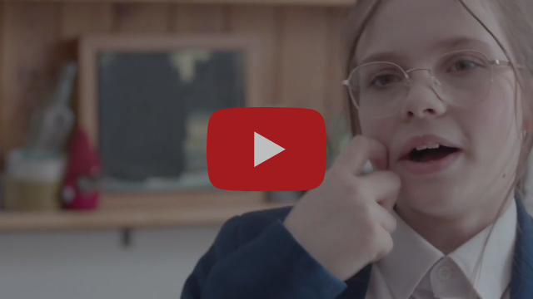

CAPVA, a form of domestic abuse that remains under-recognised, has profound impacts on family dynamics and mental health. Funded by the Merseyside Violence Reduction Partnership (MVRP), the films have been developed in collaboration with Capa First Response to help families and those working with families identify what is meant by challenging and harmful behaviour by a child towards their parent or caregiver, sometimes referred to as CAPVA.

Find out more and watch the films

CAPVA training
In conjunction with these films, the RAISE Team is offering free ongoing online training sessions for professionals, parents, and carers. These sessions delve deeper into CAPVA, equipping delegates with the skills and strategies needed to support families and children affected by CAPVA. The training will provide reflective discussions, practical tools, and a supportive space to better understand and address CAPVA in their work and daily lives.
Next event: 14/01/2025 10:00 am - 12:00 pm

Book here

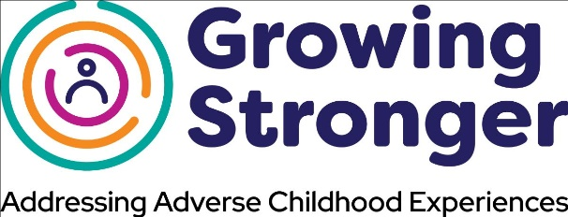

New Growing Stronger ACEs Training Dates

Are you ACE-aware?
Adults in Liverpool who want to learn about Adverse Childhood Experiences (ACEs) can attend this FREE Growing Stronger training. There are three levels to choose from:
✔️ACE-Aware (virtual, one-hour session) - for anyone interested in knowing more about ACEs.
✔️ACE-Skilled (face-to-face, half-day) for those who:
- Live in Liverpool
- Work in Liverpool; or
- Work in another Local Authority supporting Liverpool residents.
This training introduces ACEs and explores why they matter and their impact. It then explores the city-wide Growing Stronger framework and gives you reflective time to consider it in the context of your positions as individual practitioners.
✔️ACE-Leadership (full-day face-to-face) for managers and leaders within organisations who:
- Live in Liverpool
- Work in Liverpool; or
- Work in another Local Authority supporting Liverpool residents.
This course is for leaders who want to learn more about the Growing Stronger framework and how to implement it in their team or organisation.
📅 Dates until March 2025



Book here

Growing Together as a Family

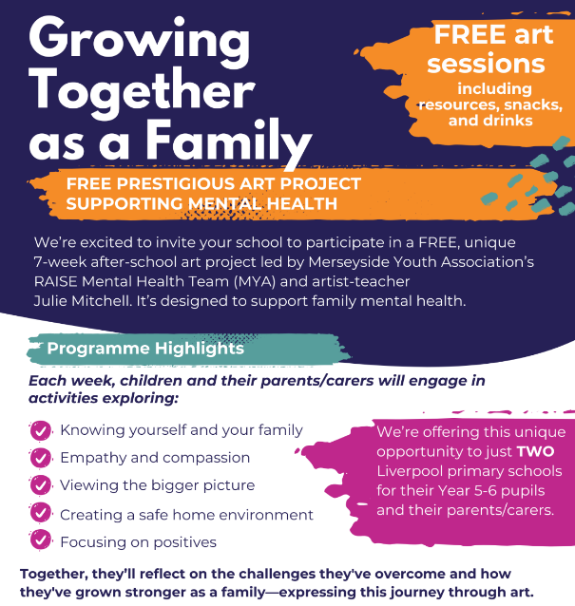

School art project supporting mental health
Liverpool schools are invited to participate in a FREE, unique seven-week after-school art project, led by Merseyside Youth Association’s RAISE Mental Health Team (MYA) and artist-teacher Julie Mitchell.

Find out more here

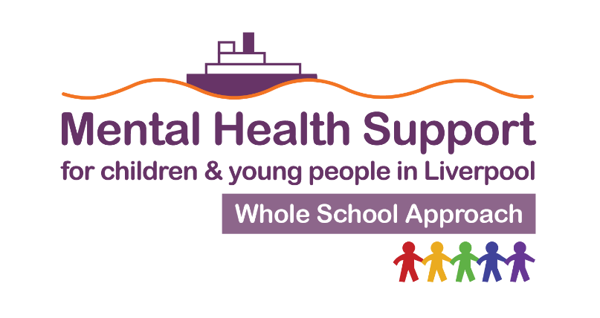

Children’s Mental Health Week 2025

2025 Children's Mental Health Week is from February 3rd to 9th. The theme is ‘Know Yourself, Grow Yourself’.
LLP will collaborate with Liverpool Mental Health Services and partners to deliver a variety of events for schools. We are considering live streaming or pre-recording sessions for all schools, including one linked to PE.

Please register interest using this link



Bed Poverty: free beds for children in Liverpool schools

Zarach is the Children’s Bed Charity. Their social mission is to end child bed poverty in England, giving children the opportunity to engage at school and break the cycle of poverty.
Zarach only accepts referrals from schools for children aged 4-18, and the child must be on roll at a Liverpool City Local Authority school.

Find out more here



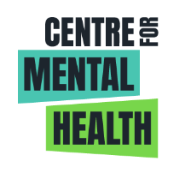

Mapping the mental health of the UK’s young people

In partnership with the Centre for Mental Health, Kooth has launched an interactive map and report highlighting the stark disparities in children and young people’s mental health in the UK.
We know that children’s chances of having good or poor mental health are shaped by the places they live in and the support available there. This new map tool enables schools, health services and local councils to understand the mental health needs of the children and young people they serve.

Find out more here

ROAR Training in schools
*New 2025 dates*


The ROAR Response Programmes equip educational staff to identify the main signs and symptoms of mental distress in children, young people, and colleagues/staff and to understand what they can do in school to support them.

🦁 ROAR Programmes include:

- Mental Health in Early Years
- Mental Health in Primary Schools
- Mental Health in Secondary Schools

- Mental Health for Children with SEND
- Racial Trauma
- Staff Wellbeing and Supervision

Find out more and book here

Get involved & CYP Mental Health Support

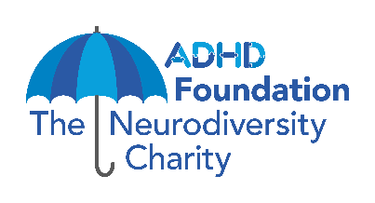

Neurodiversity 1:1 sessions
Every Tuesday, 1:30 pm - 2:30 pm at Clubmoor & Ellergreen Children's Centre and every Friday at Five Children and Family Centre and Granby Children's Centre (free to access, however, booking is essential).

Supporting your ND child - Strategies for Grandparents and Carers
Aimed at Grandparents and Carers in Liverpool to help support their neurodivergent children. Working alongside Positive Futures, we are offering face-to-face workshops to build skills and knowledge around neurodiversity.

Understanding and supporting my child’s ADHD
This three-part programme, which explores different aspects of living with ADHD and strategies to support it, is available to parents and carers.
The programme is delivered as live-streamed online sessions, with sessions available on various dates and times, including evenings and weekends.
CAMHS, local authorities, and paediatrics can make referrals for the programme. However, families can also self-refer to the service by completing our online referral form.
Liverpool families can refer to access the "Understanding and Supporting my child's ADHD" parent training programme. Find out more here
ADHD Foundation has produced a set of ADHD information booklets aimed at parents, teens, children and adults. They can be downloaded here.

Request more information

Refer here

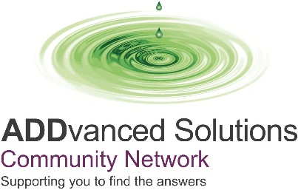

ADDvanced Solutions Community Network supports the emotional health and wellbeing of children, young people, and their families who have needs that may be associated with neurodiversity.
Community Network Groups - delivered each Tuesday morning 9.30 – 11.30am during term time at Belle Vale Children's Centre - an informal, open-access opportunity to seek advice and support around challenges you may be facing at all stages of your journey. Drop in, no need to book.
Neurodevelopmental Conditions Learning Programme for Parents and Carers: This programme aims to increase parents' and carers' understanding of neurodevelopmental conditions and build skills and confidence to better support their child or young person’s needs. No referral or diagnosis is needed.
The Autism Learning Programme is Designed to support and empower parents and carers following their child’s Autism diagnosis in their understanding of how autism is experienced by children and young people, providing learning, guidance and strategies to better support you and your family.
Professionals Neurodevelopmental Conditions Awareness Raising Training Funded training for professionals in Liverpool to increase understanding of neurodevelopmental conditions and the impact on children, young people and their families.

See the latest Liverpool newsletter for dates and details.

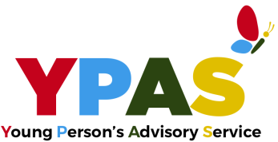

YPAS Parents & Carers Chat n' Chill Drop-in

Join YPAS on the last Wednesday of the month to connect with other parents and carers, ask questions, share experiences, and get advice.
Dates and times can be found here.

YPAS Parenting Coffee Events

Join the parenting team for a hot drink and a chat about YPAS services and get information and guidance. This is a face-to-face coffee morning hosted in our South Liverpool hub, 35 Lyndene Road Liverpool L25 1NG.
Dates and times can be found here.

Primary Care Liaison Clinics in the following GP Practices

For more information on YPAS Primary Care Liaison services, please visit Primary Care Liaison (PCL) Service - YPAS

YPAS Walk In Support Hub

The Walk-In Support Hub service at YPAS is facilitated from their central hub in the city centre. A child/young person/parent/carer can drop into Central Hub:
Monday - Wednesday 9.30am - 8pm
Thursday: 2pm - 8pm; and
Friday: 9.30am - 4pm.
You do not need an appointment or a referral to access this service.











Share

Tweet

Forward

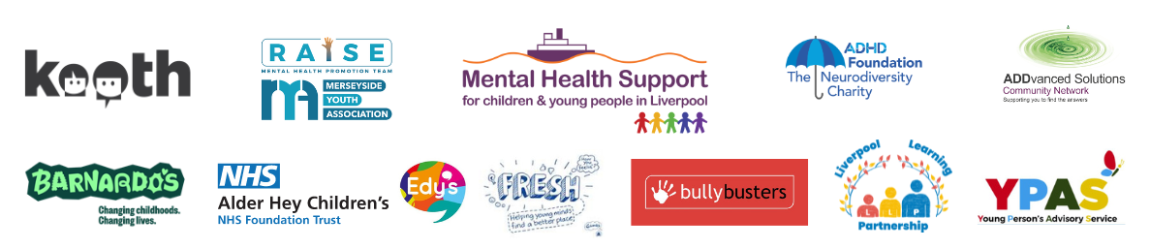



Copyright © 2024 Merseyside Youth Association, All rights reserved.
You are receiving this email because you opted in to hear about Liverpool CAMHS news.
Our mailing address is:
Merseyside Youth Association
Merseyside Youth Association
65-67 Hanover Street
Liverpool, Merseyside L1 3DY
United Kingdom

