Kingsley Mosaic
During Art Week 2019 we worked with artist Mark Stamms on a project to create a whole school mosaic. The mosaic represents our diverse school community, our past, present and future. This project was an enormous undertaking and involved every member of our school community, giving us all a great sense of ownership.
There are five panels, as can be seen in the sketch below;

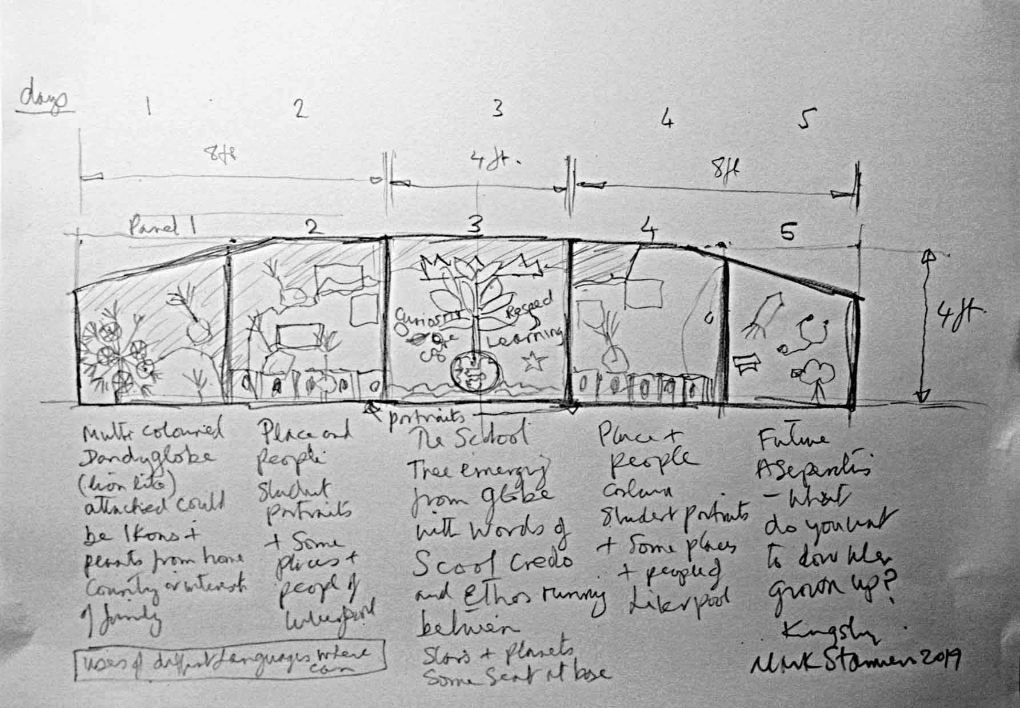
The idea is a large multi-coloured dandelion type flower shown on the left, the wind blows the seeds across the scene, attached to the flowers as they float over the scene are icons or pictures of things from the students’ home country or faith or interests of family. The Mersey estuary is shown between panel 1 and 2, the map outline to Liverpool and around it, in panel 2 and 4, in the rectangles are pictures of places and people, along the base portraits of students.
Centre panel 3 is the school logo a crown, it sits on a learning tree, that emerges from a globe of the world, interspersed with the leaves of the tree are words describing the school ethos…these are in different languages and signs….the globe is on a sea/waves of blue, around the tree is sky with planets and stars.
Panel five is future aspirations of the students: astronauts, doctors and nurses, etc…

