Kingsley Primary School

Accessibility Plan

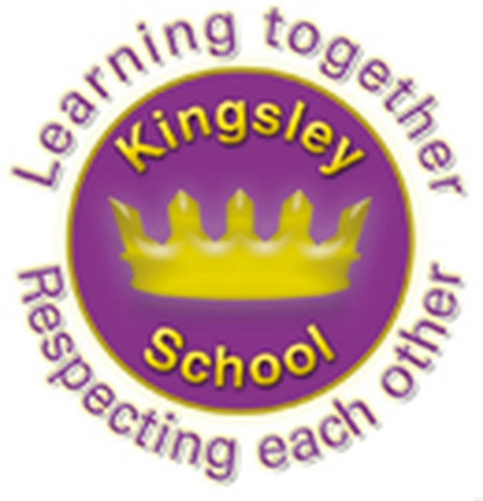

Kingsley Community Primary School
Accessibility Plan
Adopted: September 2026 Review date: September 2027

Definition of special educational needs
In this policy, ‘special educational needs’ refers to a learning difficulty that requires special educational provision.

The SEND Code of Practice 0 to 25 Years (DfE, 2014) says children have a learning difficulty or disability if they:
- have significantly greater difficulty in learning than the majority of children of the same age; or
- have a disability which prevents or hinders them from making use of facilities of a kind generally provided for children of the same age in mainstream schools or post-16 institutions; and are under compulsory school age and are likely to fall within either of the definitions above when they reach compulsory school age or would do so if special educational provision was not made for them.
Children must not be regarded as having a learning difficulty solely because the language or form of language of their home is different from the language in which they will be taught.

Definition of special educational provision
For children aged two years or older, this is educational provision additional to, or otherwise different from, the educational provision normally available to pupils of the same age.

Kingsley Community School has adopted this accessibility plan in line with the school’s special educational needs policy with the aim of ensuring that our school is socially and academically inclusive, that all pupils have access to a full curriculum, and that all pupils are appropriately challenged. This plan is linked to the inclusion action plan as part of the school development plan.
Our special educational needs policy outlines the school’s provision for supporting pupils with special educational needs and disabilities (SEND), and the school’s publication of equality information and objectives explains how we ensure equal opportunities for all our students, increased access to the curriculum, physical access to the school and access to information particular to students with SEND. This accessibility plan provides an outline of how the school will manage this part of the SEND provision.
This Accessibility Plan should be read in conjunction with the following school policies, strategies and documents:
- Behaviour Policy
- Curriculum Policies
- Emergency Plan
- Health & Safety Policy
- School Improvement Plan
- SEND Policy

Some of this information can be found on the school website or Early Help Directory. http://www.kingsley.liverpool.sch.uk/
http://fsd.liverpool.gov.uk/kb5/liverpool/fsd/home.page
The table below is based on our current assessment of accessibility for pupils with SEND. It sets out priorities across the school in a number of areas and the relevant timescales for action to increase accessibility for pupils with SEND. Progress on these measures will be updated annually and reported to the governing body.

Aim | Implementation | Who | Outcome | Date completed
Staff training
1. All staff know how  to meet the needs  of disabled pupils  2. Staff are  aware of their  responsibilities  with regards to  disabled pupils  3. Staff to know how to support children with specific or complex additional needs | Targeted training for specific staff SENCO to carry out lesson observations focusing on meeting needs of disabled pupils  Include as part of in-school TA training programme  Draw up list of generic  strategies for pupils with common disabilities e.g. ASD, Dyslexia.  Commissioning of an educational psychologist, SENISS and OSSME to recommend strategies to support specific needs of children  Links with Springwood Heath, Princess Primary school, OT and physiotherapists to support physical disabilities.  Staff to ensure they are meeting the medical needs of disabled pupils and confident in providing support.  Staff to receive training from specialist school staff or outside agencies.  Teachers to spend a day in the new provision base to gain and insight and understanding of the informal and sensory curriculum. | Training  planned for staff throughout the year delivered by the SENCO or outside agencies  SLT  SENCO  SLT  SENCO  SENCO | All staff will have a range of strategies for meeting the needs of children with common disabilities  Staff  understand  expectations and  are suited to  working with pupils  with disabilities  Staff receive the knowledge and have confidence in delivering recommendations and implementing strategies to support children’s needs.
Teaching and learning
1. Differentiation in Teaching  2. Interventions  3. Curriculum  4. Corridor quiet areas and minimal distraction room on KS1 and Ks2 corridor | Promote and facilitate impactful learning opportunities in the classroom for pupils with SEN.  To monitor quality of differentiation, quality first teaching and provision for SEND pupils who may have a pupil profile, one page profiles, pastoral plans, EHC Plan, pivats, EYFS small step targets, targets from outside agencies or care plan. As well as those who may need adapted or additional resources and equipment  Using school data to identify children in year groups to implement targeted interventions to be delivered by staff to support children’s progress and reduce the barriers to learning.  To ensure inclusion across all areas of the curriculum reducing barriers to learning through differentiated task and personalised learning.  The use of corridor spaces for children who need time out beaks during the school day. Role play areas with targeted interventions and tasks to allow brain breaks and motor skills activities to take place. | SLT during lesson observation and book scrutinises  SENCO and support staff  SENCO to lead with involvement of all staff  SENCO to lead with involvement of all staff  SENCO to oversee with Mr Wade to set up. LSAs and 1:1 support to deliver the activities | All staff to ensure work is differentiated appropriately to meet the needs of all children. Provide resources to cater for all needs.  Support staff will be responsible for the delivery, monitoring and record keeping of intervention within their year group.  Liaise and develop partnerships with other schools, therapy staff and other relevant agencies in support of inclusion  All staff to ensure work is differentiated appropriately to meet the needs of all children. Provide resources to cater for all needs.  Staff to ensure activities appropriately meet the needs of the children. Provide resources to cater for all needs
School estate – minor capital expense
1.To improve access  for wheelchair or frame  users  3. To improve the signs in school | Reduce furniture in all corridors and classes.  Gradual slope to access the year 2 classrooms from the playground.  Door signs, labels and visual timetables to be created and used across the school. | All staff  SLT and Mrs Ahmed | Wheelchair and frame users  can access key  areas with ease  Improved language for EAL children and parents when in school
School estate – major capital expense
1. Meet needs of  specific group of  children in KS1 and KS2  To meet the needs of specific children in the school | Develop and resource an area for alternative provision for children who aren’t able to access the KS1 and KS2 curriculum, have sensory needs or require social and emotional and support in yellow, KS2 sensory room and nurture room with additional  support staff  To develop an inclusive inhouse provision base that delivers a play based, developmentally appropriate curriculum for children whose learning needs prevent them from accessing the age-related curriculum. | SLT, Mr Wade, Mrs Bickerstaff and Head teacher  SLT | Pupils have  improved  opportunity to  access curriculum  Pupils access a bespoke and personalised curriculum tailored to their developmental needs, enabling them to make sustained progress.

This accessibility plan and the outcomes will be evaluated every three years to monitor the plan’s effectiveness and ensure that it covers all areas of accessibility needed in the school.

Signed by

SEN Governor Date: ...............................

Head teacher Date: ..................................

SENCO Date: ..................................

This policy will be reviewed annually

