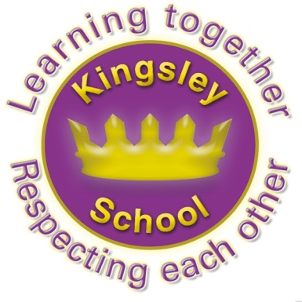
Kingsley Community School,
Eversley Street,
Liverpool.
L8 2TG.
Telephone: 0151 709 6727
Fax: 0151 708 5105
Website: www.kingsley.liverpool.sch.uk
Head Teacher: Mrs A Whittaker
July 2026

This will be the final newsletter of this academic year. It has gone so quickly! In this issue I will share some lovely pictures of the children enjoying life at Kingsley this term, update you on some of our latest news, and remind you about some arrangements for September.

Inclusion Quality Mark News

Last week, we had an assessor in school again to look to see whether we still met the criteria to be a centre of Excellence for the Inclusion Quality Mark. This is a nationally recognised accreditation which looks at all aspects of our Inclusive ethos. I am happy to let you now that we have kept the higher grade of mark. This means that not only is our practice deemed to be excellent for our pupils, but that we will continue working alongside other schools and demonstrating what we do. The assessor is the Head of a school in Cheshire, and has asked to send his staff here to learn from us. This is a huge compliment to Kingsley and a testament to the hard work of everyone here. A huge thanks to the staff, and especially Mr Harrison for putting all the paperwork and arrangements into place! You can see the full report on our website, under ‘Important information about our school, once it is published.


Mental Health Support
Liverpool MHST (Mental health Support team) will be delivering some webinars for parents over the summer and they have asked us to share this information with parents.
These will be 1 hour sessions and will cover Emotional Literacy and Transition – all information is on the Eventbrite links.
https://www.eventbrite.com/e/transition-workshop-for-parents-tickets-1993135131833?aff=oddtdtcreator - 3/08 transition for parents' workshop 5pm - 6pm.
https://www.eventbrite.com/e/emotional-literacy-workshop-for-parents-tickets-1993136151884?aff=oddtdtcreator - 13/08 emotional literacy 10am - 11am.
https://www.eventbrite.com/e/emotional-literacy-workshop-fr-parents-tickets-1993136319385?aff=oddtdtcreator - 17/08 emotional literacy 5pm - 6pm.
https://www.eventbrite.com/e/transistion-workshop-for-parents-tickets-1993136674447?aff=oddtdtcreator - 27/08 transition workshop 10am – 11am.
Transition: This is a workshop for parents/carers of children who are about to start year 7 to help them support their child with the transition to high school. The session will cover thinking about how parents/carers are feeling, think about common worries your child may be experiencing and how we can support them with this.

Important Parking / Road Changes

You will have received a letter from the council last week about the proposed changes to driving and parking around school. Early next term, potentially from September, Eversley Street will become a no driving school zone from 8.15am to 9.15am and for an hour around home time. We don’t know the full details yet, as this is not a school matter. However, my understanding is that anyone driving through and dropping their child off during this time is likely to receive a fine. I hope that once everyone gets used to this it will make Eversley Street a lot safer for our children and families. Those travelling from some distance may still decide to come by car, and park in a neighbouring street, walking their child into school for the last few hundred yards. I am hoping that a lot more people decide to walk to school instead!

Once we know more about this scheme, we will let everyone know, but it may be good to start planning for these changes now. I don’t want anyone to be caught out with a fine!


Breakfast Club
Breakfast club will continue to operate in the same way and is a useful support for many parents and families to help encourage good punctuality. It costs 50p a day, children can pay on the day, or you can pay upfront for a few weeks at the office. There is no need to book this, you can use the service for the days you want. It is open from 8.15am until 8.30 am every morning- children are then taken straight to classes by staff. This is a definite option if you want to improve your child’s punctuality. The pupils who attend love it and start the day really settled.

Term Dates
Some important dates for your diary!
17th July 2026– school closes for the Summer 12.30pm.
1st AND 2nd September- Inset days . School closed to pupils but office is open for uniform from 1pm on Tuesday 1st September
3rd September – 1st day of school for pupils ( Reception and Nursery will have staggered starts which you have been invited to)
26th October- 30th October – school closed for Half Term
18th December- school finishes for Christmas at 12.30pm
4th January- Inset day- school closed to pupils.

Kingsley Wider Curriculum Offer
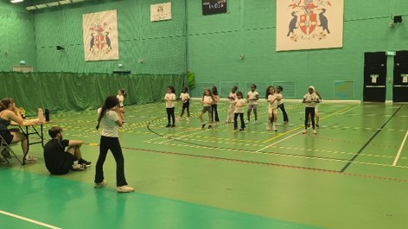
This has been an amazing term for sport and the arts at Kingsley Primary. We have been represented by our children in KS1 cricket, KS2 crown green bowls, Y3/4 dynamos cricket, Y5/6 golf sixes, ultimate frisbee, girls rugby, Y5/6 netball, KS2 Gaelic football, KS1&2 dance teams, Y5/6 rounders, Y4 boccia team, Y5/6 flag football, KS2 girls football, boys and girls target football leagues and our continued participation in the Toxteth cricket league! Special mention goes out to our Y5/6 mixed cricket team that finished second in a massive LSSP cricket event! Kingsley cricket is going from strength to strength! A second special mention goes out to our fantastic dance team and Y6 dance leaderships who choreographed our dance and practiced with our children over around 30 lunchtimes, they all really did a fantastic job!

Our Kingsley world cup has been in full swing since the end of May. Over 150 children have taken part, our finals will take place in the last week of term! Well done to all of the children who have taken part, they have been brilliant and so enthusiastic about the whole event!

Finally, looking forward to September our cross-country seasons kicks off again in the third week of term! If any of our children in Years 4, 5 & 6 are interested, make sure they practice their running over the summer. A cross-country race is 1500m and it is a fantastic achievement just to finish the race and excellent for overall fitness!

Uniform/ PE
Please can I remind you about requirements for school uniform. When we return in September we expect that every pupil attends school wearing correct uniform.
You have chosen Kingsley school for your child, so along with this you have chosen the expectations we have for pupils who attend here. One of these expectations is that pupils attend school in uniform every day.

Uniform consists of:
- Tie years 3-6 (Y3 will be given a tie)
- Dark grey trousers or skirt
- Black shoes
- Plain black or purple hijab- (NOT a long scarf)
- Purple sweatshirt or cardigan
- White polo shirt in years R to 2
- NO JEWELERY please! (Apart from small flat stud ear rings)
Jumpers/ cardigans/ ties and all in one hijabs are available to buy from the school office.

PLEASE write your child’s name in their tie and in ALL school uniform. We do not have the time to sort through the large number of items which are lost or discarded by children every day, and who do not have their name in.

The school uniform has always been very simple here at Kingsley and there should be no misunderstanding or ambiguity. Please note that we will be picking up on every single student who is not wearing the correct uniform on day one and asking them to fix this for day two. We will also speak to parents on the door if this remains a concern.

The main issue for us at the start of a new year is often trainers being worn instead of shoes. Trainers are NOT part of school uniform, neither are tracksuit tops. Please help us by checking what your child is wearing before they leave the house.

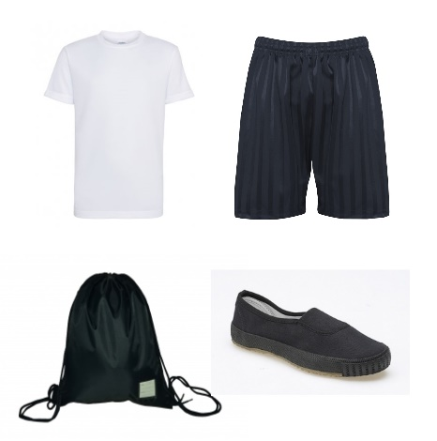
PE kits
-Plain black shorts or jogging bottoms
-Plain white t shirt (short or long sleeved is acceptable)
-Trainers or pumps.

Pupils get changed for PE in school.

For classes who swim, they need a towel and swimming costume or shorts and a hat

We will keep spare PE kits in school for children who fail to bring the correct kit into school, or whose parents do not discuss any reasons for this with us.
We will also have spare pumps in school for those who come in wearing trainers rather than shoes as this has become a significant problem for us in recent months
Please help us, and help your child to prepare for secondary school and the world of work, by making sure our rules are followed.

Granby Family Hub (Children’s Centre)
Can I also take this opportunity to remind you that Granby Children’s Centre remains open during the Summer break., Staff are there to help with families who have children under 5 and can also be able to help or signpost those with older children to services whilst school is closed.

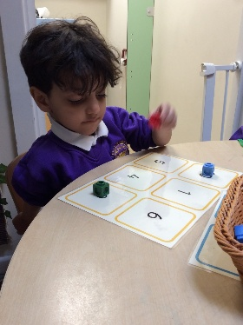
What Have We Been Up To This Term?

In Red room the children have enjoyed taking part in our number bingo to help with their number recognition and turn taking. They have also enjoyed sharing books together to support our oracy along with our listening and attention.

Year 3 walked around the local area, down Parliament Street, across Hope Street to the Liverpool Anglican Cathedral. We are incredibly lucky to have such a tremendous place to visit on our doorstep! They walked around the inside and were able to listen to the organ being tuned whilst they sat and sketched. On a scorching hot day, they also enjoyed a picnic lunch in the shade of the trees outside in the Cathedral gardens before heading back to school for Sport's Day! The children probably all had a great sleep after all that!

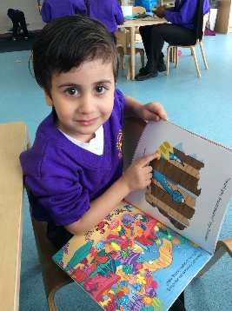
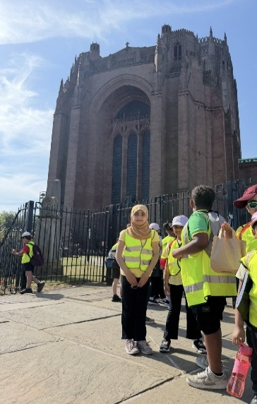

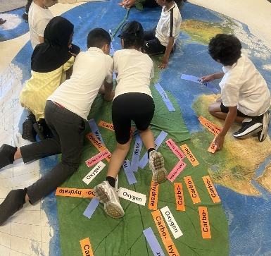
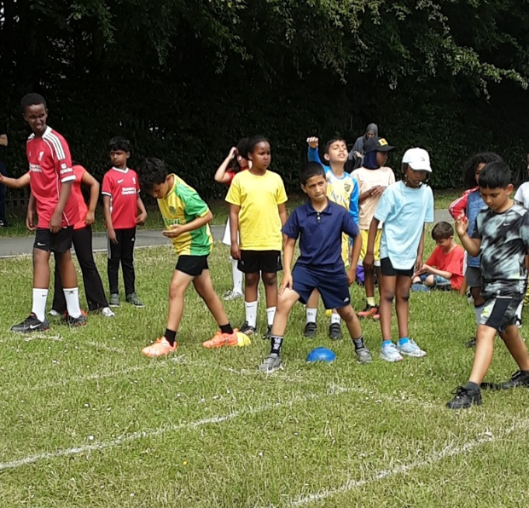

4T had an amazing time at Martin mere thinking about ecology and viewing the interesting birds.
Sports Week was a great success- despite the heat! Here is an action shot of y5 getting ready for one of their races.

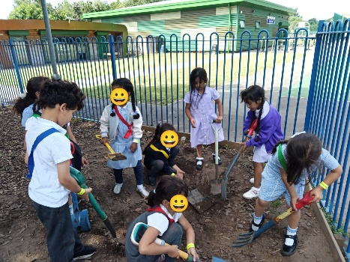
Reception RP had special visitors this half term when our pen pals from Smithdown Primary School came to visit for the afternoon. It was wonderful to see some of our old friends again and to meet new friends we had been writing to throughout the year.
They buddied up and showed their new friends around their classroom and outdoor learning area. They then enjoyed a picnic together. It was a lovely afternoon.

Year 1 brought learning to life this term with a Real-Life Maths bookshop, using place value, addition and subtraction skills to buy books with their spending money. They also enjoyed a barefoot summer scavenger hunt in the sunshine as part of their curriculum road maps.
It was a grounding and exciting experience!

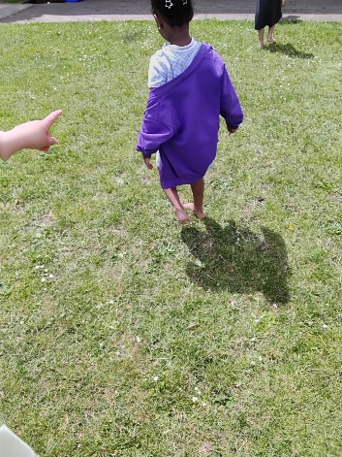
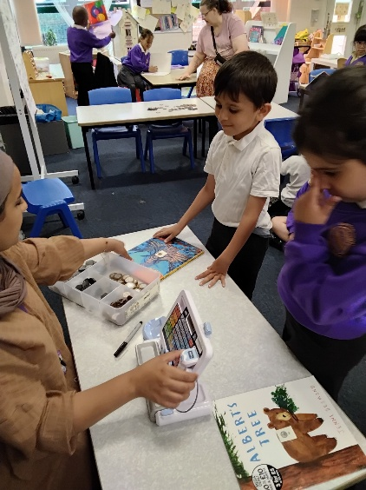

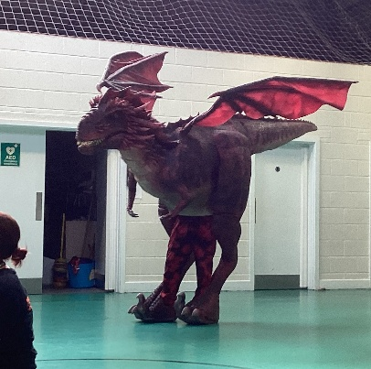

RW enjoyed a wonderful visit from Sol the Dragon and listened to a very exciting story about how he came to be including a brave warrior and some vast mountains. The children then enjoyed an assembly where some children actually got to tickle Sol's chin! After our assembly we had a very special visit in our classroom from Roger the baby dragon.

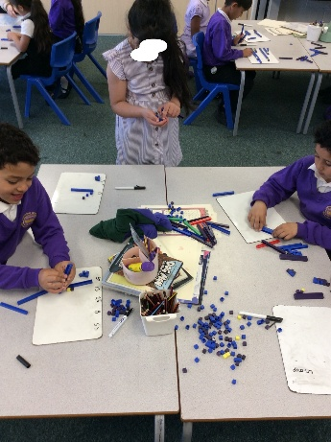
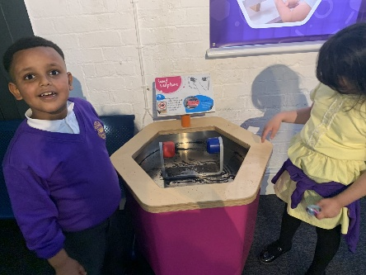
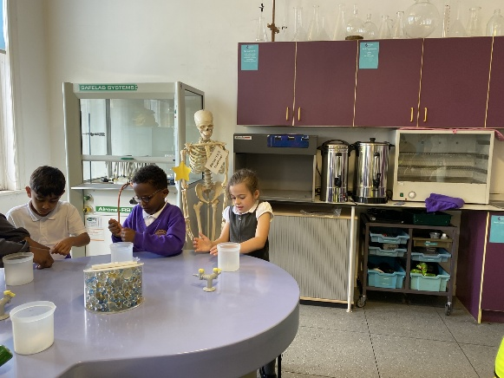
2CJ have had a fantastic summer term. A highlight was their trip to the Catalyst Museum, where the children enjoyed exploring the Discovery Area and taking part in hands-on laboratory activities. During DT Week, the children designed and made their own apple carts, linked to our whole-school oracy story. They are very proud of all they have achieved this term and this academic year!
In 2S this term the children have been on a trip to the Catalyst Museum where they learnt about plastic and made key rings.

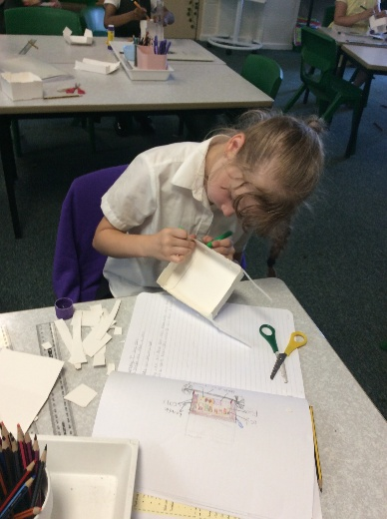

2H have shown great team work during maths lessons, using equipment to support learning.

We will bid a fond farewell to several staff this week. This includes Mr Wilkinson and Ms Davies from the Teaching staff, who are both going to teach in other Liverpool schools. Ms Stephenson, who is leaving for pastures new and Ms Abdullah who has secured her first Teaching position in another local school!

We are also saying goodbye to Ms Ahmed and Ms Fisher two longstanding members of support staff who are retiring. We are so sorry to see them go, but think they deserve a rest now after all of those years working in Kingsley! I am sure you will join me in thanking them for their hard work and loyalty to the children and families of Kingsley.

Several new staff will be joining the team in September and classes will be moving. It will be another busy and exciting time for the school!

Don’t forget, school finishes on Friday 17th July at 12.30pm. Children can be collected form classrooms in the normal way, just at an earlier time so that Teachers can get the school ready for its annual deep clean!

Finally- the last word has to be to say goodbye and good luck to our amazing year 6- we will REALLY miss you!


I hope everyone has an amazing Summer, and we look forward to seeing everyone back safe and rested on the 3rd September.

Kind regards,

Mrs Alison Whittaker, Head Teacher.

