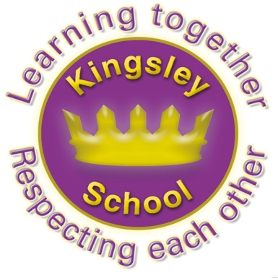
0Kingsley Community School,
Eversley Street,
Liverpool.
L8 2TG.
Telephone: 0151 709 6727
Website: www.kingsley.liverpool.sch.uk
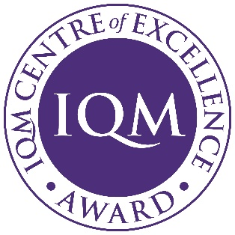

Head Teacher: Mrs A Whittaker
24th April 2026

Spring 2 Newsletter
Dear Parents and Carers,

As the second term draws to a close, I wanted to share our latest news and updates with you all.

In the News…..

Ofsted
As school Leaders we have all been closely watching the first few schools who have been subject to the new Ofsted School’s Inspection Framework. I have been part of 8 Ofsted Inspections during my 33 years as a Teacher, and seen many changes, but this seems to be the biggest change of any I have ever seen. In school we are working our way through some of the new expectations and looking to see where we can add to the offer that our pupils already receive. As part of this we look at other local schools, and similar ones nationally to try to learn from best practice. For example, Miss Edwards has been working on new projects to support handwriting in key stage 1 this year based on practice they have seen or read about in other schools, so this is something we already do as good practice.

Ofsted now no longer give a single work judgement about a school- but a report card which gives feedback on several areas. What I know so far is that the old ‘Good’ grading now translates to ‘Achieved Standard’ in the new framework. The Government and Ofsted have described raising the bar higher for everyone. The inspection process itself seems very tough, but I have always felt that its right that someone looks at what we do. We challenge ourselves constantly to do the best for our children, so I am hopeful any team that visits will see this- they always have in the past! But as I keep saying to staff, we don’t do what we do for Ofsted, we do it for the pupils!

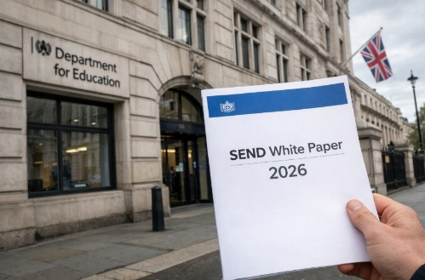
Send White Paper
In addition to Ofsted changes, the Government have also issued an Education White Paper. This contains several proposed changes, but especially for those children who have a Special Educational Need or Disability. I think the Government have correctly identified some of the problems with the existing system, but we will have to wait to see how this affects schools. I’m guessing we will be asked to do more…. We have already begun to think about improving our in- house support for those of our pupils who have severe needs and are planning an inclusion base for September to run alongside all of our existing SEND provision. There will be more news about this next term.

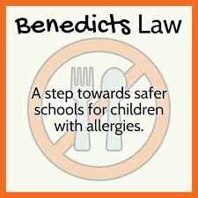
Benedicts Law
You may have heard news about new laws which come into force from September to help support allergy safety in school. We already have an allergy policy in Kingsley, which is in the policies section of our website. We are awaiting direction on whole school training so staff can recognise and respond to anaphylaxis and have easy access to emergency adrenaline auto-injectors (AAIs) where needed We also have individual healthcare or allergy action plans for pupils with diagnosed allergies and are looking to improve communication and record-keeping around allergies and allergic reactions. It is really important that if your child has an allergy, you always inform us and keep us up to date with any changes.

Lockdown and Hoax Threats
Firstly thanks to everyone for your calm and rational behaviour in a world that is getting increasingly difficult to maintain calmness in! I know I say this a lot, but Kingsley parents are really the most level headed group. In particular this term some schools have had huge problems with parents who have had concerns over the false bomb threats that have been reported on social media. Whilst every parent should, of course, be concerned about their child’s safety, some have unfortunately got carried away by what they have read on social media. What has been confirmed to me is that the threats which were reported this term, were nothing that the police felt the need to inform schools about. In other words , they were not credible threats, or never happened. Unfortunately someone, somewhere, decided to share incorrect information in a way that made a lot of people panic. To reassure you all, Kingsley got a lot of updates from both the police and the Local authority to let us know there was no cause for concern. We were able to pass this on to you all, and everyone was calm.

We will always remain vigilant here, and were we to get any notification of anything from police or from other sources we would go into emergency procedures straight away. We have actually practiced a lockdown drill earlier this term, the children were brilliant! Its really helpful for everyone that if ever you are concerned , or want to know what’s going on, you check the most reliable source- usually us, before believing what you read!


Thinking About Screen Time
Ms Yafai has held some really useful Parent workshops this term. These are always very well attended, but two in particular have been very successful. These were ones for Early Years parents about online safety and screen time. You will have heard a lot in the media about screen time and how detrimental it can be for children (and adults!) It has even made us review our own practice in school and to cut down any casual use of screens that is not linked directly to good learning opportunities.
Some course feedback:
“I have realised that I have been giving my child lots of screen time and how it has affected his behaviour.”
“I try to limit my screen time so I can inspire my children to do the same.”
“Give children healthy alternatives instead of screen time.”

We felt that the session was extremely beneficial, as well as friendly and supportive for all who attended. As a result of this, we are pleased to offer another session for those who were unable to attend. Parents who joined us previously are also warmly invited to come along and share their experiences, including any changes they have made or how they have applied what they learned.
The next Screen Time Workshop will take place on; Tuesday 28th April at 9:00am in the School Hall.
The session will mainly focus on support form younger children, but any parent is welcome. It will cover
how the brain grows and develops, the impact of screen time on language and communication, attention and self regulation, sleep, social and emotional development as well as ideas for alternatives to screen time.

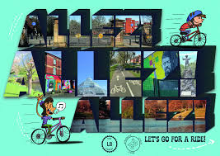
Bike Library.
Don’t forget to sign up for the amazing bike Library based on the school site and run by Peleton Liverpool Cooperative who run a similar Library in L5.

Anyone can register to join. All they ask is that you take care of the bike, treat it like part of the family and that you return to them for servicing or returning when your child grows out of it. At that point you can access another bike that will grow with your child!
www. https://peloton.coop/project/bike-library/

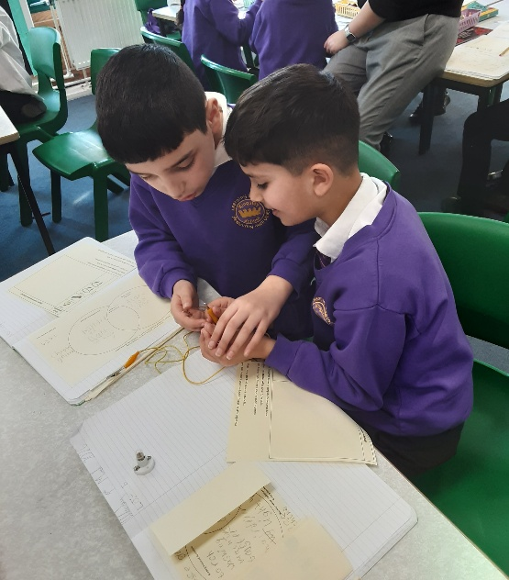
What Have We Been Up to?
Year 4 have been exploring circuits in their Science topic: Electricity. They have learnt how to connect different components to make the light bulb shine in preparation for making a torch from scratch at the end of term. "

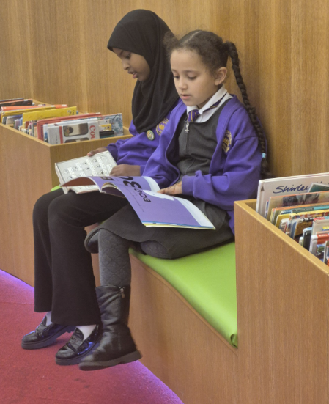

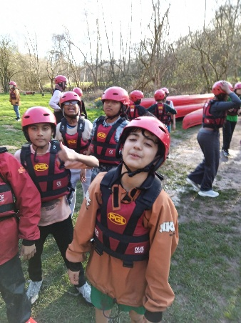
Y2 and Y6 dancers at the Liverpool Dance Festival.
Y6 had a brilliant time at PGL
The School Council recently visited Liverpool City Library. They were split into two groups; They had a gorgeous morning learning about the history of the Library and looking at book collections, especially John James Audubon’s Birds of America, which is known to be one of the world's most expensive books! They also spent some time in the archive section looking at books and posters demonstrating how democracy has changed over the years.
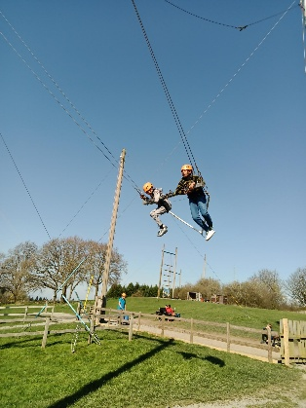
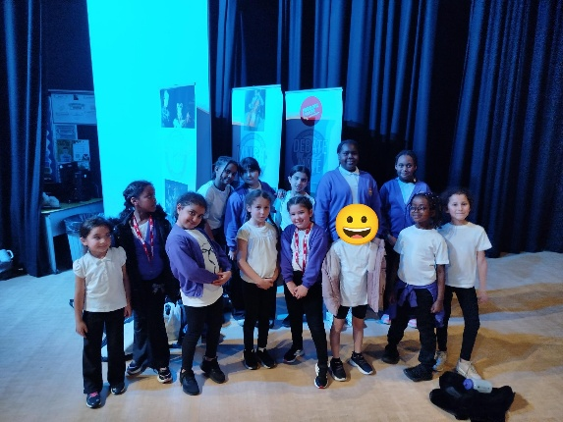

Update on Sporting Events
This half term, although short, has been action packed in terms of sport and physical activity at Kingsley.
LSSP Basketball, Y5/6 girl's football regional premier league finals, school dodgeball league, cricket matches, LSSP Y3/4/5/6 girls football city finalists!
Our y3/4 girls finished 4th in the city, with our y5/6's finishing 7th in the city - a truly brilliant achievement! Our cross-country team were back in action, 100% of our y5 children took part in bike ability, our school council had playground leader training from the LSSP, our y1 children took part in a fundamental of movement program with the LSSP, it has been a brilliant term!

Next week our children will attend and massive dance event, a gymnastics event, and a cricket festival in Sefton park! Meanwhile our y5/6 children are preparing for a flag football (American football) event in the first week back after the Easter break.

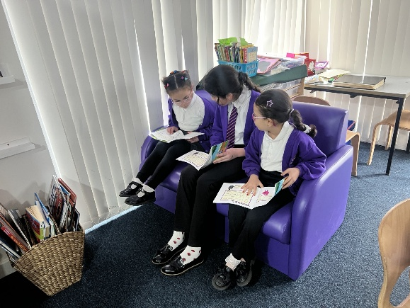
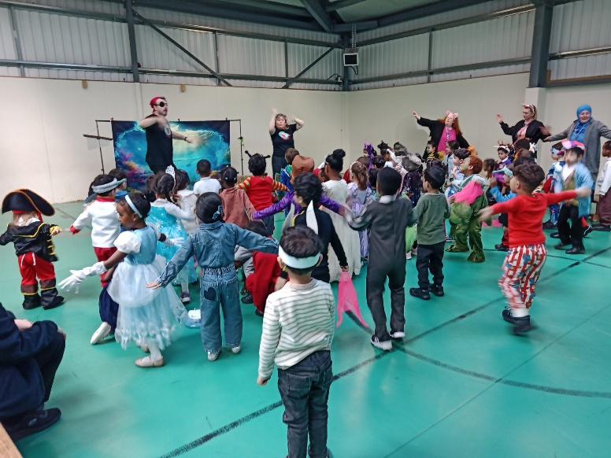
Reception had a great time during World Book day by dressing up as one of their favourite characters from a story. They also enjoyed a wonderful Performance by the Bookworm Players of 'The Snail and the Whale' by Julia Donaldson. The performance was interactive with lots of singing and acting that the children enjoyed with gusto! They then took our learning into the classroom and enjoyed lots of activities centred around the story.

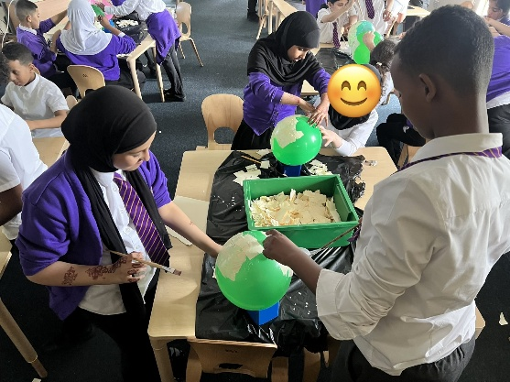
For 5M’s art topic they have been studying masks around the world. They are making their own using paper mache. FUN!

Y5 really enjoyed doing paired reading with Year 1 during World Book Day.


Spring has sprung and year 3 have been excited to learn about flowering plants in science and in particular how animals and the wind can help spread seeds to make new plants. We have also been learning about religious festivals in RE and especially the ones that have all fallen around the same time this year - Ramadan and Eid, Easter and Passover. Happy holidays to all, from year 3!

Dates For Your Diary
Friday 27th March 12.30pm. School finishes for the Easter holiday. (No Nursery today)
Monday 13th April- School Summer term starts.
4th May- School closed for Bank holiday
25th May- 29th May Summer half term.
17th July 12.30pm end of term.
Please note the last remaining Inset day has been allocated to Friday 22nd May 2026. School will be closed on this date.

Finally
There is so much that has gone on this term that I have missed here but once again, there is so much to positively celebrate about life at Kingsley. The staff continue to work unbelievably hard on behalf of your children, and we really appreciate all the support you give. Enjoy the holidays! Happy Easter !

DON’T FORGET SCHOOL CLOSES AT 12.30PM ON FRIDAY 27TH FOR THE EASTER HOLIDAYS.

Mrs Whittaker.

