
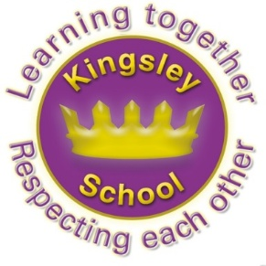
Kingsley Community School,
Eversley Street,
Liverpool.
L8 2TG.
Telephone: 0151 709 6727
Website: www.kingsley.liverpool.sch.uk
Head Teacher: Mrs A Whittaker
13th February 2026
Spring 1 Newsletter

Dear Parents and Carers,

Welcome to the first newsletter of the year 2026!

We have already had several highlights and things to celebrate, as usual, many of these are in our wider curriculum offer. This newsletter will share some of these with you, and as usual bring you up to date with other news and events. Please pay particular attention to the upcoming dates section of the letter as this will let you know of events that we know about which are coming up in the next half term. We have tried very hard this year to give more notice for events, but despite this, we have still had some parents who have felt they have missed this information. It can be difficult getting any updates or news from your children, I remember this well. Even if my boys had had a great time at school, all I ever heard was that there was ‘nothing’ to tell, or that school was , ‘fine!’. Please remember to ask your children about letters and search their bags at the weekend!

Extra Curricular Clubs and Teams
This last half term has been a busy one for sport at Kingsley! We've been to mat ball, highland games, netball, boccia, new age kurling, KS1 fundamentals, an inside out multi-activity festival, a boys team to Liverpool Academy, our girls team in the Premier league Primary Stars finals at Liverpool Academy, athletics and all the while competing in the DGT dodgeball league!

It really has been non-stop and the children have been absolutely fantastic, every step of the way! Next term is even busier and we have amazing events and trips lined up for our children to participate in as the year progresses!

Every child in y5 and 6, apart from one (and we are working on them!) has represented the school in a competition or event since September, which is phenomenal!
Like a lot of what Kingsley does- this provision is really down to the dedication and good will of several of our staff members. I can not tell you how hard our staff work, and what long hours some of them put in, but they still support the additional opportunities that go on , and which make school a great place to be.
Clubs run on a six week basis, over the year all year groups from Y1 upwards will have offers of different clubs, the children who attend are tracked so we can see who attends and try to encourage wider participation – we report to Governors about this and it our ambition to ensure that every child has had the opportunity to take part in something by the end of the year. No mean feat for 400+ children and all for free!

The office staff also really help to organise these opportunities, particularly answering a lot of calls from parents about clubs. Please can I ask again, make a note of your child’s clubs, the dates and times they run when you get the letter, rather than ringing the office.
Top Tip! Photograph your child’s permission letter before you send it back to school, then you’ll have all of the details.

Curriculum Enhancements
Each term we try to make one visit out of school and invite one visitor in so that we really enhance our learning with experiences worth talking and writing about. So far this year we have had…

Safer Internet workshops
Chinese Dance workshops
Visit to Blue Planet Aquarium
Year 4 visited the Blue Planet Aquarium . The children enjoyed learning about ocean habitats and how sea life is preserved by the aquarium team. They took part in a workshop where they learned about global warming and its impact upon our oceans. The children were so excited to ask the experts questions and handle the diver's equipment. A brilliant day of active learning from year 4 !

Christmas pantomime
Stone Age visitors
Local area walks
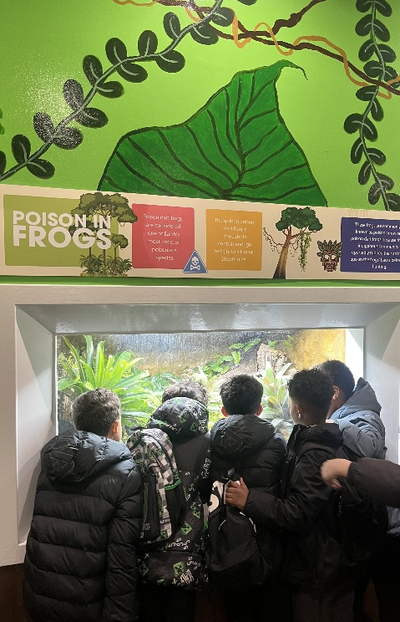
Visit to Chester Roman experience
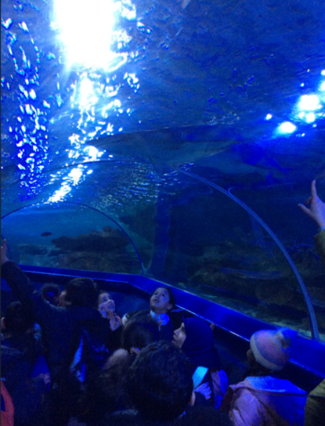
Bikeability

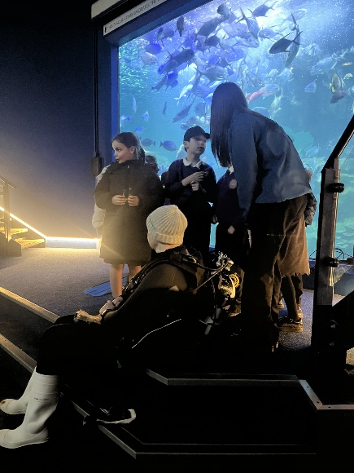

Last week Reception did a few experiments in class. The one the children were most excited over was the 'germs on the bread'. Three slices of bread were used: one handled with gloves, one with clean hands and one with dirty hands. They were put into plastic bags....and over a few weeks we watch whilst the bread went mouldy.
They watched with awe and wonder and could not believe the changes! As a class they discussed the importance of personal hygiene!

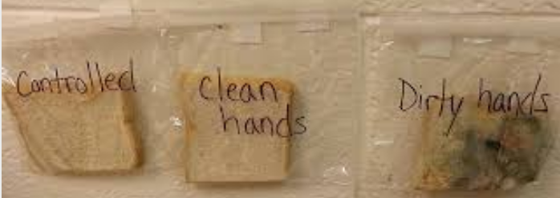
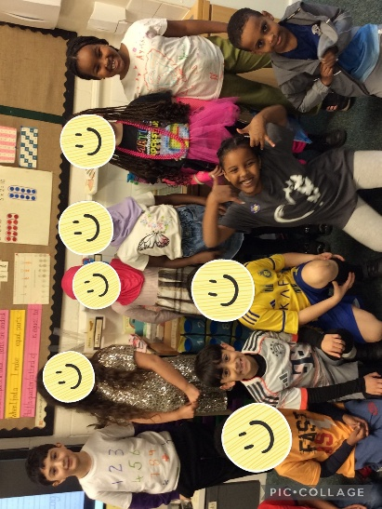
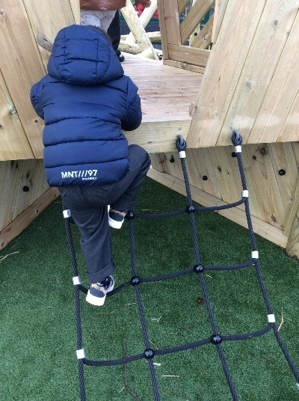

Red room have been using our new equipment to support gross motor skills, climbing down backwards is one of their key skills this term!

2H enjoyed Times Table Rock Stars day!

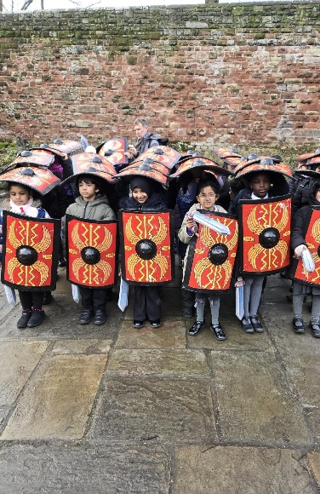
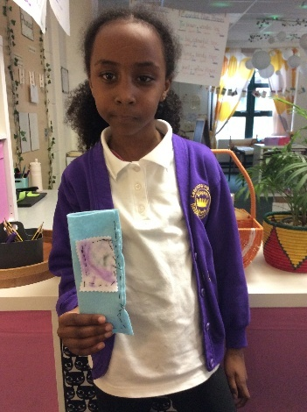
This term in Design and Technology 2CJ have learned the basics of sewing and loved practising their new skill. They learned how to do a running stitch so that they could join 2 pieces of material together. They created their own pencil cases and even sewed on an applique patch!
Year 3 had a great day in the historical city of Chester learning about the Romans. They marched through the streets chanting in Latin, holding their shields and wielding their swords before re-creating a battle in the Roman gardens. Back at the Roman Centre they also learned about life in Roman times.

Y2 visited Knowsley Safari park and watched an amazing bird of prey display!

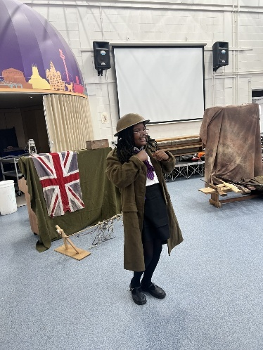
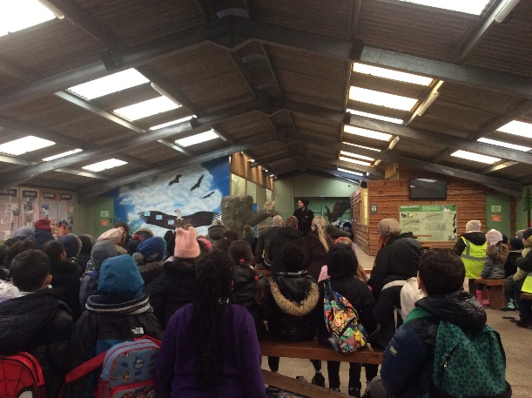

Year 5 have had an exciting and enriching week. Tempus Fugit delivered a World War One workshop, which brought our history learning to life. The children explored artefacts, learned about life in the trenches and deepened their understanding of how the war affected soldiers and families at home. They asked thoughtful questions and showed excellent engagement throughout.
This week, the children also took part in an online safety workshop focusing on how to use Artificial Intelligence (AI) safely and responsibly. They discussed what AI is, why personal information must never be shared online, and how to use AI as a supportive learning tool rather than a replacement for independent thinking. The children contributed mature and sensible ideas, demonstrating a strong awareness of how to stay safe in the digital world.
This term, Year 5 have also taken part in a fantastic LFC Foundation – Empower workshop, focusing on building confidence, resilience and positive decision-making. Through engaging activities and discussions, the children explored the importance of self-belief, teamwork and respectful communication. It was wonderful to see them reflecting on their strengths and considering how their choices can positively impact themselves and others.

Events Next Term.
Look out for letters about- World Book Day- Early March, this year we will be dressing up as Book Characters- details will follow.
‘Easter Eggshibition’- End of Spring term, decorate an egg and bring it in to show everyone- details will follow.

Dates For Your Diary:
Half Term: 16th- 20th February
Mental health week- activities in school - w/b 23rd February.
World Book Day- dress up as a book character- Thursday 5th March
School closes for Easter Friday 27th March 12.30pm
School opens for Summer term-Monday 23rd February
May half term week- 25th – 29th May
School closes for the Summer- Friday 17th July at 12.30pm.

One more inset will be arranged, around the end of May, we will let you the exact date after the holidays.

Ramadan and Fasting.

We sent letters out to all parents about this in January. Please remember, if your child is in y5 or 6 and you would like to give permission for them to fast, permission forms are available from the school office. You can also pick up a copy of our Fasting Policy from the office, or view it on our website under Parents section. Children CAN NOT fast in school unless we have this permission letter (for many reasons ,including the fact that some parents do NOT want their child to fast and have been upset with school when the children have tried to!)


On Line Safety

We have been thinking a lot about online safety this month. It’s a concern for many parents, alongside the overuse of screen time and the whole debate about what we should allow our children to have access to. We have noticed this year that a few more children have tried to bring phones into school, and we have also seen a slight rise in concerns about pupils having problems with social media. School often finds itself trying to sort out problems between pupils who have argued or been unkind to each other online. I’d like to remind you that the age for most social media sites is actually 13 and Primary age children really should not be accessing snapchat and other such sites. Please take a moment to look at the internet safety page of our Parents page on the website, or read the termly safety newsletters that we send home. You can always come into school to talk to us about this aspect of parenting if you have any worries. We share your concerns in this matter and are working hard to try to educate our pupils in this manner. Their curriculum has e safety elements threaded throughout, including staying safe on line, as well as lessons on misinformation and disinformation.

This week we have hosted Big Foot Arts workshops and drama performances throughout the school to promote internet safety.

We are also organising a workshop for parents after half term, hosted by an external provider- please look out for details which will be sent home after the half term holiday. I have also attached a special MGL Internet safety Week Information page to this newsletter.

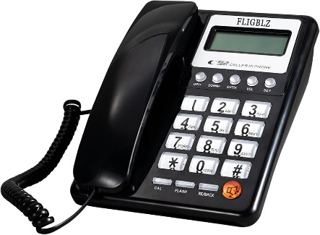
Thank you all for your patience this week with our phone lines. We have had issues with internet and phones all week and I know this has been frustrating at times as we haven’t been able to receive calls. Remember- we always put text messages out to let you know what’s going on when we can, if you are not receiving these, please let the office know.
Enjoy a happy and safe half term everyone

Mrs A Whittaker, Head Teacher,

