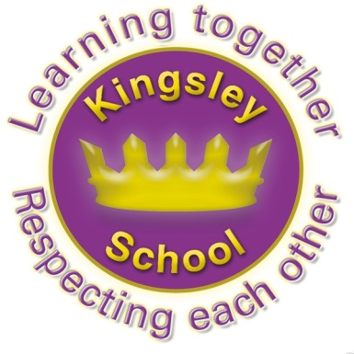
Kingsley Community School,
Eversley Street,
Liverpool.
L8 2TG.
Telephone: 0151 709 6727
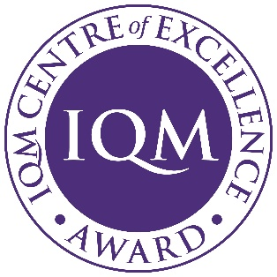
Fax: 0151 708 5105
Website: www.kingsley.liverpool.sch.uk

Head Teacher: Mrs A Whittaker

END OF TERM NEWSLETTER

Dear Parents/ Carers, December 10th 2025

What a long term, but we are almost there! School does not finish until next Friday (19th December), but I wanted to make sure that everyone got this newsletter, with dates etc on in good time. Its so busy at this time of year that things can easily be missed.

This is only the second newsletter I have had the chance to put together this term as things have been incredibly busy. I have tried to make up for this with an extra long newsletter this time!

Retirements and Staff Movement
I want to say thanks to Mrs Hassan who is leaving her lunchtime supervisor’s role this Christmas. She has worked here for many years and has been an important part of the team. We wish her well for the future. We also said farewell to Mr Troy and Ms Timoney who have moved on to different careers.

Building Work

Thanks for everyone’s patience whilst we completed building work this term. Although we got phase 1 started over the Summer holidays, a lot of this carried on into the 1st term. I am pleased to say it all now appears to be finished! We have an amazing new early years playground, and new equipment on the key stage 1 and 2 yard too. I genuinely think we have the best playtime facilities in Liverpool. A huge thanks to Mr Forde and Mr Moore for their project management (including lots of financial paperwork and persuasive reports to the council who wanted to claw back money we had saved for this!) and to Governors who met several times to look at plans and to agree finances. Also thanks to Nursery, Children’s Centre and Reception parents who have had to use a separate entrance whilst emergency safety work was carried out on the Children’s Centre entrance. Fingers crossed we should all be back to normal now.
​

New Policies and other Information
Our website is a useful place for many pieces of information that you may need . It is not designed as a place to find out every detail of school, however, I often feel that it is an under used resource by parents. On the website, you can find lots of useful information, including:
- Dates for the year
- An overview of every curriculum subject for each year group
- Class pages with photographs and useful information about expectations for the class
- Advice around SEND
- Advice around safeguarding, including online safety
- Policies which parents may need
- Newsletters
We are currently updating some of our policies and procedures. Once written, these are agreed by Governors, then shared with staff and parents. I’d like to draw your attention to our revised Complaints policy, and new policies for Unreasonable Complains and Parental Conduct policy.

Maintaining the website is a full time job, and we simply don’t have the funds to employ someone to do this, so the job is shared out. This means the level of detail some would like is simply not possible for us as staff workload would be unsustainable. As we always say, check the website first, but then if you can’t find what you need, ask your child’s teacher, or a member of senior staff on the gate in the morning. We are all really approachable, come and speak to us!

Parental Feedback
Thank you to everyone who responded to our parental questionnaire in September this year. We received 50 responses, about a quarter of our families, which is a few less than we have had previously. Nevertheless, we were delighted with the responses we received. The overwhelming majority were incredibly positive. I took these home one weekend to analyse and they absolutely made my day!
I have put the full feedback on the parents section of the website, but here are a few of the things that have made us happy in school:
My child is happy at Kingsley- 100% agree or strongly agree
My child feels safe at Kingsley- 100% agree
Staff in Kingsley are approachable and available- (96% agree (4% didn’t know!)
I would recommend this school to other parents in the area- 98% agree
‘The staff always take things seriously and are cooperative’. ‘I feel safe with my son in this school’. ‘The staff really push themselves and do the right thing with school’.
‘Everyone is happy as parents with the way they treat us.’

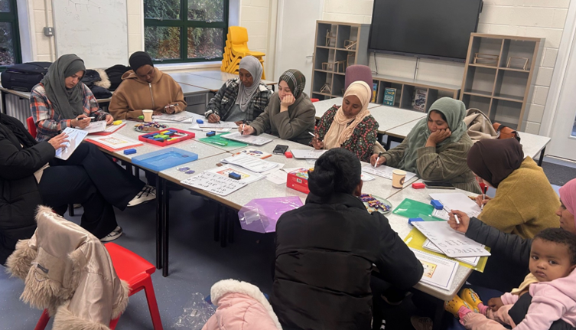
Your feedback really does matter, even if we can’t always fulfil everyone’s wishes. Lots of our best plans and ideas have originated in parental suggestions! We are always happy to talk, there is no substitute for an early conversation if you are worried, or have any ideas- we would much prefer to do this in person, so always ask to speak to someone, either at the gate, classroom door or at the office. Sometimes our staff can’t see parents there and then, but we will always ring you back or make an appointment with you. Our default position is to always talk in person where we can.

Photo: Reception Parents at ‘It’s Your Child’s Life’ workshop this term- amazing work everyone!

Charity News
It has been a feature of Kingsley, for a long time, that we try to encourage everyone to think of the needs of others and the importance of charity plays a big role in our annual calendar of events. We know that many of our families also share this view. Usually we have one ‘ event ‘ to fundraise a half term, so far this year the school has raised the following money for our chosen charities:
- Pink Day (Brest Cancer) £515.09
- MacMillan Coffee/ Worst Girls gang (staff only) - £170
- Woolies For Whitechapel is today! (homeless charity)

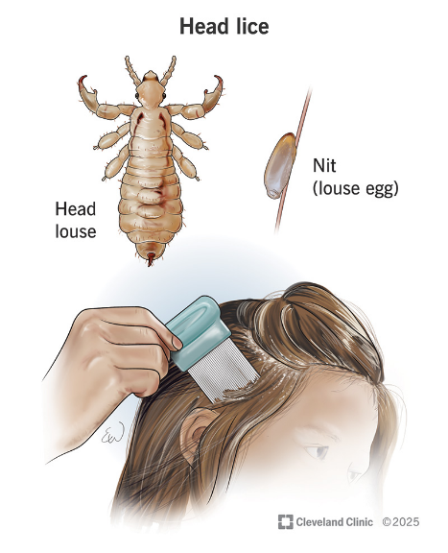
Head Lice and Other Concerns Raised.
We have had some concern about children coming to school with headlice this term. Headlice are a very common childhood affliction- you are very lucky indeed to get through primary school without catching them. They are usually harmless and easily treatable, however, some concern has been expressed that some parents are aware that their children have head lice (also called ‘nits) , but are not treating them. Although mostly harmless, they are irritating, can make children itch and become uncomfortable so we really don’t want them to spread.
Please check your child’s head regularly and if you find any lice or their eggs, please visit the chemist and get some lotion (this is often free if you ask for care at the chemist). If you need help- just come and speak to a member of office staff and we may be able to support you to get treatment. You can get further advice from: https://www.nhs.uk/conditions/head-lice-and-nits/

Uniform
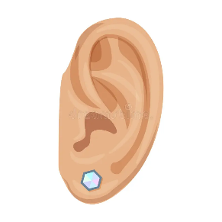
Just a quick nag this time- uniform has been MUCH better this year, thank you all very much for your efforts. Be aware that your child will be challenged if they come to school in incorrect uniform. Wearing uniform is part of what you agreed to when you chose Kingsley for your child, and we expect all parents to support us in this matter. Please take a particular close look at jewellery as this is still causing us some concerns. No jewellery apart from small, flat studs should be worn by children. Hoops should NOT be worn. Your child will be asked to remove jewellery that does not meet these requirements.

Eco Update

Pre-loved shop: This term the pre-loved shop will be open in the Eco Pod classroom near the forest on Monday the 15th of December, from 3pm until 3.40. We have a selection of jumpers, shirts, skirts and trousers, PE items, hats and scarves. All money raised from our shop will be donated to Unicef to help others around the world.
Outdoor Learning: Next term Y2 will be taking part in Outdoor Learning lessons every Monday afternoon. Please make sure they come with suitable clothes for outdoors, and footwear for the weather and if they have wellies bring them into school every Monday.

What Have We been Up To this Term?

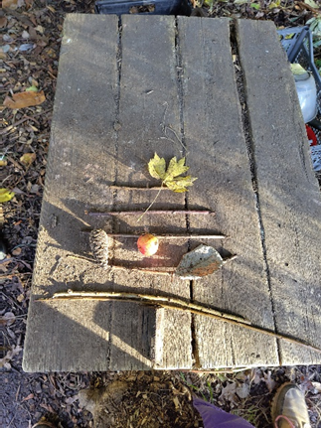
Reception and Year 1 Outdoor Learning Reception and Year 1 have been comparing stick lengths, finding the longest and shortest and putting them in order. They then added decorations they found in the forest and turned them into Christmas trees!
Our whole school sustainability plan has been written and is now on the school website.
Early Years:
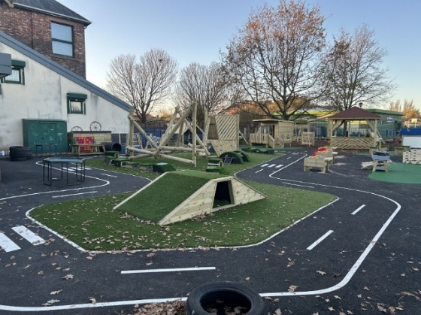
Early years have been LOVING their new playground! You may have seen the very new and exciting outdoor area Reception are now lucky to have! We now have a construction area, reading hut, water wall, sand play, digging area and the amazing climbing frames.
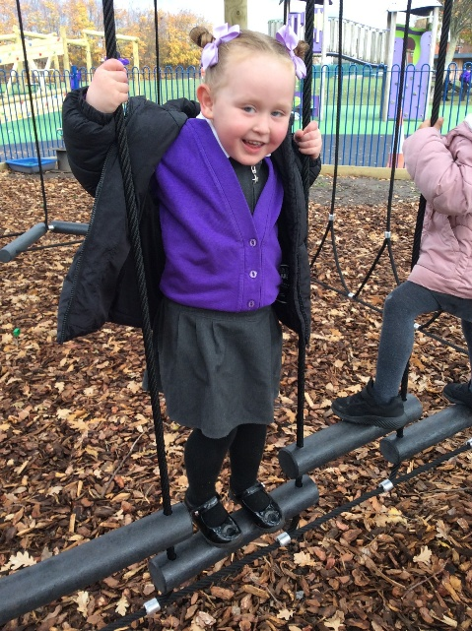
The children have been very busy exploring the fabulous outdoor equipment this term and building on their confidence, resilience and independence.
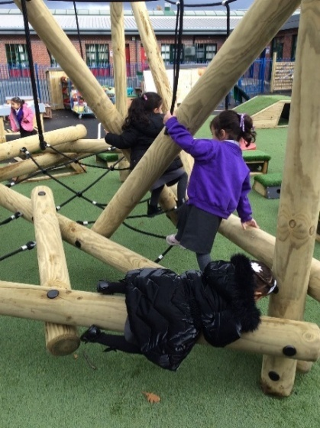
It is wonderful to have such a fantastic area to extend our learning outside and we very much enjoyed our Stay and Play when our parents came to visit and the children showcased their new skills.

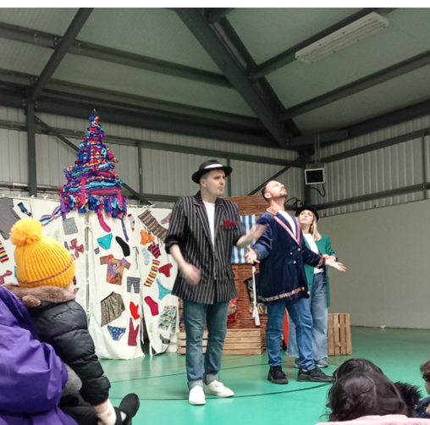
Reception went on a local walk around the school. This was linked to a geography lesson looking at land marks and maps. When they came back to school the children all drew a map of where they went and what they could see along the way. Children were excited to go on the outing with lots of help from the grownups. The children pointed out where they lived and places they have been, like Princes Park. The children enjoyed talking about their experiences in some of the buildings like the mosque, shop, doctors etc.
All of Early years have also enjoyed a visit from a drama company performing a traditional Christmas Pantomine
Key Stage 1
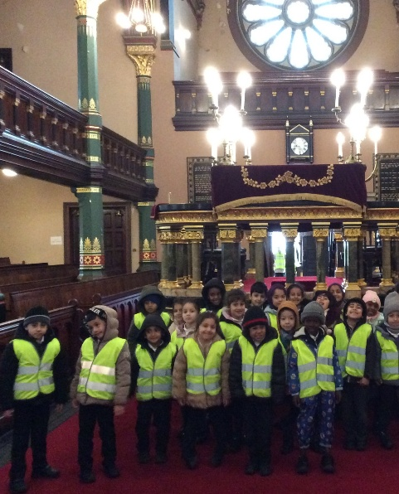
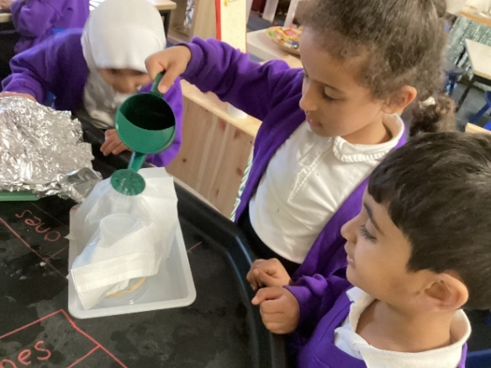
Year 1 have had a mystery on their hands! With several items going missing around school, they decided to write to Hermelin the Mouse Detective and ask him to help us crack the case. He even came to visit them! They have also been investigating what materials would be best to help Miss Shannon. The roof on her shed broke so we wanted to help her keep the things inside dry whilst waiting for a new shed.
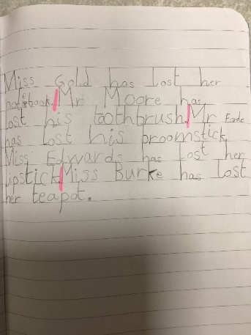
Year 1 have also been making free standing structures in DT and used the skills of folding to create a tower for Rapunzel.

This week Year 1 made a visit to a local synagogue. The children asked brilliant questions and were able to show off their own knowledge about a world faith. Great job everyone! Thanks in particular to all of the parents in Y1 who accompanied the children.
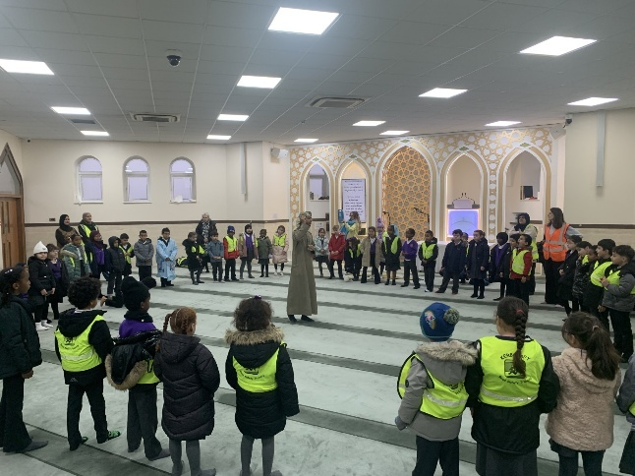
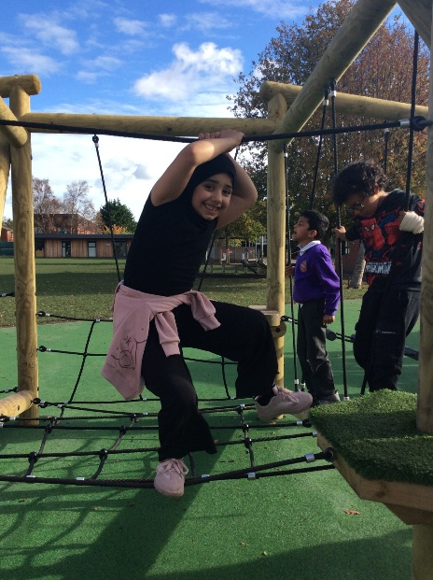
Year 2 had the great opportunity of visiting the Al-Rahma Mosque. We had the most wonderful time! Abdul taught us so much about what happens within the Mosque and the relationship that the Mosque has with our community. Lots of our children were also very proud of being able to share with their friends, their experiences that they have when they visit the Mosque

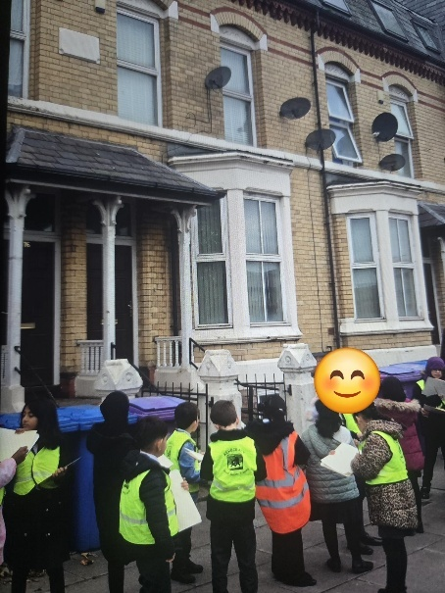
2S are really enjoying the new climbing frame on the KS1 and 2 playground!

Lower Key Stage 2

Year 3 have really enjoyed their geography topic about the local area. They went for a walk to see the different types of houses and buildings near to Kingsley and compared them to Smithdown using Google Maps. Amazing geography skills!
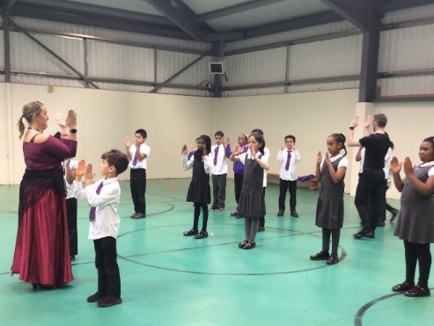
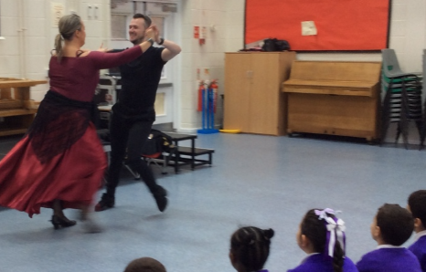
Year 4 had a workshop with Dance Passion and explored the steps of the Paso Doble dance. We had some amazing dancers of our own!

Upper Key Stage 2
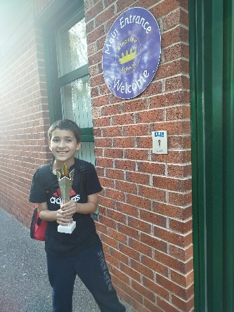
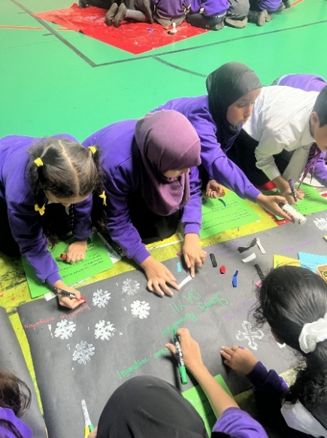
The slavery museum delivered a workshop for children in year 5. After telling the story of Anansi the Spider the children had different activities including making posters and placards.

Also this term, 5H have been busy exploring the vast expanse of space – even singing our favourite space song as part of our learning!

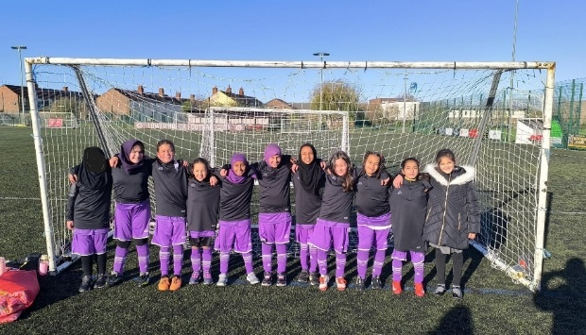
Y5 welcomed visitors from the Liverpool Slavery Museum to help them to understand how the transatlantic slave trade shaped our city’s past and present. Alongside curriculum adventures, 5H have proudly represented the school in a range of sporting events, including cricket, football, dodgeball and archery.

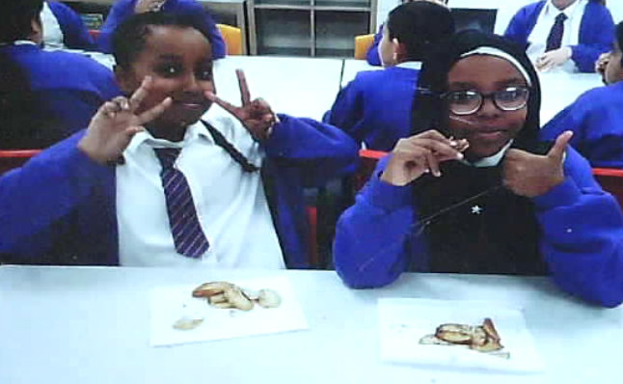
Class 6S have been practising their peeling and cutting skills in Design Technology. They have tried a variety of different seasonings and researched ingredients in preparation for making their own celebration meal.

Thank You
As always, although this time of year is busy, I try to reflect on things I have to be thankful for, and I try to take the time to say thank you to various people. My job can be very demanding, but I am truly grateful to work here at Kingsley in L8. We have had a lot of visitors to school this term, many from other schools or partner organisations, and they unfailingly only ever have positive things to say about Kingsley. I and the Senior staff have been reflecting a lot lately on what a great school this is, our pupils are so lucky to have the range of opportunities that we give them and that you, as parents, support us with. This is 100% down to the skill and dedication of the staff here, both in school and in the Children’s Centre. Sometimes, when you are in a place every day, you take it, or the people, for granted, and I just wanted to end my Christmas letter with a massive thanks to all of you. I look forward to continuing this great partnership in 2026.
Dates for your Diary

- Friday 19th December- School finishes for Christmas holidays at 12.30pm
- Monday 5th January- Staff Training Day (School closed for pupils)
-Tuesday 6th January Spring term begins.
-Friday 30th January- Times Table Rock Stars Day- (Details will follow!)
-16th- 20th February- School closes for Half Term.
Please check the school website for all other holiday dates.

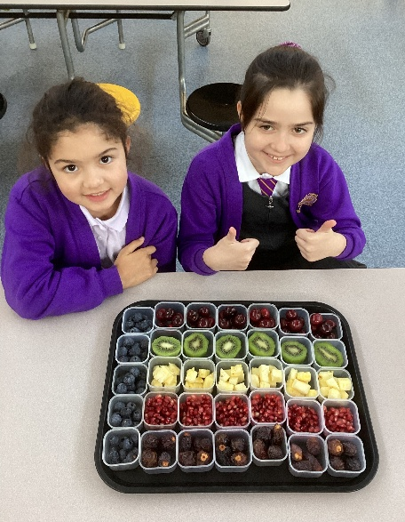

Many thanks to Tesco (and to Mr Moore for making a second successful bid!) for providing us with lots of yummy free fruit and vegetables again this academic year.

Enjoy the holiday everyone, and Happy Christmas.

Kind regards,

Mrs Alison Whittaker, Head Teacher.

