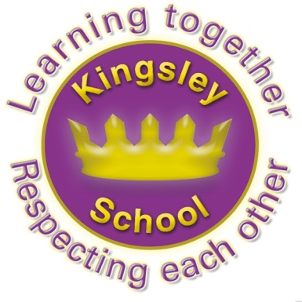
Kingsley Community School,
Eversley Street,
Liverpool.
L8 2TG.
Telephone: 0151 709 6727
Fax: 0151 708 5105
Website: www.kingsley.liverpool.sch.uk

Head Teacher: Mrs A Whittaker 12th September 2025


START OF TERM NEWS:
Dear Parents and Carers,

I hope you’ve had a wonderful summer. It’s been lovely to welcome everyone back this week! An especially big welcome to all of the new pupils in Early Years and throughout the school, and their parents.

As well as welcoming you all I want to take the opportunity to give you some reminders about things happening in school this term, and to update you on a few changes.

Results To Celebrate
You know I always say results in tests only give you part of a child’s achievements- however it’s worth us celebrating some of last years achievements, because once again Kingsley pupils did us all proud.
We equalled the National Average for attainment in phonics in year 1, which is a phenomenal achievement for a school where the vast majority of pupils don’t speak English as their first language. Amazing!- thanks to all the staff who prioritise this and to parents who back up phonics and reading at home.
Equally impressive is the very high number of pupils in last years y4 who scored highly in the times table checker- in this area we exceeded national results!

Our year six made phenomenal progress and did extremely well in their SATS. The school achieved at least national standard in writing and maths and was close to this in reading. Once again, individual pupils made some phenomenal progress, often from very low starting points. It’s a testament to their hard work, the hard work of ALL staff – throughout school, and parents alongside this, and the huge resilient attitude of our pupils.

One all the results are validated, probably around late October, they will be available for you to see on the school website.

Fruit Scheme Continues!

Thanks to Mr Moore and Mr Christopherson who are ensuring our amazing free fruit and veg provision continues! Mr Moore has secured fantastic funding again this year from Tesco and Mr Christopherson is looking forward to shopping again for all the amazing exotic fruit and new vegetables that you all get to try during the day and at lunchtime. A big shout out to class 3T who were the first winners of the ‘Best Manners’ award and got an extra fruit feast on Friday! Thanks to Tesco for an amazingly generous second year of funding.


Exciting Building Work!
You will have all seen the amazing new piece of play equipment which is being installed on the field this week. This is phase 2 of huge building works that were started over the Summer holiday. We have amazing new Early Years outdoor provision scheduled for installation this half term. This will support the learning in Red room Nursery and Reception. We then also added on some additional climbing equipment for the children in the rest of the school. Its such a big job that it will take several months in total, thank you for your patience whilst the field and playground is disrupted somewhat!
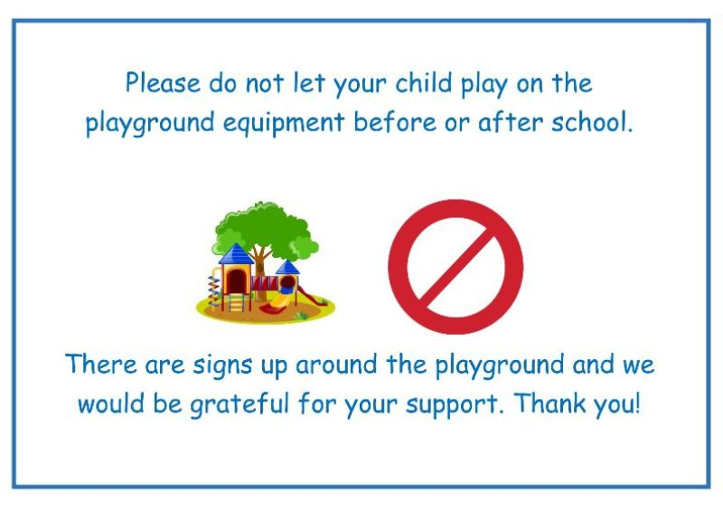

End of Day Playground Use.

Can I please ask you to help keep everyone safe by doing the following:
DO NOT allow your children to play on the playground equipment at the end of the day. Children are not supervised and could easily have an accident. We do not have insurance like a public park and can not allow unsupervised access to the slide, adventure playground, climbing frames and gym equipment.


Please can I also ask you to NOT allow children to ride on scooters or bikes on the playground. A nasty accident occurred last term by a child who was riding a scooter around, unsupervised by a parent, on our yard. Either do not bring a bike or scooter when you collect your child, or only allow them to ride it outside the school gates.

I’m sorry to have to be the one to spoil end of day fun in this way- but school can not take responsibility for the safety of children on this equipment or on vehicles, once pupils have been handed over into the care of parents.


Breakfast club
Many of you use this service – but we wanted to remind you about how it operates. Children who wish to attend should arrive at the main entrance at 8.15am. Breakfast club costs only 50p a day, which can be paid daily, or as a weekly amount of £2.50. Pupils will be offered toast, cereal and a drink to set them up for the day. You do not need to book your child’s place at the moment, we will only need to consider this if numbers increase dramatically. Pupils must should arrive between 8.15 and 8.30 am or they may not be allowed admittance.

Uniform.

- Tie years 3-6

- Dark grey trousers or skirt
- Black shoes
- Black or purple hijab (one piece, not a long scarf)
- Purple sweatshirt or cardigan
- White polo shirt in years R to 2 white shirt in y3-6
- NO JEWELERY please! (Apart from small flat stud ear rings)

As per my letters in the past, we have expected all pupils to return to school wearing correct school uniform. PLEASE write their name in their tie and in ALL school uniform. Staff do not have the time to sort through the large number of items which are lost or discarded by children every day, and who do not have their name in. I can already see a huge pile of ‘lost’ jumpers in lost property- all un named. It’s such a wate of time and your money as parents if we can’t reunite a jumper with its owner, but with over 500 pupils in the school this is impossible without a name!

Trainers are NOT part of school uniform, neither are tracksuit tops. Thankyou so much to every parent who has ensured children are not wearing trainers for school!

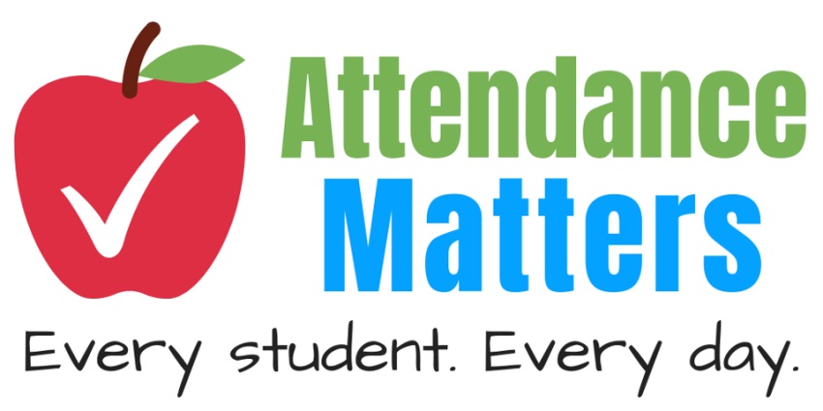
Attendance
I need to ask for your help again in this area. Most pupils attendance here is amazing and this definitely is one of the things which helps our pupils do so well in school
BUT both myself and Mr O’Shea have spent hours in the last week, trying to find ‘missing’ children. These are children who have clearly gone on holiday, but their families have not told us. Not only is this a massive safeguarding concern for us, it has caused us a significant amount of work.

Its never good to take holidays in term time, as I have talked about a lot over the last year- but there has been a worrying trend this term where children just haven’t returned to school, and other people are telling us its because they have gone on holiday. If you go on holiday without telling school , you run the risk of your child being categorised as ‘ missing in education’ , and they could, in some circumstances, lose their school place as we simply don’t know where they are or if they are going to return.

Please do not put us or yourselves in this position, always let us know of tour plans, and in particular of your return date.

Punctuality
Hand in hand with attendance comes good timekeeping. Gates on Kingsley and Eversley Street will be locked promptly at 8.50 am, as this is the time of day children should already be in class starting lessons. If your child arrives after this time they will be marked as late and have to enter via the main office where they will be registered with a late mark.

Dates
You can keep an eye on dates for the year by checking the school website, however, here are some dates for your diary:
- October Half Term closed to pupils- Monday 27th October to Friday 31st October
- School Closes for Christmas holidays at 12.30pm – Friday 19th December

- Inset Day (school closed for pupils) Friday 24th October
- Inset Day (school closed to pupils)- Monday 5th January 2026
- February Half Term closed to pupils- Monday 16th February to Friday 20th February.
- School closes for Easter Holiday at 12.30pm on Friday 27th March - Monday 13th April
- May Bank Holiday school closed Monday 4th May
- May Half Term closed to pupils- Monday May 25th to Friday May 29th
- School closes for Summer holidays- Friday 17th July
- Inset day for staff training school closed to pupils – Monday 20th July
- School reopens Tuesday 1st September 2026 (inset day, pupils will return on the 2nd)
There will be one additional inset day allocated, in the Summer term

Some Words Of Reassurance

Once again, I feel like the country and the world has been very unsettled over the Summer. Some of this has felt targeted towards certain groups and individuals. I want to take the opportunity to tell ALL parents and carers that your child is welcome and safe in our school. I have seen that there has been some anti -migrant/ anti certain group tensions in parts of the country in recent weeks (and indeed abroad) and I know this has been incredibly upsetting for some children and their families.
I want to reassure you that that our school is a safe space, we value inclusion, respect and kindness.
We will continue to talk to all of our children about how welcome they are in our school, whether they are new to us or whether they have been here for years.
We will continue to talk about respect for those who are different to us.
We will continue to talk to our children about respect for those of different faiths, of different family backgrounds and those who have different ways of living than they do. Nothing has changed here, it’s what we have always done, and our children are amazing in their capacity to show kindness and respect.

I believe our inclusive policy is a cornerstone of Kingsley. Our children are some of the most respectful and kind pupils I have taught in the city and I am convinced that our ethos helps them to go out into the wider world, ready to work alongside people who are different to them. Your input as parents is vital and very much appreciated.

Finally, good luck to you all for the year ahead. The atmosphere in school this term is once again calm and positive. The school is industrious and purposeful and everyone is determined to continue with our ethos of kindness and high aspirations for all. Our new staff (10 of them! ) have fitted in amazingly well- like they have always been here! Thank you for your continued support in this. I say it every year, but children flourish in school when there is a true partnership with parents, keeping children safe, supporting where we can, celebrating successes and being on the same page when improvements are needed. I look forward to this continuing this academic year.

Kind regards,


Mrs A Whittaker, Head Teacher.

