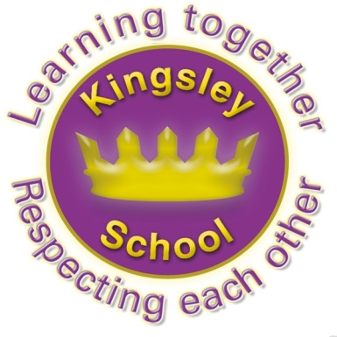
Kingsley Community School,
Eversley Street,
Liverpool.
L8 2TG.
Telephone: 0151 709 6727
Website: www.kingsley.liverpool.sch.uk

Head Teacher: Mrs A Whittaker
April 2025
Spring 2 Newsletter
Dear Parents and Carers,

As the second term draws to a close, I wanted to share our latest news and updates with you all.
We have lots to be proud of this term, and in particular we are going to try to share more of the great pictures of our trips, visitor experiences and clubs and teams, by including some wider news from classes in this letter. In addition we are looking to find further ways of sharing more with you either through class dojo, or similar, as we know so many parents appreciate seeing what goes on in school! Watch this space for updates on this.
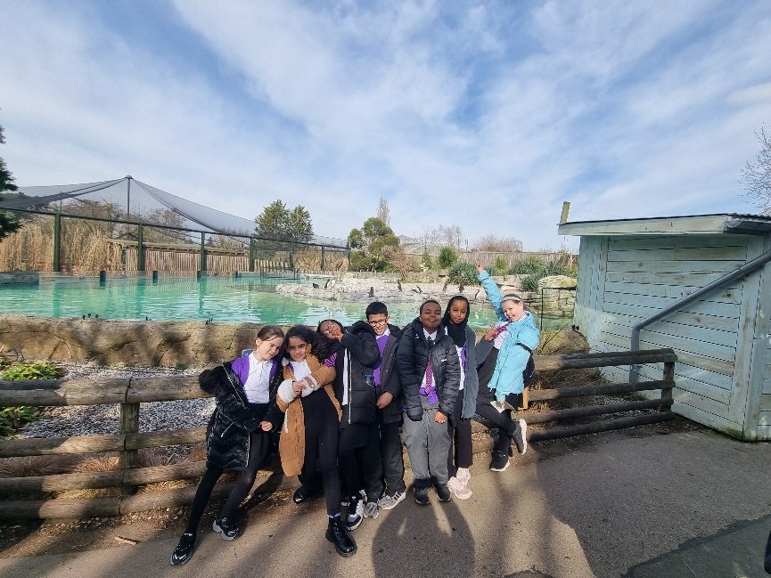
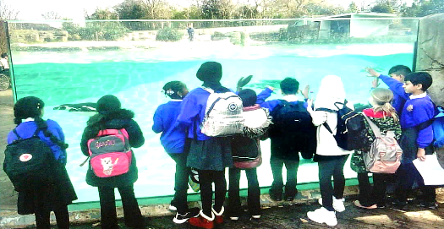
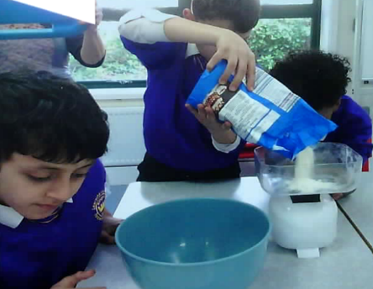
Year 5 enjoyed a great day out at Chester Zoo.

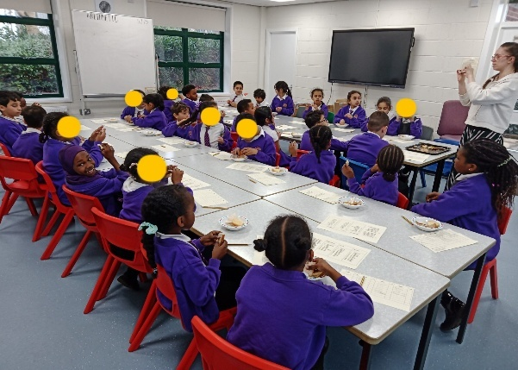
Y5 Made pancakes in our new DT room, whilst learning about shrove Tuesday. Year 3 also made use of this space, 3B have been looking at sandwiches. They have learnt where our food comes from, created some grand plans for their dream sandwiches and got to try a variety of food in their deconstructed sandwich tasting afternoon. The children discussed foods they liked and disliked and commented on the taste, texture and smell. We had a fantastic afternoon and many of the children discovered they liked some new foods!

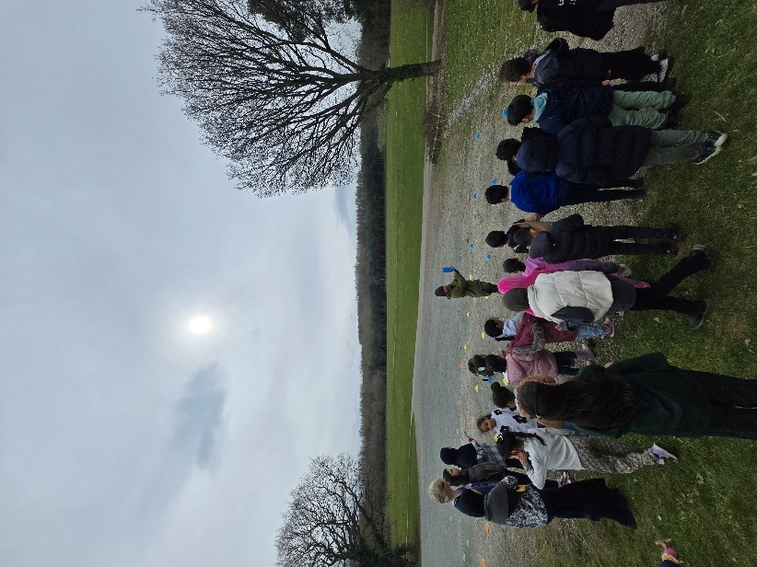
RW, and the staff, thoroughly enjoyed dressing up for History Day and learning about the passing of time. We took part in a fantastic workshop making our own human timeline to show history! We also enjoyed using our oracy skills to talk about who we came dressed up and wrote about them for a display you can see in our classroom. Well done to all !🙂

Year 2 students had a fantastic time engaging in experiential learning during their recent Maths lesson, where they made delicious cookies! This hands-on activity gave them the perfect opportunity to apply their knowledge of measuring length, capacity, and mass in a real-world setting. As they followed the recipe, they carefully measured ingredients like flour, sugar, and butter. They also practiced measuring lengths for cutting dough and shaping cookies. They faced some challenges and showed fantastic problem solving skills. Not only did they enjoy the creative process, but they also deepened their understanding of these important mathematical concepts in a fun and meaningful way. We are proud of their efforts and the tasty results!

Just in time for Spring, year 3 enjoyed a Geography fields trip to Delamere Forest. They practised map and compass skills before taking a hike up to the top of a hill for fantastic views of the forest and beyond.
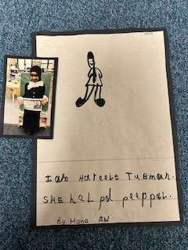
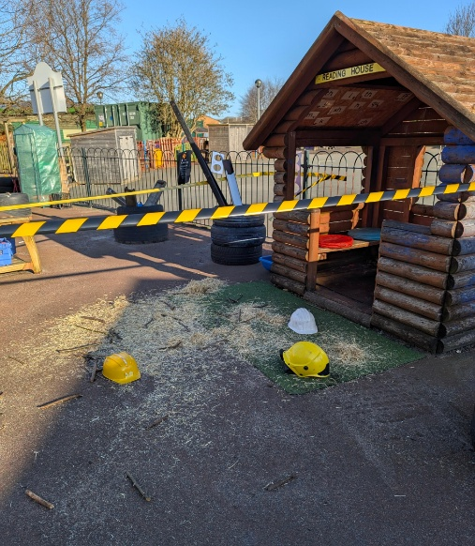
RA had something very strange happen in their outdoor area this term...the children had to investigate to see what had happened. The children were visited by woodland animals and interviewed them to try and get some clues and piece together what might have happened.
They found out that it was the wolf from the three little pigs he had blown the pigs homes down that they had built in our forest school.

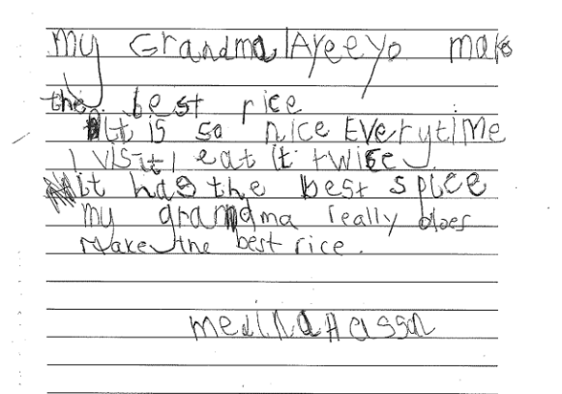
Age Concern Poems.
Our Reception children recently submitted some poems for a special 'Age Concern' charity competition. The poems spoke about how much the older people in their lives mean to them, and were judged by Liverpool's oldest resident, Aunt Marj, who is 111 years old! Both Aunt Marj and the charity were so impressed by the poems that a special visitor from Age Concern will be visiting school this Friday to give the children who took part a medal and a certificate each - well done to all those who took part!

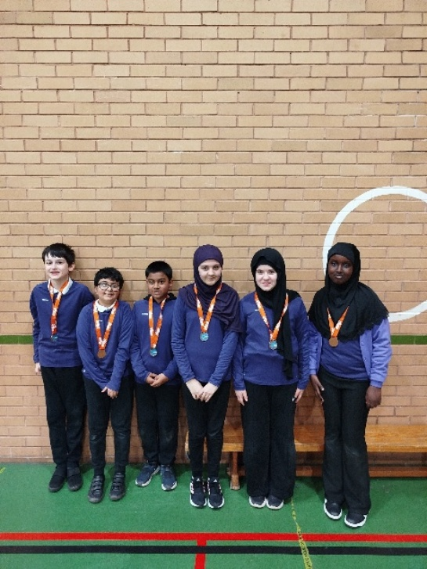
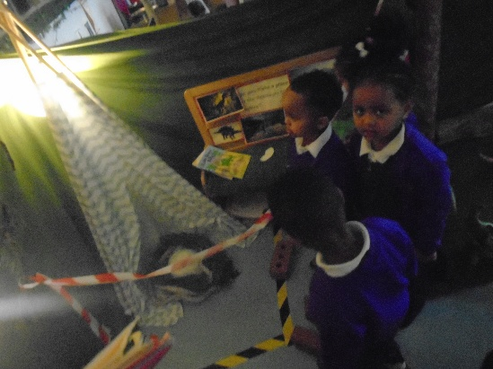
Year 1 – A Magical Half Term!
Year 1 have had a fantastic half term exploring the first signs of Spring as part of our science work. They’ve planted daffodils, made wild flower bombs, and observed their adopted tree. They've also done really well continuing to monitor and record daily weather patterns.
They also enjoyed a visit from Mini Maestros, where children learned to read early musical notes, explored instruments, and even performed a song!
In English, they've been diving into enchanted lands, inspired by letters from the Wild Things and visits to magical places where giants live. The children enjoyed a Wild Rumpus party!
Monty the axolotl continues his weekly adventures with the children – who will take him home next?

This half term Red room Nursery have been looking at dinosaurs. We found a dinosaur egg in our classroom and waited for it to hatch. The egg hatched over night and we became detectives following footprints and clues to find the dinosaur.
We have been celebrating Ramadan and practicing for our Eid play we can’t wait for our grownups to come and see us.
We've had a visitor from the children's centre who came and read a very special story to us.

Y6 kinball team, who won bronze at that event!

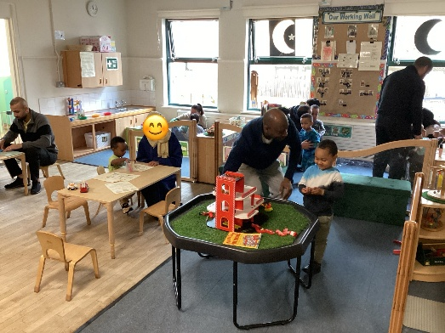
This month Blue Room have learned all about Easter. We had stay and play where we did lots of fun activities with the children and their parents. We made Easter cards and painted eggs. Also, we talked about Eid and made Eid boxes for the children to open when Ramadan was over. Celebrations all round!

Community Links
We have some very exciting news to share with the children at Kingsley and people living in the wider community! A free to access bike library will be landing on our site over the Easter break. We are very fortunate to be involved in such an amazing initiative and it will be a great way to make cycling more accessible in our community. It is run by the Peleton Liverpool Cooperative who run a similar Library in L5.
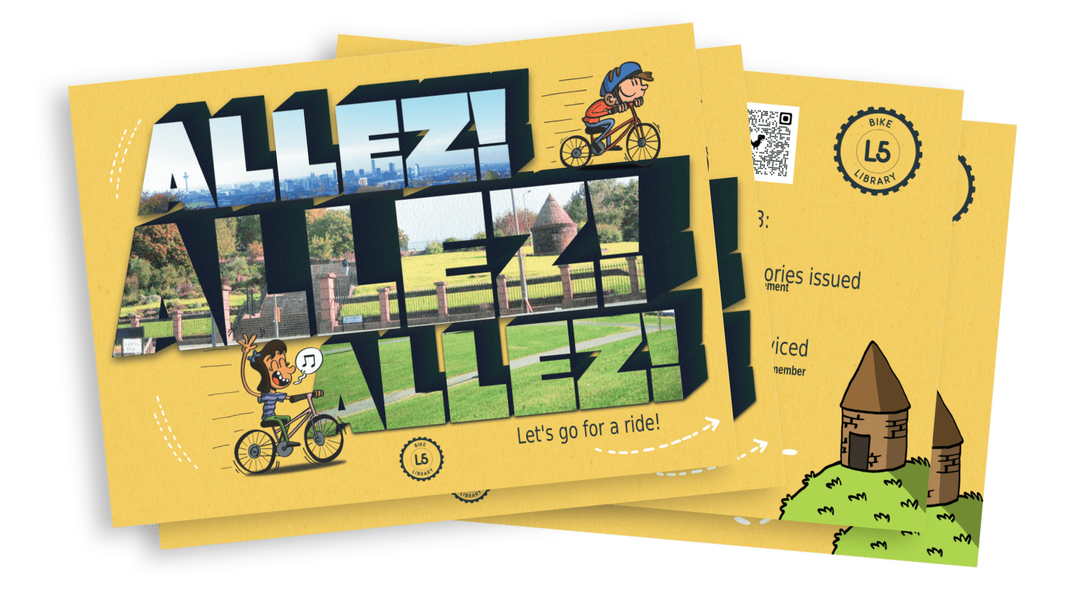
Anyone can register to join. All they ask is that you take care of the bike, treat it like part of the family and that you return to them for servicing or returning when your child grows out of it. At that point you can access another bike that will grow with your child!

Watch this space as more information will follow…

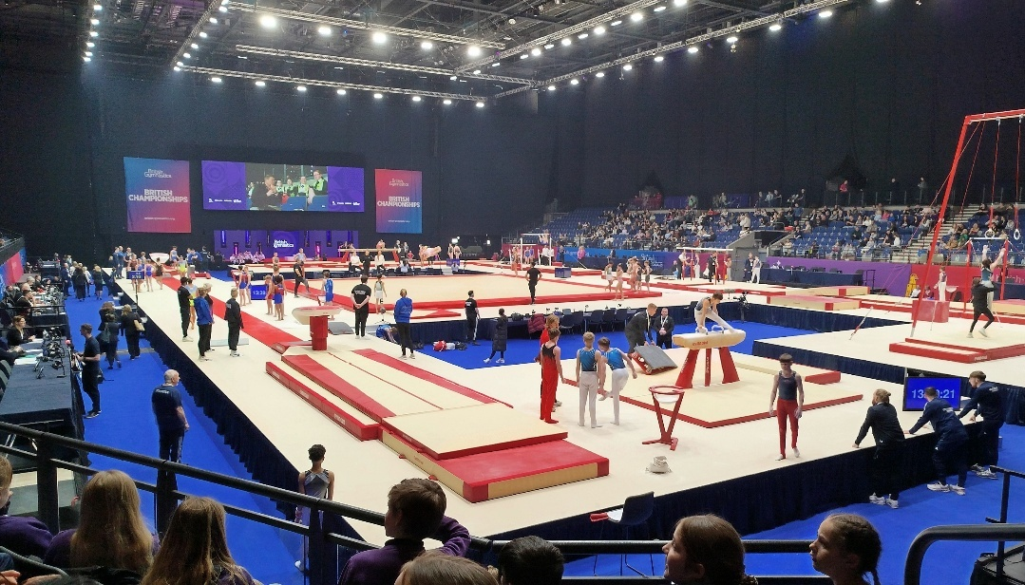
Some children in y3 and 4 had the opportunity to watch the U16 British Gymnastics Championships at the M and S Bank Arena

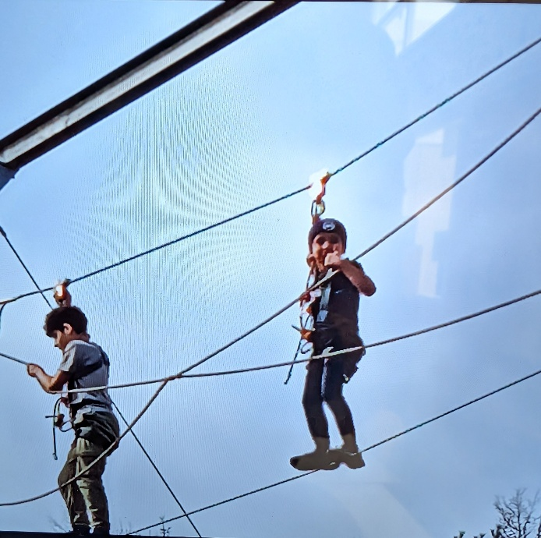

Year 6:
A few weeks ago, some pupils from y6 went on a fun and exciting trip to PGL. The children enjoyed taking part in the trapeze jump, which involved conquering their fear of heights by climbing high, jumping off and catching a trapeze and swinging all on their own. They also put their minds to the test by problem solving in the forest and a dance off in the evening to polish off a fun and action-packed few days in Shrewsbury.

The remaining y6 pupils enjoyed making cheese and tomato pizzas and chocolate cornflake cakes, which they tasted and self-reviewed their handiwork as "Delicious!" and "Better than the shops!" They also enjoyed a sunny walk to the local park where they played cricket, football and Frisbee and generally basked in the sun with their friends. Then, back to school to for the afternoon to enjoy getting stuck in with some clay designing animals, aliens and a whole lot more.

During the rest of the term, 6M have worked hard with their studies for their upcoming exams, which start on Monday 12th May 2025 until Thursday 15th May 2025.

Dates For Your Diary
Friday 4th April 12.30pm. School finishes for the Easter holiday. (No Nursery)
Tuesday 22nd April- School Summer term starts.
5th May- School closed for Bank holiday
26th May- 30th May Summer half term.
18th July 12.30pm end of term.

There is one other inset day to allocate this academic year, this is likely to be around the time of Eid in the middle of June, but we will confirm this as soon as we can.

Finally
There is so much that has gone on this term that I have missed here but once again, there is so much to positively celebrate about life at Kingsley. The staff continue to work unbelievably hard on behalf of your children, and we really appreciate all the support you give. Enjoy the holidays!
Mrs Whittaker.

