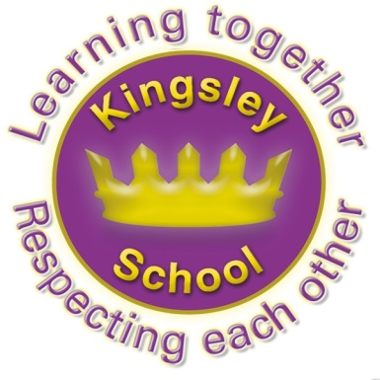
Kingsley Community School,
Eversley Street,
Liverpool.
L8 2TG.
Telephone: 0151 709 6727
Website: www.kingsley.liverpool.sch.uk

Head Teacher: Mrs A Whittaker
13th February 2025
Spring 1 Newsletter
Dear Parents and Carers,

Despite some very cold and difficult weather, I’m delighted to say we have had a really good first half term for the year 2025!
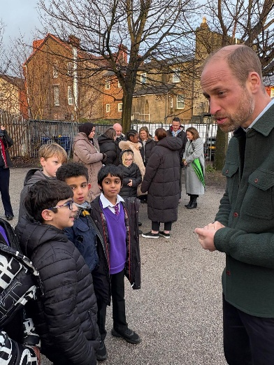
We have already had several highlights and things to celebrate, especially in our wider curriculum offer. This year this includes meeting royalty! Our school council were invited to meet HRH Prince William at Tiber Street project in January. The Prince chatted to them about football and quidditch, amongst other things, and proved himself friendly and interested in everything our children had to say.
Extra Curricular Clubs and Teams
After school clubs are run entirely by school staff (apart from drumming) so we are very grateful to everyone who goes above and beyond to make sure our children get these opportunities. It does mean we occasionally have to cancel if we have a lot of absences, but we also try very hard to cover them in these cases. Places are allocated on a rota basis so we aim for every child to have been able to access at least one club if they want to. This is why we change the clubs and the children regularly.
This half term has been another action packed one in terms of sport here at Kingsley!
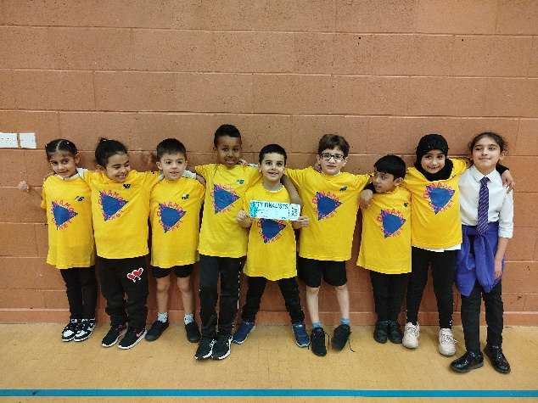
Our y2 mat ball team have reached the city finals after some excellent play a few weeks ago at North Liverpool Academy. Our award-winning cricket league has started up again with 8 schools from the local area playing matches every Wednesday and Thursday! Our team have had some very close games and are on the verge of their first win of the indoor season!

We competed in indoor athletics, basketball, sports festivals, inclusive athletics events, table tennis, football and there is so much more to come, with a few exciting trips and opportunities on the horizon! Children across all KS1 and KS2 have represented the school this half term.
Y5 keep an eye out next half term as bike ability happens at the end of March and we are also a part of an exciting coding/bike skills workshop at the end of February.
Like a lot of what Kingsley does- this provision is really down to the dedication and good will of several of our staff members. I can not tell you how hard our staff work, and what long hours some of them put in, but they still support the additional opportunities that go on , and which make school a great place to be.
KS1 mat ball finalists
Clubs run on a six week basis, over the year all year groups from Y1 upwards will have offers of different clubs, the children who attend are tracked so we can see who attends and try to encourage wider participation – we report to Governors about this and it our ambition to ensure that every child has had the opportunity to take part in something by the end of the year. No mean feat for 400+ children and all for free!

The office staff also really help to organise these opportunities, particularly answering a lot of calls from parents about clubs. Please can I ask again, make a note of your child’s clubs, the dates and times they run when you get the letter, rather than relying on ringing up the office and asking them. This will really help them to manage their workload!

Curriculum enhancements
Each term we try to make one visit out of school and invite one visitor in so that we really enhance our learning with experiences worth talking and writing about. So far this year we have had…
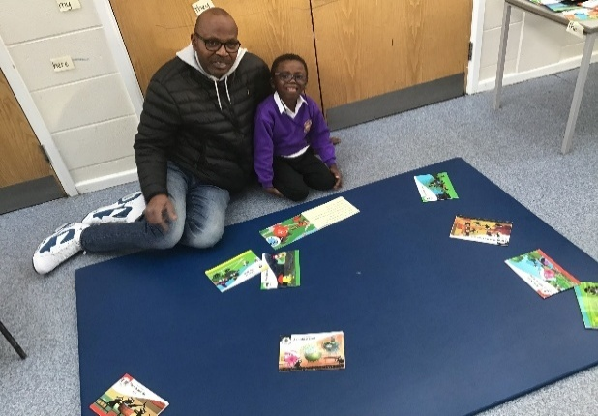
Diwali dance workshops
Chinese Dance workshops
PHSE drama workshops
Visit to Blue Planet Aquarium
Visit to University Science Labs
Christmas pantomime
Stone Age visitors
Mouth Music beatbox workshops
Stay and Read in y1
Local area walks
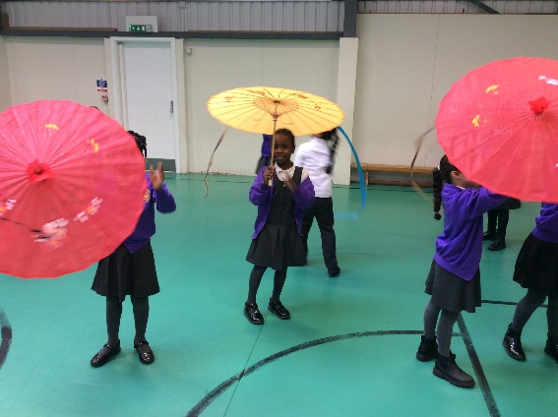
Teddy Bears Picnic

Y2 Dance workshop

Parents Workshops

We have also been trying really hard to offer workshops for parents around various curriculum topics. These have started to run and have been SO popular! So far we have held :
Y1 Stay and Read
Y6 arithmetic session
Several EYFS Stay and Play sessions (monthly)
There will be more of these as the term progresses, look out for letters coming home.

Ms MacArthur commented on the parents workshop for y6: This term we invited parents into school to participate in a live lesson with their teacher. A lot of eager and enthusiastic parents arrived and donning their best uniforms and behaviour, they settled down with their child to attempt some tricky Year 6 arithmetic maths.
The participation was FANTASTIC! Students became the teachers and parents enjoyed watching their children showing off their skills and knowledge whilst tackling different styles of questions with ease. Questions were asked by both children and adults, demonstrations were made in front of our audience by our pupils and the entire session was a resounding success!
Thank you to all those who attended. Keep your eyes peeled for another session in the not too distant future. 🙂

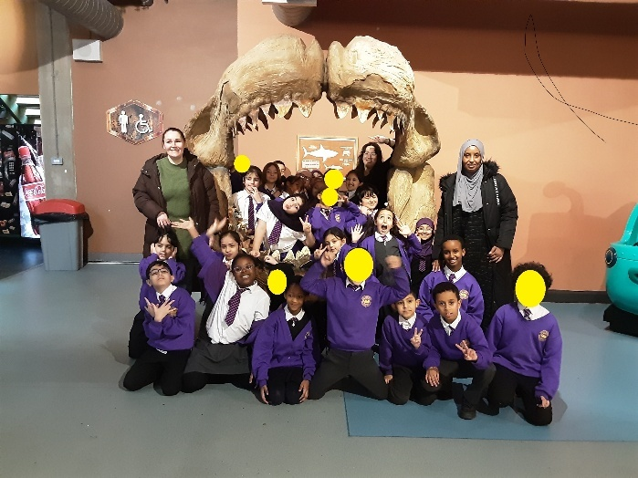
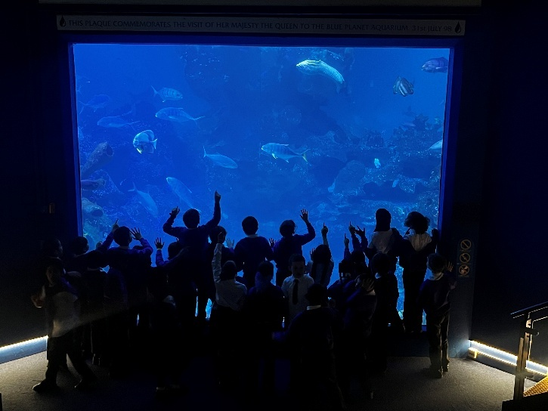
Y4 had an amazing visit to the Blue Planet Aquarium last month. Thanks to all of our parent volunteers who helped out on the day!

Events Next Term.
Look out for letters about-
5th March – Own Clothes Day To Fundraise For Love Jasmine Charity
6th March Crazy Hair Day to celebrate World Book Day

Ramadan and Fasting.
Remember, if your child is in y5 or 6 and you would like to give permission for them to Fast, permission forms are available from the school office. You can also pick up a copy of our Fasting Policy from the office, or view it on our website under Parents section. Children CAN NOT fast in school unless we have this permission letter (for many reasons ,including the fact that some parents do NOT want their child to fast and have been upset with school when the children have tried to!)

PE kits REMINDER!!!!
Our PE uniform is:
- Plain black shorts or jogging bottoms
- Plain white t shirt
- Trainers or pumps.
We will keep spare PE kits in school for children who fail to bring the correct kit into school, or whose parents do not discuss any reasons for this with us. We will also have spare pumps in school for those who come in wearing trainers rather than shoes. A Barcelona kit, or similar is NOT allowed for school PE lessons, please can you make sure your child wears the correct uniform for PE, as they do for all other lessons, and that they remember their kit every week when they need it.


Can I also remind you , again, that swimming is a compulsory part of the curriculum. It is a legal requirement that we teach it and we have to report to Governors and the DFE about this. No child can be excused from this and children MUST bring a swimming kit to attend every week. We have had quite a few problems with children who repeatedly do not bring a kit. Please can you ensure that they have one every week from now on. Y4 will be in swimming straight after half term. All children have been given a hat and this MUST be worn every week.

Clothing In Cold Weather
Can we ask everyone to make sure that children wear appropriate clothing for the weather, especially when they have outdoor learning. In Reception and Y1 in particular hats and gloves are really essential as children can complain when they are outdoors in sometimes quite flimsy clothing. We are so lucky to have Forest school and it is amazing fun, but at this time of year children need to be wearing appropriate clothing for a Liverpool winter.

Pre Loved Clothing
Ms Smith will be running the pre loved uniform shop again on the first Monday back after half term at 3-3.45 in the pod.
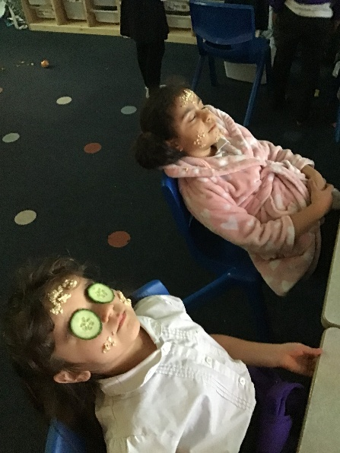

Well Being Week

Children and staff at Kingsley had a great week last week (3-9 February 2025. ) for National Children's Mental Health Week.
The week’s focus theme was Know Yourself, Grow Yourself, with the aim to equip and empower children to embrace self-awareness and explore what it means to them. Across the school children took part in online events and quizzes with Liverpool Learning Partnership as well as a variety of activities in class. KS1 had a wonderful, relaxing time at their spa day. Some of KS2 learnt more about emotions with Inside Out.
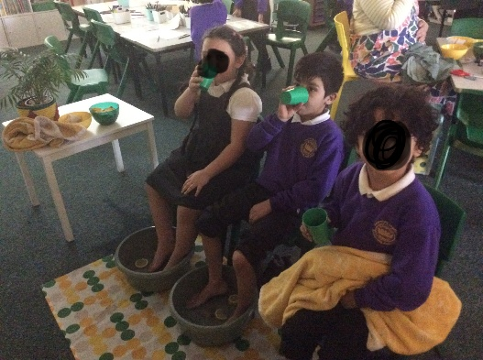
Mental Health is something we all have and these events are an important reminder of how we can all take care of our wellbeing.
Ms Garrity, Mental Health Lead.
KS1 Spa day!

Parking

Thanks evertyone for supporting us with safer parking on Eversley Street. Our new ‘pupil signs’ are really helping remind cars not to stop on the zig zags, so its much safer for everyone to cross.

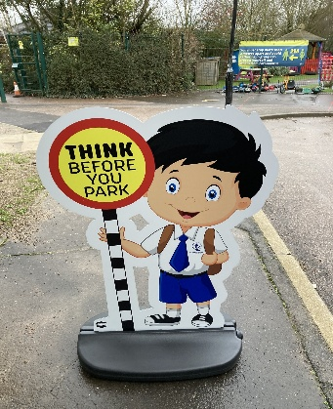

Dates For Your Diary:

Easter Holidays- 7th – 21st April (12.30 finish on the 7th)
May Day bank holiday- Monday 5th May
Summer half term- 26th- 30th May
School finishes for Summer- Friday 18th July 12.30
Autumn Term begins- Tuesday 2nd September
(Monday 1st is a staff training day)

Enjoy a happy and safe half term everyone

Mrs A Whittaker, Head Teacher,

