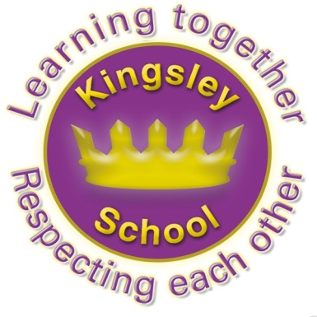
Kingsley Community School,
Eversley Street,
Liverpool.
L8 2TG.
Telephone: 0151 709 6727
Fax: 0151 708 5105
Website: www.kingsley.liverpool.sch.uk
Head Teacher: Mrs A Whittaker
14th July 2025

Dear Parents/ Carers,

This will be the final newsletter of this academic year. It’s my last chance to share good news, let you know about arrangements for September and wish you well over the Summer holidays.


Inclusive Centre of Excellence.
Firstly some great news to share with you. You may remember that last year we underwent a rigorous assessment process to become an Inclusion Quality Mark School. Not only were we granted the award, but at its highest level, we were designated a Centre of Excellence. Mr Harrison has recently led us through our first re assessment of this and I am delighted that we have retained this status. The assessor remains very positive about our schools inclusive ethos, the resources we deploy and the commitment we have in supporting all children and families to be included. A clear strength is the provision we have for children with additional needs, particularly those with neuro divergent needs. We have been asked to support other schools in their provision and to host a cluster group here to share our good practice. Well done to all of the staff team, this really has been a whole school effort.

Good Food Award.
Y4B Children Shine at the Good Food Awards! 🌟🥗
Five children from Y4B recently visited Toxteth Annexe to accept a Good Food Award on behalf of our school. This special award recognises all the brilliant things we do around food — including cooking lessons, Design & Technology, growing fruit and vegetables, involving our parents, celebrating food from different cultures and festivals, and, of course, enjoying our delicious school lunches!
We’re incredibly proud to say that we were one of only three schools out of 127 primary schools to receive this award!
Our children did a fantastic job presenting to a room full of adults and children — they were confident, clear, and brilliant ambassadors for our school. They even helped make some of the food served at the Awards Buffet. Well done to all involved — what a fantastic achievement!

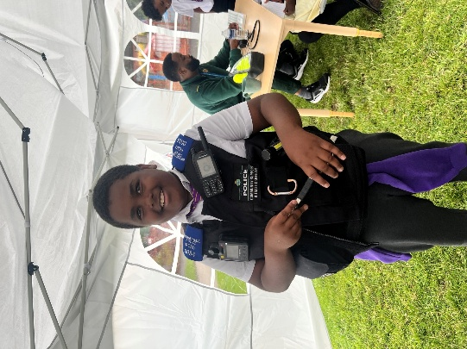
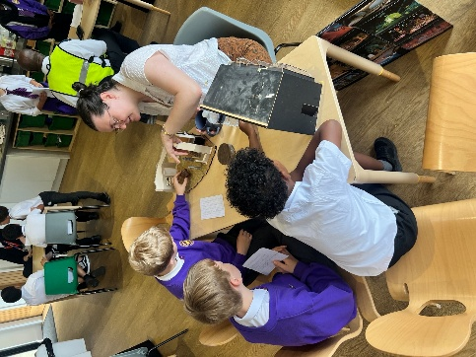
Careers Day
This term, Kingsley hosted its bi-annual Careers Day, and we were delighted to welcome a diverse range of professionals to inspire our pupils. Careers represented included a doctor, paramedic, police officer, computer/gaming engineer, TV director, and many more. The children had a fantastic day, engaging in meaningful conversations, asking insightful questions, and beginning to consider their own future career aspirations.

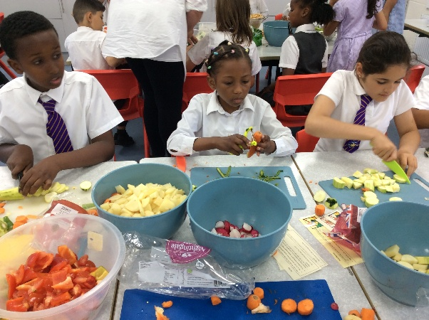
Experiential learning in year 1. - This term in history we have been learning about the Titanic, children had the opportunity to make their own 3D models of Titanic .

Year 4 had a great time cooking! I'm sure they enjoyed their vegetable curry when they got home.
Year 4 loved our trip to Martin Mere this Summer! We really enjoyed exploring the wetlands in the sunshine, meeting all the unique wildlife and of course hurtling down the zipwire! We also met Ava (part human, part bird!) whose story we had learnt about in class. We helped her return to her family by completing various challenges in the outdoors, both at Martin Mere and in our forest back at school. These included, building a nest of our own and walking bare foot through nature!

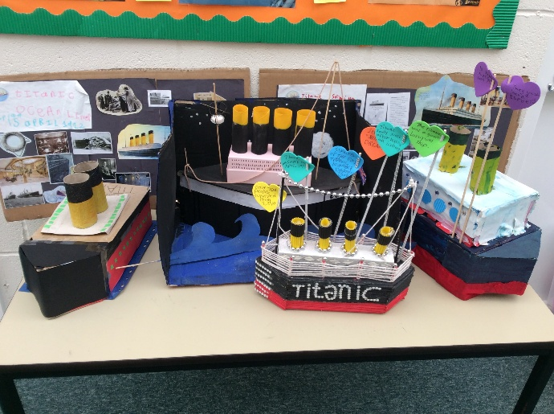
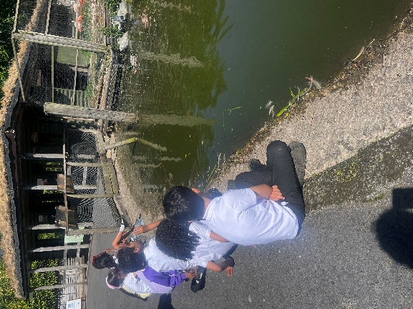

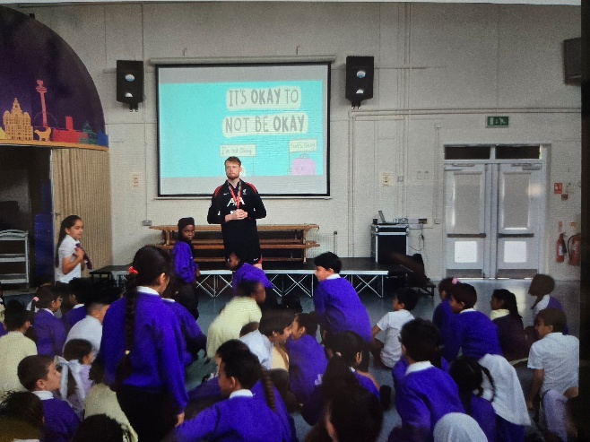


Year 3 have enjoyed a series of Health and Wellbeing lessons this term with the LFC Foundation. We have learned more about ways to keep healthy and explored healthy food, too much sugar, physical exercise, dental hygiene, mindfulness and mental health. Last week we also had a special Mental Health assembly and talked about how we all have mental health, that it is okay to not be okay, how to cope with difficult thoughts and feelings and where to ask for help if we need it.

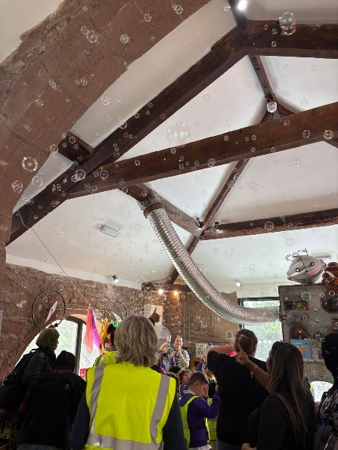

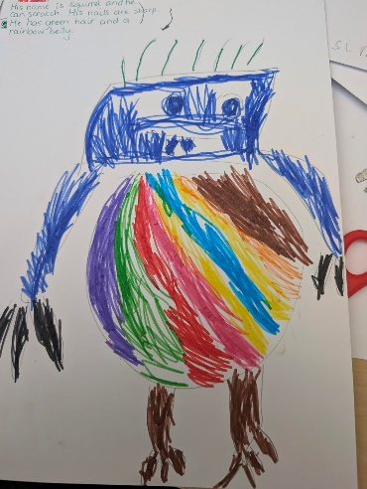


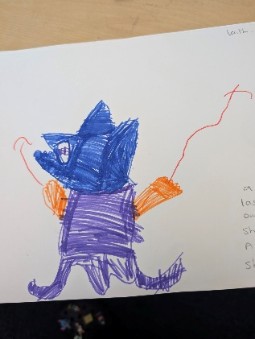
Bubble fun in the story barn.

Reception used A.I. to create the creatures that they had drawn following a trip to the park and story barn. They drew their creatures then turned them into cartoon images. They are amazing!

National Sports Week.
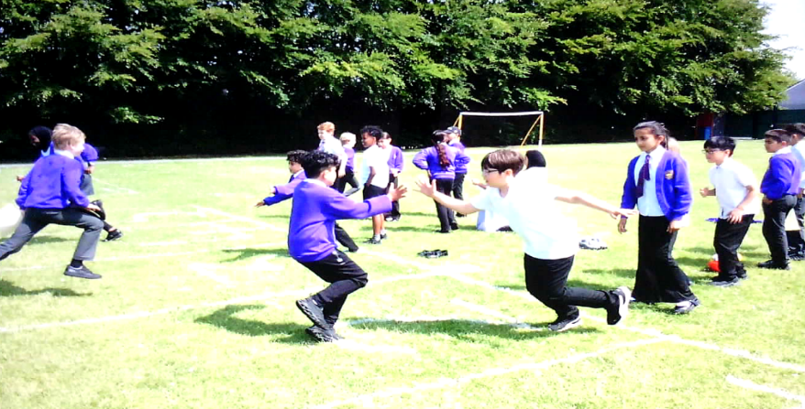
National Sports Week (16th - 22nd June 2025) saw this year's theme call for all schools, organisations and families to get involved and champion up to 60 minutes of PE, sport and play every day to help all young people to adopt an 'Always Active' approach towards their health and well-being.

Incorporating up to 60 minutes of active learning inside the classroom each day helped our children to stay energised and focused. Activities like movement breaks, action-based learning games and interactive lessons that involved physical movement also helped enhance concentration and overall engagement. Alongside classroom activities, our children were encouraged to be more active on the playground too and to join in with sports such as cricket, football, basketball and archery!
Y5 keeping active!

Our school's Sports day for both KS1 and KS2 was also a great success! The sun shone brightly as all students took part in a range of fun and challenging activities, from sack races and obstacle courses in KS1 to relay races and competitive skipping events in KS2. Children cheered each other on, showing excellent sportsmanship and enthusiasm throughout the day. Parents and staff joined in the excitement, creating a supportive and joyful atmosphere. Sports week at Kingsley was a fantastic celebration of movement, well-being and school spirit!
Our trip to Chester Zoo was fantastic! The children in y2 measured the age of trees and were delighted to discover a variety of animals from around the world. It was a brilliant way to connect with wildlife and learn about different habitats.
We also had an inspiring Altru Workshop focusing on Rosa Parks, which sparked important discussions about equality and social justice.
Additionally, our visit to the Catalyst Museum was a highlight, especially the Discovery area, where the children enjoyed hands-on science experiments.

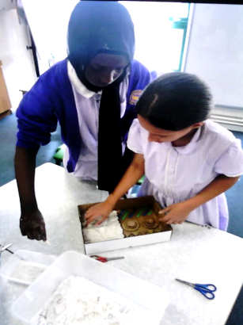
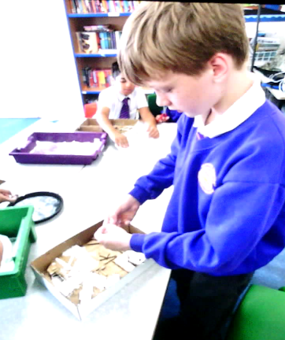

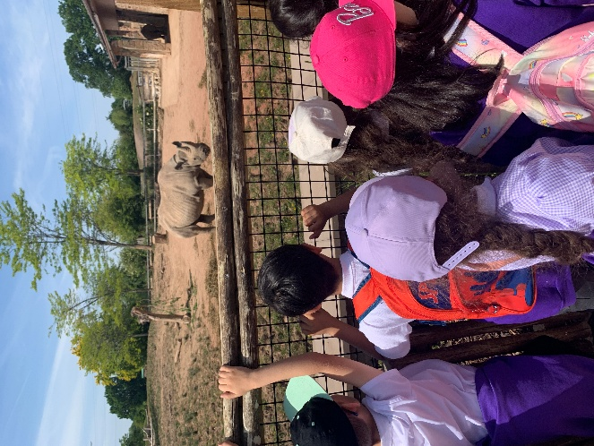
Y5 enjoyed art week, building cardboard templates in the style of William Mitchell and using Mod Roc.

Praise for our Pupils.
We get a LOT of praise for our pupils behaviour when they are out of school, from providers and from members of the public. However, I particularly wanted to share this one from the Head of Kings Leadership Academy:
‘I am writing on behalf of everyone at King’s Leadership Academy Liverpool to offer our sincere thanks and admiration for the outstanding conduct of your pupils during our Year 6 Transition Day.
From the moment they arrived, your students demonstrated exceptional manners, maturity, and a genuine eagerness to engage with every aspect of the day. They were respectful, enthusiastic, and a real credit to your school. Our staff were incredibly impressed by their willingness to participate, their thoughtful questions, and the way they supported one another throughout the activities.
It was clear to us that they had been extremely well prepared for this important next step in their education. Their behaviour was exemplary, and they represented your school with distinction and professionalism far beyond their years.
Please do pass on our thanks and congratulations to the pupils who attended, as well as to the staff and families who have played such a significant role in nurturing their positive attitudes and values…’

Punctuality and Attendance

Our school attendance looks to have dipped somewhat this year, which is disappointing. However, many children have managed to increase and improve their attendance , which is great news! What has really impacted on our positive attendance data is the number of holidays or requests for leave of absence which have been made during term time. As a reminder , Leave of absence for travel, including holidays is NEVER authorised. We are simply not able to authorise such leave. Parents will be fined in many cases, again, this is not something that school decides, but it is the direct instruction from the local authority as a response to poor attendance in the city.

We are still considering further measures to try to support better punctuality as lateness to school has also been a concern this year. Interestingly, we often find that once children get to y5 or 6 and can bring themselves to school, their lateness improves enormously! You my find some processes around lateness change in September as this is also currently impacting on the ability of office staff to carry out their role (due to having to keep letting in late pupils, log them in and take them to class in some cases!)

Please, please, please, if you are a parent of a child who is regularly arriving late (after 8.50am) make it a family mission to get to the gate by 8.40 every morning in September. Those lost minutes can make a huge difference to pupils learning and to how they feel for the rest of the day. We are always here to help you if you are struggling in the morning, or possibly talk about a place at breakfast club if this will help. Just ask and we will do what we can. Mornings can be very stressful but a good, regular routine where parents are organised and structured really helps.

Breakfast Club
Breakfast club will continue to operate in the same way and is a useful support for many parents and families who need an early drop off or to help encourage good punctuality. Breakfast club costs 50p a day, children can pay on the day, or you can pay up front for a few weeks at the office. There is no need to book this, you can use the service for the days you want. The children have a drink, cereal and toast and spend time with their friends – it’s a very chilled start to the day!

Term Dates
Some important dates for your diary!
18th July – school closes for the Summer 12.30pm.
1st September- Inset day . School closed to pupils but office is open for uniform etc from 1-3pm.
2nd September – 1st day of school for pupils ( Reception and Nursery will have staggered starts which you have been invited to)
24th October – Inset Day – school closed for pupils
27th – 31st October Half Term- School closed for pupils.
19th December- school finishes for Christmas at 12.30pm

5th January- Inset day- school closed to pupils.
Pupils finish school on the 17th July 2026. Please make a note of this date for booking holidays . There is a staff inset day on the 20th July 2026 - but pupils will not be in school on this date.

A full list of school holidays for 2025-6 has already been sent out, but you can also view this on the school website.

Other Important Date- Applying for Secondary School.
One more very important date for those children in y5 is the meeting in school to support/ inform parents about how to apply for their new secondary school. This is a really important meeting- please make every effort to attend if your child will be going into y6 in September.
The meeting will take place on 10th September at 9am. Please ensure you arrive on time, as you may not be admitted once the meeting has started.

Uniform/PE
Please can I remind you about requirements for school uniform.
You have chosen Kingsley school for your child, so along with this we feel that you have chosen the expectations we have for pupils who attend here. One of these expectations is that pupils attend school in uniform every day.


Uniform consists of:
- Tie years 3-6
- Dark grey trousers or skirt
- Black shoes, NO TRAINERS
- Plain black or purple hijab- (NOT a long scarf)
- Purple sweatshirt or cardigan
- White polo shirt in years R to 2
- NO JEWELERY please! (Apart from small flat stud ear rings)
Jumpers/ cardigans/ ties and all in one hijabs are available to buy from the school office.

All pupils are expected to return to school wearing correct school uniform. PLEASE write their name in their tie and in ALL school uniform. Staff do not have the time to sort through the large number of items which are lost or discarded by children every day, and who do not have their name in..

The school uniform has always been very simple here at Kingsley and there should be no misunderstanding or ambiguity. Please note that we will be picking up on every single student who is not wearing the correct uniform on day one and asking them to fix this for day two. We will also speak to parents on the door if this remains a concern. The main issue for us at the start of a new year is often trainers being worn instead of shoes. Trainers are NOT part of school uniform, neither are tracksuit tops.
Please make sure that your child has the correct PE kit to bring to school with them.


PE kits
- Plain black shorts or jogging bottoms
- Plain white t shirt (short or long sleeved is acceptable)
- Trainers or pumps.
Pupils get changed for PE in school.
For classes who swim, they need a towel and swimming costume or shorts- modesty costumes are welcome if you prefer this.
We will keep spare PE kits in school for children who fail to bring the correct kit into school, or whose parents do not discuss any reasons for this with us.

Granby CC
Can I also take this opportunity to remind you that Granby Children’s Centre remains open during the Summer break., Staff are there to help with families who have children under 5 and may also be able to help or signpost those with older children to services whilst school is closed.

Don’t forget, school finishes on Friday at 12.30pm. Children can be collected form classrooms in the normal way, just at an earlier time so that Teachers can get the school ready for its annual deep clean!

Good Luck to our y6 pupils who will be starting their new secondary schools in September, and to staff who are leaving this term. We will miss you all. I hope everyone has an amazing Summer, and we look forward to seeing everyone back safe and rested on the 2nd September.

Kind regards,

Mrs Alison Whittaker, Head Teacher.

