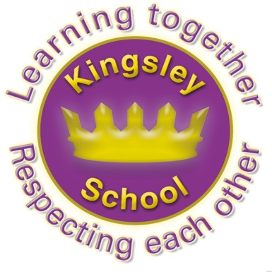
Kingsley Community School,
Eversley Street,
Liverpool.
L8 2TG.
Telephone: 0151 709 6727
Website: www.kingsley.liverpool.sch.uk

Head Teacher: Mrs A Whittaker
26th March 2024
Spring 2 Newsletter
Dear Parents and Carers,

Goodness me, this term has really flown by, and this is the first newsletter I have managed to get out. It has actually been our shortest term for a long time (but it doesn’t feel like it!)

We have shared some continued good progress as well as some fun days and themed weeks and our attendance has continued to improve. Once again I am really pleased to report how many more extra curricular clubs and inter school competitions we have been able to provide. It’s a real strength of the school, especially sine we contine to make NO charge for any of these events.

Extra Curricular Clubs.
The following clubs have run this term:
Monday | Tuesday | Wednesday | Thursday | Friday
Stitch club y4  Year 2 Computing  Y3/4 Keyboard Club  Sats Club Y6  Y3/4 Gymnastics club | Year 1/2 Multi-Sports Club  Year 2 Computing  Y3/4 Keyboard Club  Y4/5Choir Club  Reading Club Y2  Sats Club Y6  Y5/6 Newspaper Club | DODGEBALL COMPETITIONS  Year 3 / 4 Drumming | CRICKET LEAGUE  Eco Club Year 3/4/5  Arithmetic Club Y2 x 3 | Year 5/6 Flag Football  Year 1 Computing

Competitions and Team Events attended, both during the day and after school
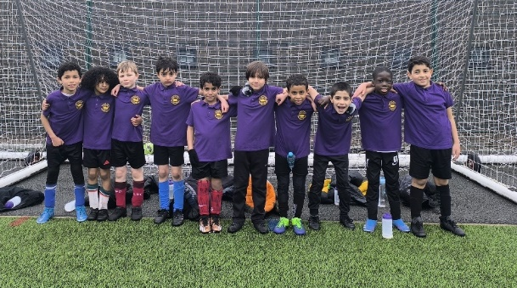
Year 3 football team
15th Jan - Y1 new age kurling  16th Jan - Y5/6 Basketball,  17th Jan - Y5/6 Dodgeball  18th Jan - Y1/2 Matball,  19th Jan - CRICKET LEAGUE  22nd Jan - Y6 New age kurling  24th Jan - Y3/4 Dodgeball  26th Jan - CRICKET LEAGUE  29th Jan - Y5 New age kurling  30th Jan - Y3/4 Indoor athletics  31st Jan - Y1/2 Dodgeball | 2nd Feb - CRICKET LEAGUE  5th Feb - Y4 New age kurling  7th Feb - Y5/6 girls dodgeball  9th Feb –cricket league  20th Feb - KS1 Dance  27th Feb - Y3/4 Gymnastics  29th Feb - Y6 Boys football  4th Mar - Y3/4 Highland Games  7th Mar - Y5 Boys football  14th Mar - Y4 Boys Football  21st Mar - Y3 Boys Football

Like a lot of what Kingsley does- this provision is really down to the dedication and good will of several of our staff members. I can not tell you how hard our staff work, and what long hours some of them put in, but they still support the additional opportunities that go on , and which make school a great place to be.
Clubs run on a six week basis, over the year all year groups from Y1 upwards will have offers of different clubs, the children who attend are tracked so we can see who attends and try to encourage wider participation – we report to Governors about this and it our ambition to ensure that every child has had the opportunity to take part in something by the end of the year. No mean feat for 400+ children and all for free!

The office staff also really help to organise these opportunities, particularly answering a lot of calls from parents about clubs. Please can I ask again, make a note of your child’s clubs, the dates and times they run when you get the letter, rather than relying on ringing up the office and asking them. This will really help them to manage their workload!

Curriculum enhancements R- Police visitors
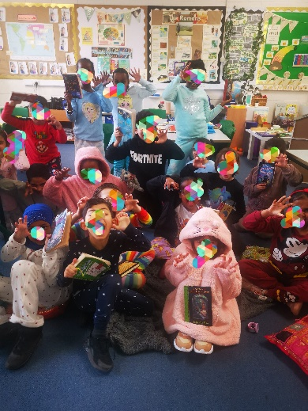
Y2 – Music Visit to Philharmonic
Y3 - Music visit to Philharmonic
Y5- Local Area Walk- Geography, Music Visit to Philharmonic
Y6- Altru Drama- Early Islam, Philharmonic visit- music.
Whole school – Chinese dance workshops.
Maths day- January 2024
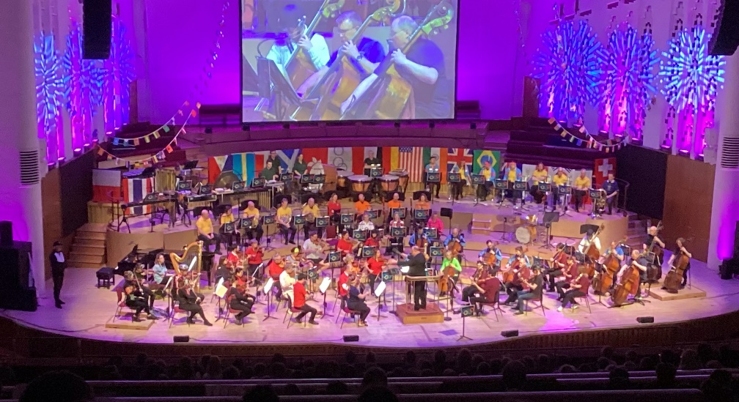

Y5 dressed ready for a bedtime story
during World Book Week - March 2024

Y5 dressed ready for a bedtime story during World Book Week - March 2024

The amazing Philharmonic Orchestra performing Olympic music.

Designers of the Future.

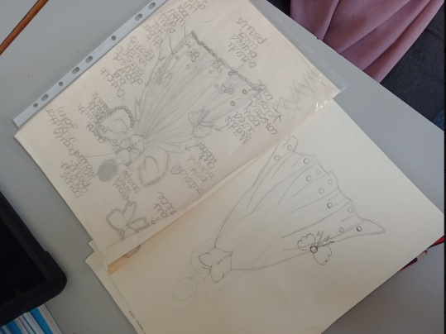
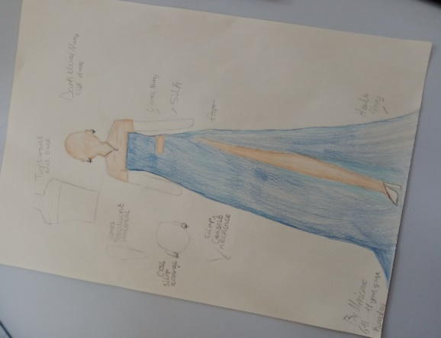
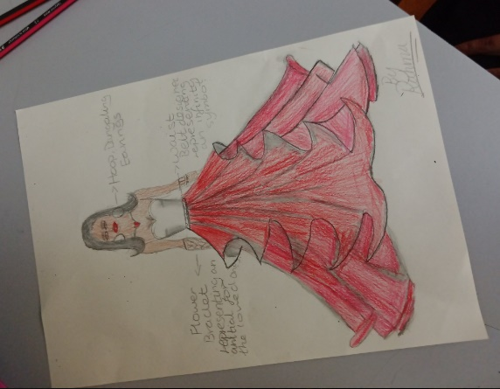

Some of y6 have been working on designing fabulous outfits for the Young Designer competition for local designer, Kirsty Doyle. They are amazing! I think they could all definitely have a career in fashion

Fundraising/ Charity Events.
As you will know, our fundraising events tend to be led by ideas from the school council. We try to balance national events , with things that are meaningful to our children- and we also try not to ask for money too often. This is why you will see that Kingsley doesn’t always take part in some national charity events (Such as Red nose day this year for eg) – simply because we have done some of our own.
£105 Silly socks- anti bullying alliance November 23.
£307.82 Woolies for Whitechapel Dec 23
£204.20 Number Day- NSPCC- January 24
£252.51 Culture Day - Save the Children February 2024
Once again, even during tough times, our families think of those in need ,thank you for your support.

Staffing
This term we will say goodbye to Ms Rice who is leaving us to work in another school at Easter. We wish her good luck and thank her for all her hard work at Kingsley- especially leaving us this term with an amazing pupil newspaper (which I am sure more people will read that this newsletter!)
Uniform Reminder

I’ve been really pleased with the effort that all of the children continue with uniform this year, year 6 in particular have been setting a great example for the younger pupils. The school uniform has always been very simple here at Kingsley and there should be no misunderstanding or ambiguity. Please note that we will be picking up on every single student who is not wearing the correct uniform on day one and asking them to fix this for day two. We will also speak to parents on the door if this remains a concern. The main issue for most schools at the start of a new year is often trainers being worn instead of shoes. Trainers are NOT part of school uniform.

Ties are part of uniform from Y3 upwards, please ensure your child is wearing one.

If your child choses to wear a hijab, or kufi/ prayer hat- please remember that these should also follow uniform policy- they should be black or purple and plain material. A hijab should be a one piece item, not a scarf with loose trailing ends. This is especially important during PE lessons when loose clothing can be a hazard.
Please make sure that your child has the correct PE kit to bring to school .

PE kits
- Plain black shorts or jogging bottoms
- Plain white t shirt
- Trainers or pumps.
We will keep spare PE kits in school for children who fail to bring the correct kit into school, or whose parents do not discuss any reasons for this with us. We will also have spare pumps in school for those who come in wearing trainers rather than shoes.


Can I also remind you , again, that swimming is a compulsory part of the curriculum. It is a legal requirement that we teach it and we have to report to Governors and the DFE about this. No child can be excused from this and children MUST bring a swimming kit to attend every week. We have had quite a few problems with children who repeatedly do not bring a kit. Please can you ensure that they have one every week from now on.

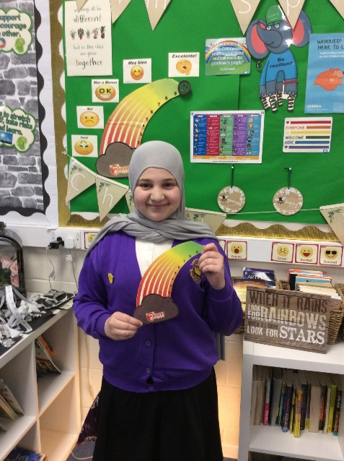
Well being Ambassadors

Our Wellbeing Ambassadors are children from years 3 to 6 who help spread KINDNESS, which is Kingsley's Number One school rule. The Wellbeing Ambassadors have been trained in ROCKET by Merseyside Youth Association. ROCKET stands for Resilience, Open, Caring, Kind, Equal, Togetherness. During National Children's Mental Health Week ( 5th - 9th Feb) they delivered assemblies about Mental Health and Resilience around the theme of 'OUR VOICE MATTERS' and the importance of speaking about thoughts and feelings. Children across the school produced some lovely work and joined in some livestream events with some other schools. We all have Mental Health so please visit the Wellbeing page on our website to see how you can also support your children using our Whole School approach and keep talking!
A y6 Well being Ambassador with
our ROAR rainbow of feelings.

Ms Garrity, Mental Health Lead.

Parking – Another Reminder


You will all have seen the heavy police presence around school over the last few weeks. I believe they are really trying to clamp down on dangerous parking and unsafe dropping off of pupils. Unfortunately, as soon as they left, we have seen parents continuing to park on the zig zag lines and drop off even very young children in the middle of the road. Our next step is to have a police/ council camera installed outside all school entrances, to support better parking and driving. We are on the waiting list for this. Several of you commented how calm and safe it felt to walk your children to school when the police were there, so lets keep trying hard to encourage safe, respectful driving.


Dates For Your Diary
28th March 12.30pm. School finishes for the Easter holiday. (No Nursery)
15th April- School Summer term starts.
27th May- 31st May Summer half term.
19th July 12.30pm end of term.

There is one other inset day to allocate this academic year, this is likely to be around the time of Eid in the middle of June, but I will confirm this as soon as I can in April.

Finally
There is so much that has gone on this term that I have missed here but once again, there is so much to positively celebrate about life at Kingsley. The staff continue to work unbelievably hard on behalf of your children, and we really appreciate all the support you give.

The news both nationally and internationally continues to remind us that the world can seem increasingly divided and dangerous place. I want to ask for your support again, in giving our pupils the right messages about how we live with one another. Number one school rule- Be Kind! In a world where you can be anything, why not be kind? I know that our school and our wider community always offer amazing support and tolerance and I am very grateful for those of you that help us to spread this message. If you haven’t already seen it , please take yourselves and your children to see the amazing mural of Leroy Cooper on the end wall of the adult learning centre on Granby Street. Love is indeed everything.

Happy Easter and Eid Mubarak to all of our families who celebrate over the holiday.
Mrs Whittaker.

