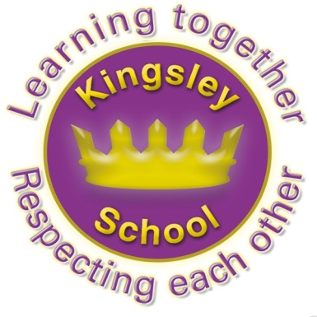
Kingsley Community School,
Eversley Street,
Liverpool.
L8 2TG.
Telephone: 0151 709 6727
Website: www.kingsley.liverpool.sch.uk

Head Teacher: Mrs A Whittaker
25th October 2024
Autumn 2 Newsletter
Dear Parents and Carers,

Welcome to the second newsletter of this year. The Summer seems a long time ago, as so much has been going on at school this half term!

Black History Fortnight
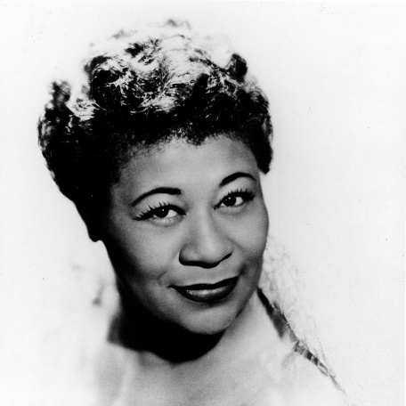
As you know, our curriculum is written in a way which not only covers all the things that the Government say we MUST teach, but also in a way which celebrates achievement and raises aspirations for OUR children. We give a significant priority in all subjects to black achievement, alongside that of other groups who traditionally can be under represented. We continue to celebrate black history during these weeks, but we try to embed this in all subjects , rather than treating it as a one off. Focusing together music and Black History our classes have all had an exciting musician to research, and listen to including Stevie Wonder, Ella Fitzgerald and my favourite, Charlie Pride! You will see lots of displays going up around the school to reflect the work that the children have done linked to their class musicians. School has been a lively place to be lately!

IQM

We are immensely proud that following our assessment in July , our school ahs not only been awarded the nationally recognised Inclusion Quality Mark, but we have been designated a ‘centre of excellence’ in this area. We have a super new plaque on the front of the building and a lovely report which you can view on our website. Once again congratulations to Mr Harrison and all the staff team for their hard work, creative thinking and approach to including all children in the life of the school. We are VERY proud of Kingsley’s inclusive ethos. No matter where you are from in the world, no matter your learning needs, no matter your family makeup or circumstances, no matter your faith or residency status, no matter your age or ability , we hope you feel welcome in our school and by our school. We will now be able to share our practice with other settings across the North west and continue to learn ourselves.

Tesco Fruit Bonus

A huge thanks to Tesco who have given us an amazing grant to buy extra fruit and veg for our pupils this term. We are only one of three schools to have been given this in the entire North West- thanks to the excellent bid submitted by Mr Moore! It means we can buy lots of extra goodies for the children. So far we have been able to offer a wider range of veg in the canteen at lunchtime, as well as extra strawberries and mango (which I believe went down a treat!) and give Reception classes a big fruit tasing session of things they may not have tried before! Persimon or figs anyone?

DFE Visit
Thanks to another great bid writer, Ms Gold, we were the lucky recipients of some extra funding from the Department of Education last term, to help support progress in Early years. We have been able to purchase programmes to support early speech and early writing in particular and have started to use these across reception and year one. We hosted some important visitors from the North west Department of education this week, who wanted to see a school where the grant had been put to good use. As usual our children and staff did us proud and our visitors went away with a great impression of Kingsley , and of Liverpool Learners.

Breakfast Club Reminder
Children who wish to attend should arrive at the main entrance at 8.15am. Breakfast club costs only 50p a day, which can be paid daily, or as a weekly amount of £2.50. Pupils will be offered toast, cereal and a drink to set them up for the day. You do not need to book your child’s place at the moment, we will only need to consider this if numbers increase dramatically. We do, however insist that pupils should arrive between 8.15 and 8.30am or they may not be allowed admittance.

School Teams and Clubs

Once again, one of the best things about this term has been the number of teams and competitions we have been able to support our pupils with! This in addition to afterschool clubs which staff put on. Again, we continue to manage these without charge (many schools DO charge for these things) and we could not do this without the commitment of staff. We also have a host of exciting clubs planned for next half term. These are rotated and limited to half a term in most cases, so that everyone in school from y1 upwards gets several chances to join in and be part of an extra curricular club. Mr O Shea also tracks involvement in competitions and events – our aim is that by the time they leave, every pupil will have had the chance to represent the school.

A word from Mr O’Shea:
Wow! What a half term of sport it has been in Kingsley this half term! We have already competed in a huge amount of competitions including football, dodgeball, quidditch and futsal

Our girls' football team are in the running at the top of their league, and our boys have shown a very resilient attitude after some tough results! Through it all though the children are enjoying representing the all of the school teams! Our Y3/4 dodgeball, year 1 football and year 2 dodgeball teams all missed out on the city finals by one point each respectively! A fantastic effort!

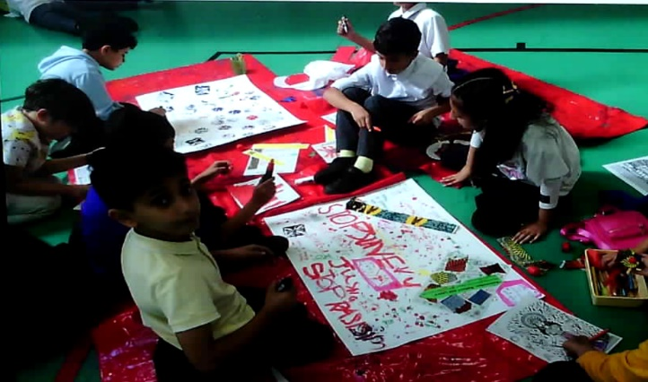
The children in year 4, 5 and 6 have been taking part in our new young leader training program, culminating in them teaching some of our younger year groups during their PE sessions. It has to be said our older children rose to the challenge, they did a fantastic job, and we are all very proud! We have also trialled bringing our older children out to sports competitions with our KS1 children to help support and coach them through the games and events. They have been building on the leadership skills they have shown in school where they have been giving up their own lunchtimes to help our younger children learn and play! Well done to Kinnan, Rodrigo, Piaz and Khalil!

Curriculum Enhancements:
Other events include workshop with Merseyside Museums ( as in the photograph) mental health day, Stone age workshops and straight after half term we will have workshops in school around the theme of Diwali.

Uniform Reminder
Thanks to all of you for supporting us in our drive to ensure all pupils are wearing correct uniform. It really is important that pupils follow school rules and often when they don’t follow the uniform rule, there can be a slippery slope into not following other rules… The school uniform has always been very simple here at Kingsley and there should be no misunderstanding or ambiguity. Please note that we will be picking up on every single pupil who is not wearing the correct uniform on day one and asking them to fix this for day two. We will also speak to parents on the door if this remains a concern. The main issue for most schools is often trainers being worn instead of shoes. Trainers are NOT part of school uniform, neither are tracksuit tops. If your child tells you they can wear these for anything other than PE, please remind them they can not, and do not allow them to leave the house without correct uniform.
Ties are part of uniform from y3 upwards, please ensure your child is wearing one.
Please make sure that your child has the correct PE kit to bring to school with them this year, on the correct day.

Years 4 and 5 Swimming

Can I also remind you that swimming is a compulsory part of the curriculum. It is a legal requirement that we teach it and we have to report to Governors and the DFE about this. No child can be excused from this and children MUST bring a swimming kit to attend every week. We have had quite a few problems with children who repeatedly do not bring a kit. Please can you ensure that they have one every week from now on.

Parking – Another Reminder

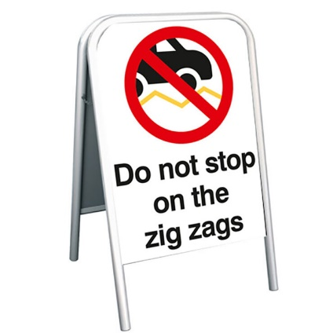
Most of you will know that it’s a bad idea to park anywhere near the main entrances to the school at start and finish times. It creates real problems in terms of gridlock and safety for children and other school users. However, many parents do chose to drop children off at the gates in Eversley street in particular, sometimes in the middle of the road. This is incredibly dangerous and frustrating for other road users.

You may have noticed a greater police presence this term, this is no coincidence as the number of complaints about poor driving and parking has increased, both to school and to the police. The police have issued several fines. Please think of children’s safety and don’t be caught out.

It is NEVER ok to pull up and park on the zig zags.

Dates For Your Diary
20th December - school finishes at 12.30 for the Christmas holidays.
7th January start of Spring term ( There is a staff training day on the 6th)
17- 21st February – Spring Half term- school closed.
4th April, school closes 12.30pm for Easter holidays
There is 1 other inset days to allocate this academic year, this will be decided in the new year, depending on need, it is likely to coincide with Eid.
18th July- school closes for the Summer holiday for pupils.
Please look on the school website for all other dates.

Finally
There is so much that has gone on this term that I have probably forgotten! Once again, there is so much to positively celebrate about life at Kingsley. The staff continue to work unbelievably hard on behalf of your children, and we really appreciate all the support we get from you. Enjoy half term everyone.

Kind regards,
Mrs A Whittaker
Safeguading Updated Information

Remember- it is your role as parent to monitor what your child has access to online. This can be really tricky to navigate but is vitally important. These websites may help you.


Helpful websites for Parents and Carers

Advice for parents about talking to your child about creating, sending or receiving explicit images:
http://www.nspcc.org.uk/help-and-advice/for-parents/talking-about-sex/sexting/sexting_wda96795.html
An e-learning tool for parents and carers:
https://keepthemsafe.safeguardingchildrenea.co.uk/
Support for parents and carers
http://www.paceuk.info/This pack offers guidance on how to approach discussions with children about commercial content online:
http://www.mediasmart.org.uk/parents/digital_packBack to school basics for digital families:
http://www.slideshare.net/uKnowKids/back-to-schoolbasicsfordigitalfamilies-slideshare
Facebook privacy settings:
http://internet-safety.yoursphere.com/2013/01/facebooks-new-privacy-settings/Top tips for iPhone, Blackberry, Nintendo, Playstation, Xbox, iPad and iPod touch:
http://www.kidsmart.org.uk/parents/parental-controls.aspxChild Exploitation Online Protection (CEOP) Centre website for parents and carers:
https://www.thinkuknow.co.uk/parents/

A website designed by young people for use by young people on staying safe
http://www.ayph-behealthy.org.uk/
A leaflet from Barnardos - Be aware, stay alert, keep safe!
http://www.barnardos.org.uk/spot_the_signs_cyp.pdf

A mini booklet about Child Sexual Exploitation
http://safeguardingni.org/sites/default/files/sites/default/files/imce/CSE%20Kids%20Leaflet.pdf
Healthy Relationship Checklist
http://thisisabuse.direct.gov.uk/worried-about-abuse#relationship-checklist
Child Exploitation Online Resources for Young People
http://www.thinkuknow.co.uk/
The Underwear Rule
www.youtube.com/watch?v=72Sh-wjmdzw

If you are ever concerned about a young person’s safety or well being- you can seek advice or get professional help by contacting Liverpool children’s safeguarding board.
You can telephone CASS (Children Advice and Support Service) on:
01514592606
Or at casscontacts@liverpool.gov.uk

Or by emailing school at:
safeguarding@kingsley.liverpool.sch.uk

