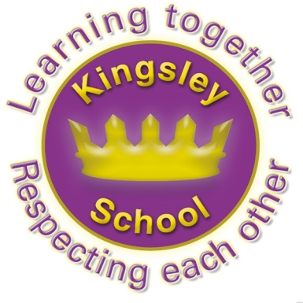
Kingsley Community School,
Eversley Street,
Liverpool.
L8 2TG.

Telephone: 0151 709 6727
Fax: 0151 708 5105
Website: www.kingsley.liverpool.sch.uk

Head Teacher: Mrs A Whittaker

December 18th 2024
END OF TERM NEWSLETTER

Dear Parents/ Carers,

Just time to end the year with some updates and messages for next term!

Attendance

An enormous thanks to everyone of you who has supported us and the city towards better school attendance. You will remember I sent out information in September about the legal changes for school in relation to this. I have also talked to the children a lot about the importance of being in school every day. Our current attendance for the year is a 96.2% which is much improved already from last year. I have to say that it would probably have been in the 97%s but for the significant number of school days we have lost due to children being taken on holiday during term time. Please can I ask again that you try very hard not to do this. We NEVER authorise a term time holiday, as we are told not to by the local education authority. Please think carefully about booking holidays where children will miss lessons, especially at the start of the year in September. It can be very difficult for children to catch up on what they have missed, or more importantly, on social factors such as friendship groups. This can really affect a child’s well being. I have sent out a school calendar, and also put this on our website, so please try to avoid booking holidays during term time.

A reminder that school starts at 8.50 every morning. Gates close at 8.50 promptly. Unfortunately we still have a lot of pupils who arrive every day at 5 or 10 minutes past this time. There is no apparent reason for this, but the children miss the morning mission every day. This recaps prior learning, or gives a boosts to key areas such as phonics or reasoning in maths. Late arrivals also creates a lot of work for the office staff who have to log children in manually as they have missed the register. Children walk into class after everyone else has settled and can often feel disorientated for the rest of the day. If school starts at 8.50, your child should be here, at school by 8.45 at the latest. Lets all try to start the new year punctually.


Uniform.
I have done a lot of nagging about uniform this year and I wanted to say thankyou for your support in this. For the most part children follow our rules and expectation (trainers still need policing!) However I have noticed jewellery appears to be creeping back in. please remember jewellery is NOT allowed in school, apart from small stud earrings. Please do not send children in with hoops or dangling earrings as we may have to remove them as they are a potential hazard, especially during playtime, and physical activities.

Amazing Results Just Verified!
Although we get SATs results for year 6 a few weeks after they have sat these tests in May, we always have to wait for verified results until November, the term after. This means we have all results, including re marks and dis-applications, as well as being able to compare with National Data.

Once again Kingsley pupils made us proud with their achievements. They achieved higher than national in all but one key area:

 | Reading | Writing | Maths | 3 combined
Kingsley | 77% (GD 15%) | 79% (GD 12%) | 79% (GD 21%) | 75% (GD 6%)
National | 74% (29%) | 72% (13%) | 73% (24%) | 61% (8%)
(GD = Greater Depth = pupils working above national standard)

These results reflect the hard work put in by pupils and staff over several years, but what they don’t show fully is the FANTASTIC progress made by some pupils. (This year group did not sit SATs in y2 as there was a covid lockdown) Most of the cohort join Kingsley speaking English as a second language, many joining the school having missed early years and key stage 1. Their progress is always something we celebrate, not just their attainment.

Staff Changes
We are sorry to be saying farewell to Ms Williams from the school office this month. Ms Williams has been an integral part of our reorganised office team, but we are delighted for her that she has gained a promoted position in another local school from January. I am sure you will join me in wishing her all the best for her new post and extending our thanks for the support she has given to staff, pupils and parents in the time she has been here.


Thankyou
At this time of year I reflect a lot on things I have to be thankful for, and I try to take the time to say thank you to various people. Being a Head Teacher can be very demanding, but I am truly grateful to work here at Kingsley, in L8. We have had a lot of visitors to school this term, many from other schools or partner organisations, and they unfailingly only ever have positive things to say about Kingsley. Myself and the Senior staff have been discussing lately what a good place this is to work and study, our pupils are so lucky to have the range of opportunities that we give them and that you, as parents, support us with. This is 100% down to the skill and dedication of the staff here, both in school and in the Children’s Centre. Sometimes, when you are in a place every day, you take it, or the people, for granted, and I just wanted to end my Christmas letter with a massive thanks to all of you !

The parents in Kingsley genuinely make this a great place to work, you are so supportive and we all really appreciate you, as much as we appreciate your children.

I have attached some pictures of the wide range of opportunities your children receive from Kingsley. We try very hard to give pupils an experiential learning opportunity as often as we can, and really try hard to enrich our curriculum with trips and visitors. Once again, this takes a lot of organisation and hard work from staff- so thankyou staff!
The world can still seem an increasingly difficult place to understand, and to live in. I feel that there is potential for a lot of hate out there. What I feel from the Kingsley Community is the opposite, there is positivity, love and kindness. If you ask any of our children what the number one rule in school is, they will tell you it is be kind . Lets all try to embrace this over the holiday and into the new year. Let your default position be kindness. Enjoy the holiday everyone and
Dates for your Diary


Friday 20th December 12.30pm. School closes for Christmas holidays.

Monday 6th January 2022, staff training day (school closed for pupils)

Tuesday 7^{h} January- school opens for pupils.

Monday 17th February- Friday 21st February- School Half Term (closed)

19th-21st March -Y5/6 residential to Colomendy.

Friday 4th April 12.30pm school closes for Easter holidays

Tuesday 22nd April school reopens for Summer term

Monday 26th May- Friday 30th May- June half term (closed)

Friday 18th July- school closes for the Summer holidays

There will be one more inset day to be arranged in 2025.

Dates for academic year 2026-7 are also now on our website! Please check these out before booking any holidays.


Happy Christmas.

Mrs Alison Whittaker, Head Teacher.

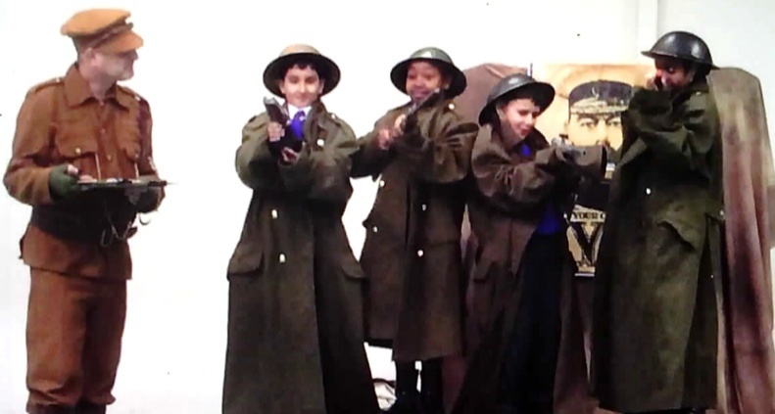

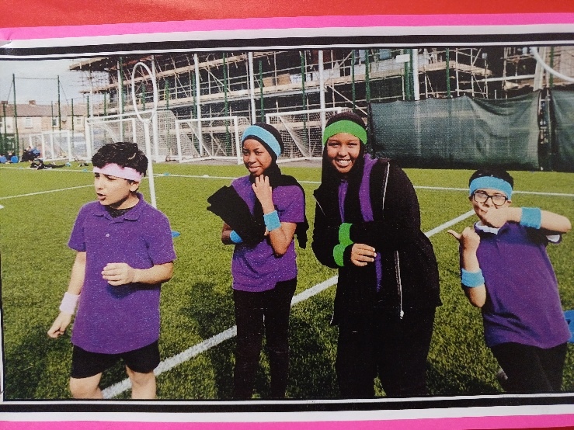

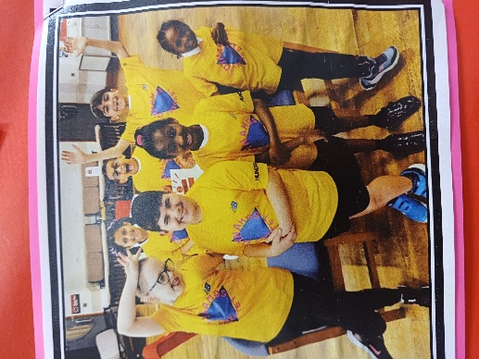

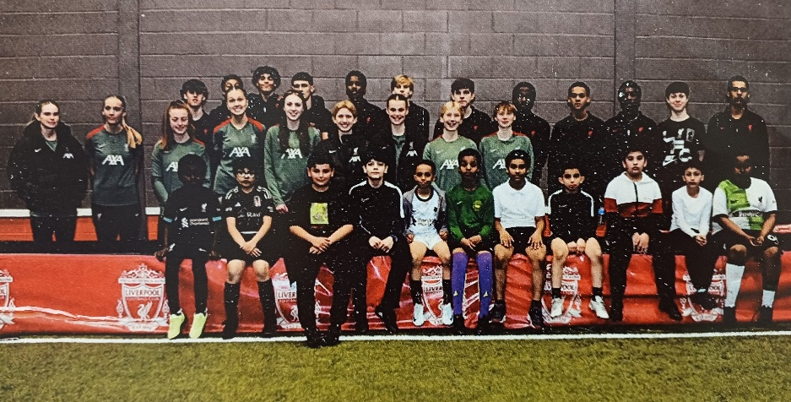
Y5 World War1 Workshop, Kingsley Quiddich Team, y3/4 Athletics Squad and Boys Football Team at Liverpool FC Academy


